Costumes
- Open the Costumes file and save it as “LastName_Costumes” to your Word folder on Cobra.
- Change file properties (backstage)
  - Title Costumes
  - Add Author Your own name
  - Tags Columns, breaks, pictures
- Insert blank 3 column header. Insert using Document Info button
  - Left Author (your name)
  - Center Title
  - Right Keyword
- Insert page number – bottom of page – Plain number 1
- Change the top margin to .8 and the bottom margin to .5
- Insert page border – 3 pt., green accent 6, box border
- Modify the Heading 1 style – spacing after to 12 pt. (Hint: right click style button, modify, format button on bottom left, paragraph)
- Apply the Heading 1 style to:
  - Renaissance Period, Renaissance Costume, Costume Vocabulary, Costume Books
- Select the first two sections and change them to two columns.
- Put your insertion point in front of “Costume Vocabulary”
  - Insert a page break
- Ctrl + Home to put your insertion point at the beginning. Insert PTLogo (from website) & format:
  - Text wrapping – top & bottom
  - Position-- Horizontal – Absolute position -3.5” to the right of the right margin
  - Size – Absolute height 1.75”
- Select the 5 lines of text under “Costume Vocabulary”
  - Define a new bullet (custom bullet) using the Picture file PT Logo
- Select the 6 lines of text under the heading “Costume Books”
  - Convert text to table -- 2 columns separated at tabs
- Format Table
  - Resize the table to fit text
  - Insert a row at the top and label the columns, “Author” and “Books”
  - Apply the table style – Grid Table 4 – Accent 6
  - Sort the table by Column 2 -- ascending
Figure 1--What it should look like
- Insert Caption for the Table
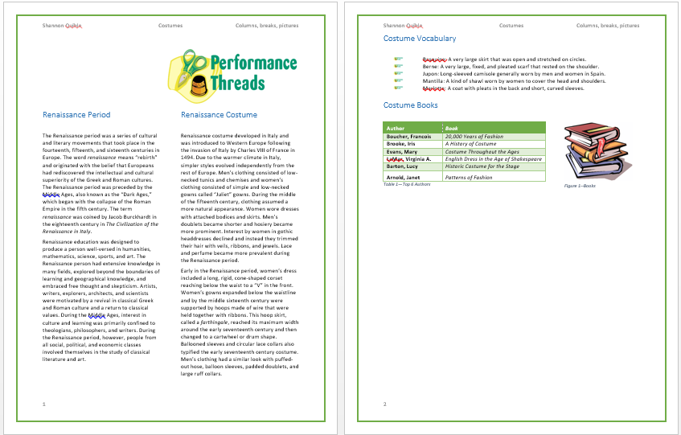
  - Table 1– Top 6 Authors
  - Position – below selected item
- Insert an Online picture – search Three stacked books to find the clip art
  - Text wrapping – Square
  - Position – Using your eye, position to the right of the table you just formatted
  - Size – Height 1.5”
- Insert Caption for picture
  - Label – Figure
  - Figure 1 – Books
  - Position – below selected item
- Save again. Copy to your “to be graded” folder on Cobra for credit.

