Gmetrix Account Set-Up Instructions
- Visit the Gmetrix site: www.gmetrix.net
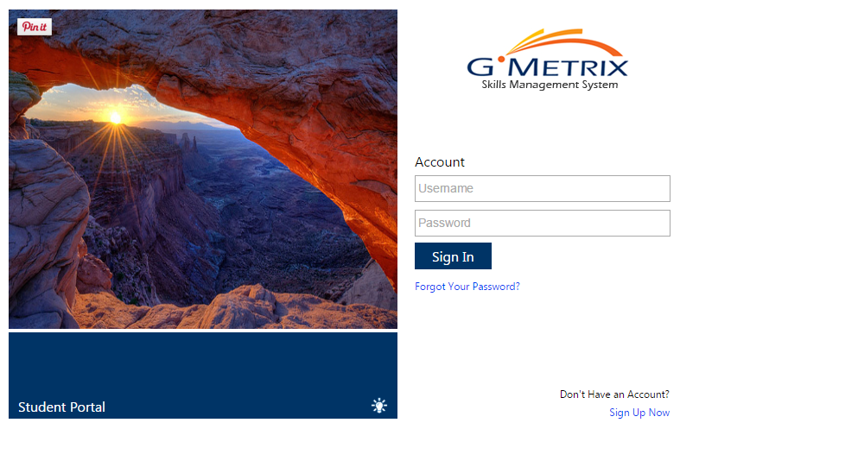
- Click on the “Sign Up Now” link on the bottom right of the page.
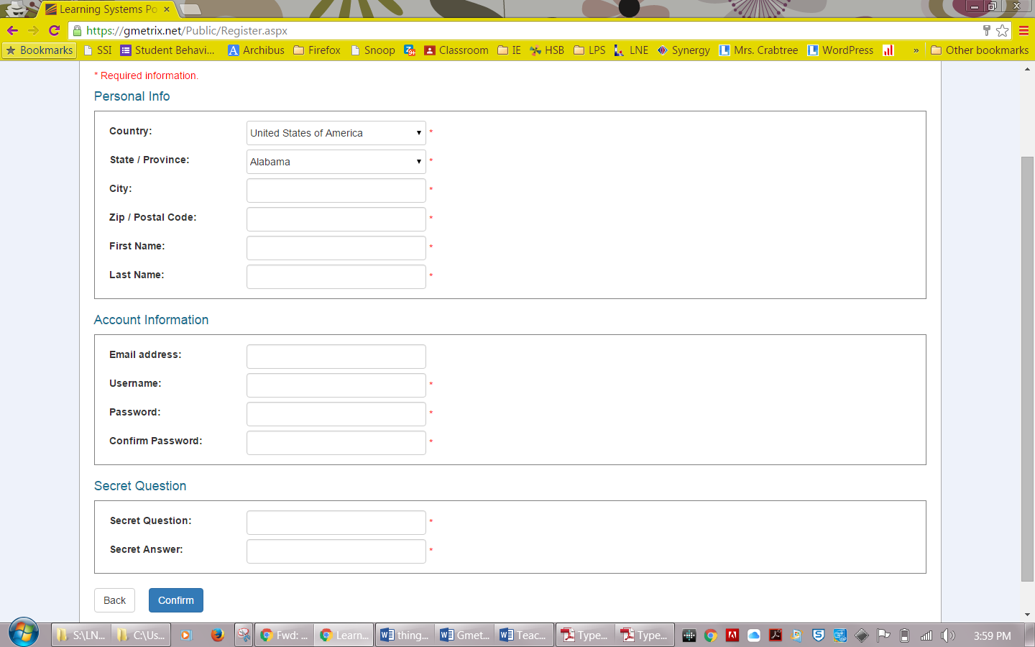
- On the following screen enter in the below information:
Country: USA
State: Nebraska
City: Lincoln
Zip: 68507
First Name: Your First Name
Last Name: Your Last Name
Email Address: LPS Email (StudentID@class.lps.org)
Username: LPS_StudentID# (e.g., LPS_123456)
Password: LPS Password
Secret Question: Enter a question (e.g., What town you were born?) and then the answer (e.g., Lincoln)
- When finished entering your data select “Confirm” at the bottom of the page.
  - You will get a confirmation page to review the information you entered, double check that it is correct, then select “Create Account” at the bottom of the page.
  - NOTE: It may take you back to a page to enter in information again, just select “Login Page” at the bottom and it will take you back to the original login page.
- Your account is now created!

