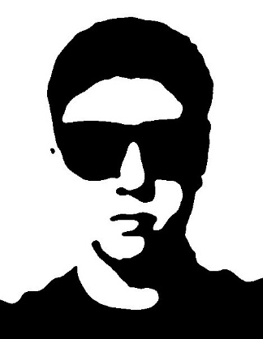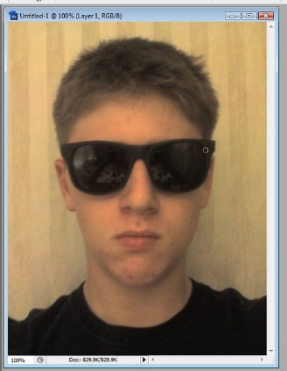
Get This…………. From This!

Directions:
- Using Photoshop, open one of your green screen images – crop it to just focus on your face (shoulders and up).
- Save as: LastName_Stencil to your Photoshop folder on Cobra.
- Duplicate the background layer and turn the eye off of the original background.

Step 1: Rough Shapes
First we make it into a rough two-tone shape:
- First we need to make a two-tone shape. Ensure you are on your background copy layer.
- Select Image > Adjustments > Posterize
  - You don't want it to look too different. I posterized it to 10 levels (play around and find the level that works best for your photo).
- Select Image > Adjustments > Threshold
  - Slide the bar around until you see something that looks like a stencil. You have to keep it as simple as possible (avoid random “blobs”). I set my threshold level to 100 (play around and find the level that works best for your photo).
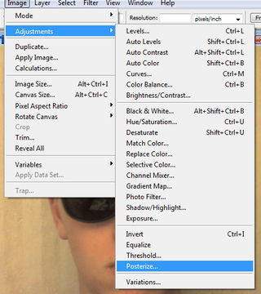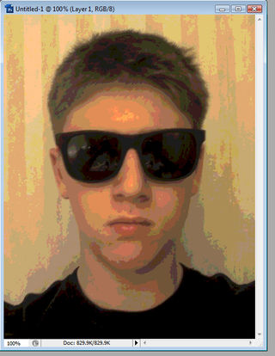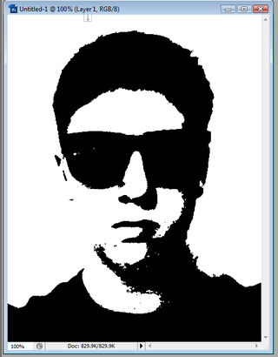

Step 2: Cleaning it up
- Right now we have a very rough, jagged stencil – we need to sharpen it up a bit.
- Select Filter > Blur > Gaussian Blur
  - Set the radius to a level that still leaves a distinct image, but with evenly blurred edges. 4 pixels was perfect for me.
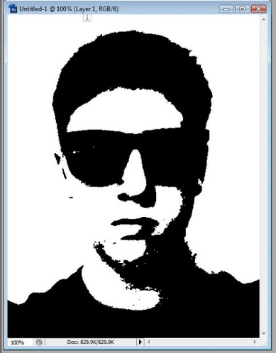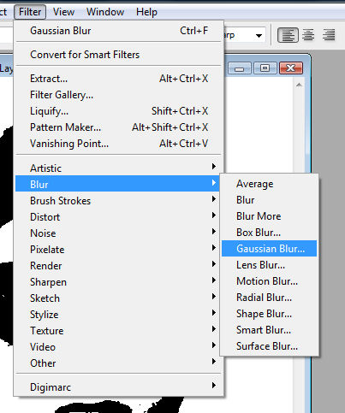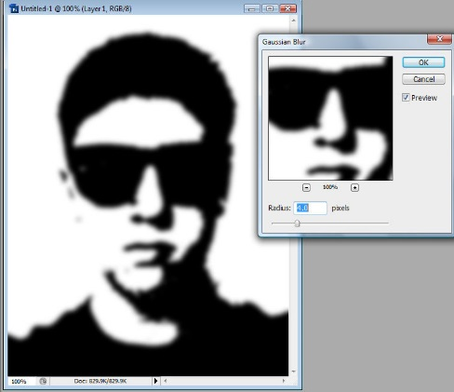
- Select Image > Adjustments > Posterize (again – you did this in the first step)
  - This time select 2 levels (or close to it to sharpen up your image)
- And now you have your finished product!
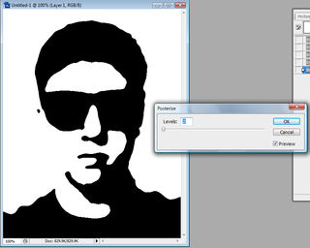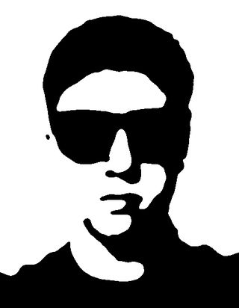

Step 3: Optional Add-ons / Saving
- If you wish, try adding a color to the white sections of your stencil (HINT: grab your paint bucket, select a color, and then click on the white sections to fill)
- When finished, save again, then SAVE AS a .jpg – Copy the .jpg to your “to be graded” folder on Cobra

