Wacky Water Slidz

For this project, assume you are the office manager for a new business in Lincoln—Wacky Water Slidz, a water park that has something for everyone. Before you begin, create a logo to represent your business, choose a water park address/phone number, decide on a list of attractions (with creative names), and decide on passes (Youth, Senior Citizen, Adult, Family Season Pass, etc.). Have fun with this project! You will complete four required items and choose two other items that are required. So, just to be clear, you will complete six (6) items!

NOTE: for all assignments, both print and submit electronically (“to be graded” folder)! This final project is worth 146 points SUMMATIVE!!
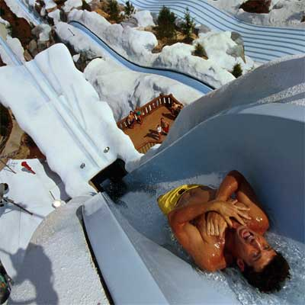
Some examples can be viewed from my website.

Sites that might help you get ideas flowing—
- http://www.worldsoffun.com/ - Worlds of Fun site
- http://www.adventureland-usa.com/ - Adventureland
- http://www.whitewaterwest.com/ - company what sells to parks
- http://www.themeparkinsider.com/ - Theme Park Insider
- http://www.waterparks.com/ - All about Water Parks – great tips!
Required Item #1: Create in either Photoshop or Illustrator
Logo; size--3” x 3”; you must create this from “scratch” – may not include clipart. Should have a summer/water theme integrated with the name of your park. Use a “fun” or “funky” font and arched words/text on a path. Your initials should be in a really small sans serif font (like copyright/trademark symbol sized) and included on the logo. The logo must appear on all documents.
Requirement | Possible Points | Your Rating | Teacher Rating
Name of Park | 2
Summer/water park theme – may include slogan but does not have to | 3
Contains at least two colors | 2
“Fun” font that is appealing and readable | 3
Creativity of logo – WOW Factor! | 4
Quality/professionalism | 4
Total for Logo | 18

Required Item #2: Create in InDesign
Grand Opening Flyer; must include the logo, address (physical and web), grand opening date, an attention getting display font for the headline, and neat use of shapes (layering). May use either portrait or landscape orientation.
Requirement | Possible Points | Your Rating | Teacher Rating
Pertinent info (name, date, phone, address, web address, etc.) | 3
Attention getting display font | 2
Appropriate use of Clipart | 2
Logo, appropriately sized and readable, slogan too. | 3
Creativity of flyer – WOW Factor! | 4
Quality/professionalism | 4
Total for Flyer | 18

Required Item #3: Create in InDesign
Park Guide; a two-page folded guide for visitors. Have an attractive cover that uses your logo, an image, and use of shapes, center spread that shows pictures of attractions, dining establishments, etc. (can include a “map”), and a back cover that lists prices/season pass, special discounts, logo, address, phone, etc. This should be colorful and visual.
Create this as 2 pages (8.5 X 11”)
Fold
Requirement | Possible Points | Your Rating | Teacher Rating
Contains two physical pages – Fold it in half. Cover encourages people to pick it up, middle highlights what visitors will experience, back lists prices, dates, contact information | 8
Logo on cover | 3
Image on cover | 3
Park Slogan is included – it should go with fun, water park, etc. | 3
Center spread—photographs/clipart – looks fun and inviting | 8
Descriptions – for pictures/attractions/food | 4
Back cover—pricing included with discounts | 3
Logo on back cover | 3
Contact information on back cover | 3
Spelling/grammar | 6
Overall quality—visual, colorful, high quality photos without watermarks | 6
Creativity – WOW Factor! | 4
Quality/professionalism | 4
Total for Park Guide | 58
Page 1
Back  Cover | Front  Cover

Center Spread

Page 2
Required Item #4: Create in Illustrator or Photoshop (or both)
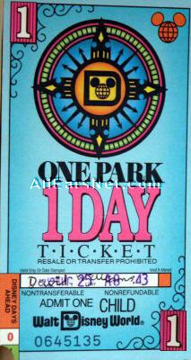
Ticket; theme park entry ticket. See example Disney World tickets here-- http://allears.net/tix/tixpix90.htm
Ticket must include rotation (text, shape, or image), logo, date box (for stamping), clipart/images, and utilize text with a stroke.
Requirement | Possible Points | Your Rating | Teacher Rating
Sized 4” tall by 2” wide | 1
Rotation (text, shape, or image) | 2
Text with stroke | 2
Date box (for stamping) | 1
Logo, appropriately sized and readable | 2
Additional Clipart | 2
Creativity – WOW Factor! | 4
Quality/professionalism | 4
Total for Flyer | 18

Required Item #5: Choose 1A or 1B

Your Choice #1A: Create in InDesign
Water Slide Rules; decorated flyer with a border that can be placed near rides. Must have at least 6 rules posted and must be informative, but fun. Regular sized letter paper.
Requirement | Possible Points | Your Rating | Teacher Rating
Page border | 1
Decorated with images, shapes, or clipart and in a fun way | 2
At least six rules, readable | 3
Logo Included and readable | 2
Creativity – WOW Factor! | 4
Quality/professionalism | 4
Total for Water Slide Rules | 16
OR

Your Choice #1B: Create in InDesign, Photoshop, or Illustrator – make sure that you create a border showing size!
Billboard; suitable to put on the highway to advertise the business. Include the logo, use of either a border or lines/shapes, and three images blended together. Landscape setup, 7.5” wide by 4” tall (use a border).
Requirement | Possible Points | Your Rating | Teacher Rating
Border and/or lines/shapes – size of billboard is correct | 3
Quality of images (no watermarks, not blurry, colors match) | 3
Logo included | 2
Creativity – Wow Factor! | 4
Quality/professionalism | 4
Total for Billboard | 16

Required Item #6: Choose 2A or 2B

Your Choice #2A: Create in Illustrator or Photoshop – make sure that you use the t-shirt graphic from Frillio’s!
T-Shirt Design; create a t-shirt design to showcase either your park or your signature ride/attraction. It should encourage people (teenagers) to want to spend money on it!!! Use the t-shirt image (from Frillio’s clipart page) to show where the design will be (front, back, large, small, etc.) and what color(s) the t-shirt will come in.
Requirement | Possible Points | Your Rating | Teacher Rating
Creation of design – highlights either the park or signature attraction – create something that teenagers would want to purchase. CREATIVITY! | 8
T-shirt graphic is used to show how the printing will look (t-shirt colors included) | 4
Logo included and readable | 2
Overall quality/design | 4
Total for T-Shirt | 18
OR

Your Choice #2B: Create in Illustrator, InDesign, or Photoshop – make sure that you use a border to show size!
Coupon; Coupon for one free 30-minute swim lesson at your water park. Must specify ages, expiration date, and phone number to contact to set up lesson. Utilize a drop shadow on text, washed out photograph for the background, the logo, and one clipart item. Set up 5” wide and 3” tall.
Requirement | Possible Points | Your Rating | Teacher Rating
Correct size—5” x 3” – border is used to show size | 2
Drop shadow on text | 2
Washed out/faded photograph behind text | 2
Appropriate clipart used | 2
Logo included and readable | 2
Creativity – WOW Factor! | 4
Overall quality/design and required info included | 4
Total for Coupon | 18

Clipart Help
http://www.clipartpal.com/clipart/entertainment/amusementpark1.html
http://www.clipartof.com/gallery/clipart/amusement_park_ride.html
http://www.graphicsfactory.com/search/park_P1.html
http://www.clipartof.com/gallery/clipart/water_park.html
http://www.canstockphoto.com/vector-clipart/water-park.html

Picture Help
http://www.joyrides.com/
http://www.bigfoto.com/themes/amusement-park/index.htm
http://themeparks.about.com/od/waterparksphotogallery/Water_Parks_Photo_Gallery.htm - click on links for pics

