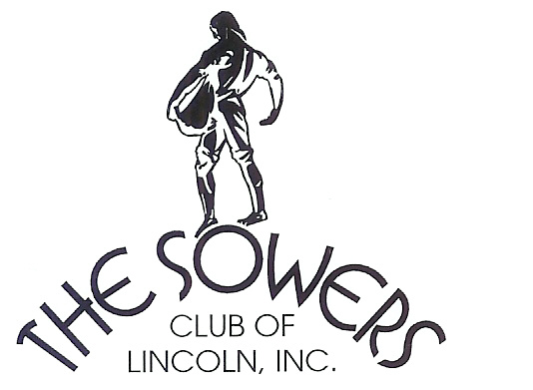

The Sowers Run 4 Youth
5K Run & Walk/1 Mile Kids Run
Theme: Mis-Match

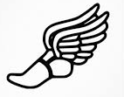
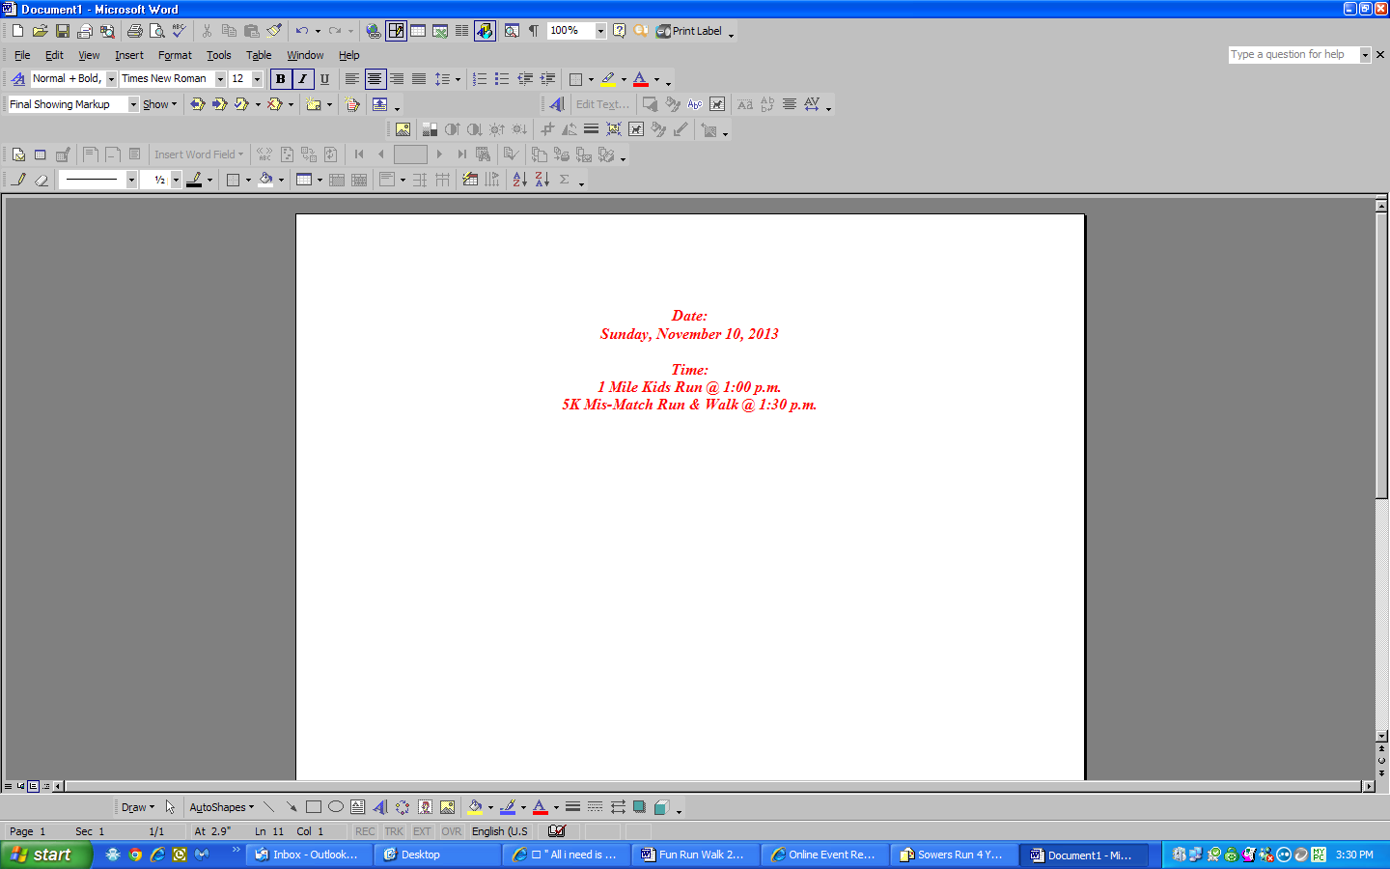

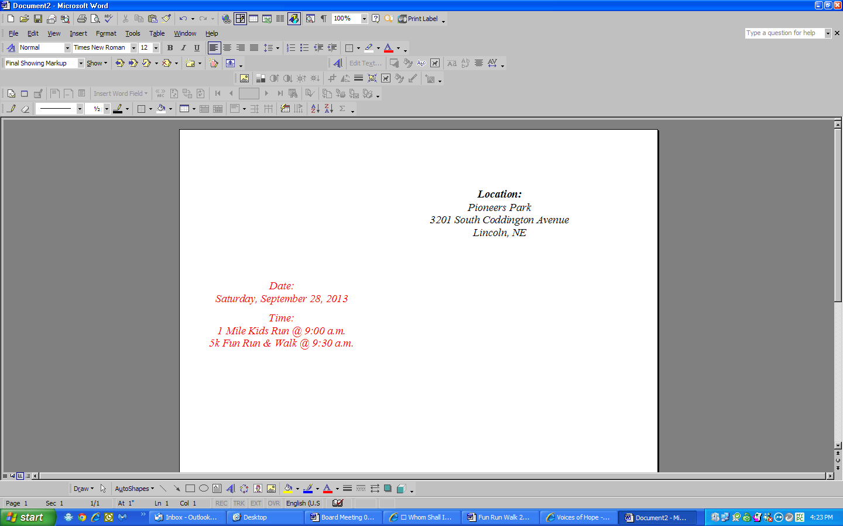

This event is designed to support the Youth of Nebraska.
Proceeds will benefit Clinic with a Heart, Lincoln Arts Council,
The Sowers Club of Lincoln, Inc. and Voices of Hope.

Registration Closes at 5 p.m. on November 4, 2013.

Every participant will receive a t-shirt and goodies with their registration.
Prizes will be awarded to the Best Mis-Match.
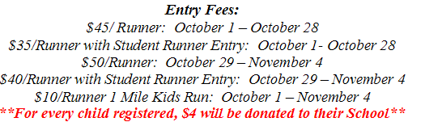

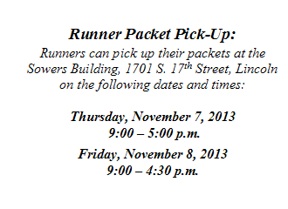

Registration via www.active.com or call 402-438-2244.
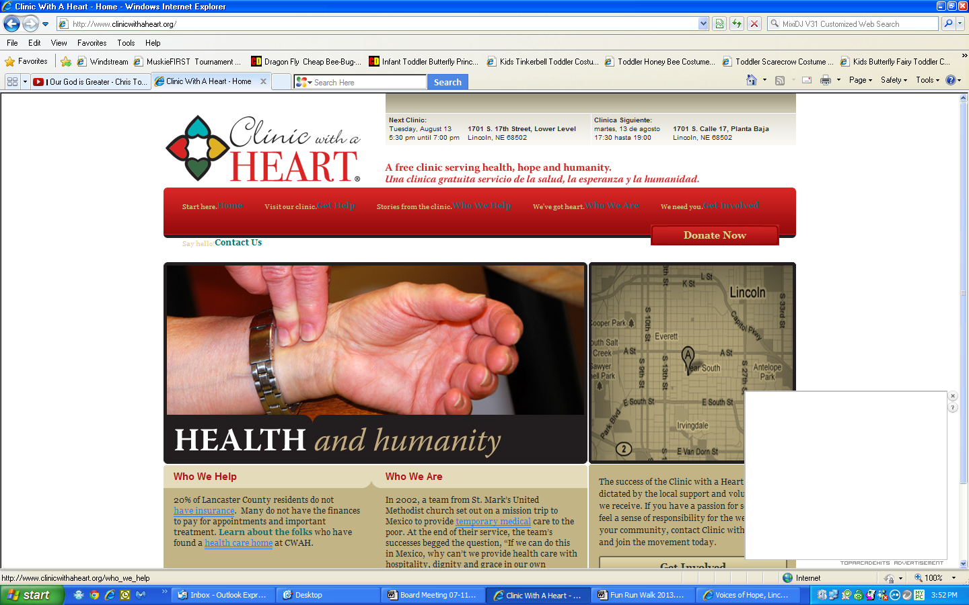
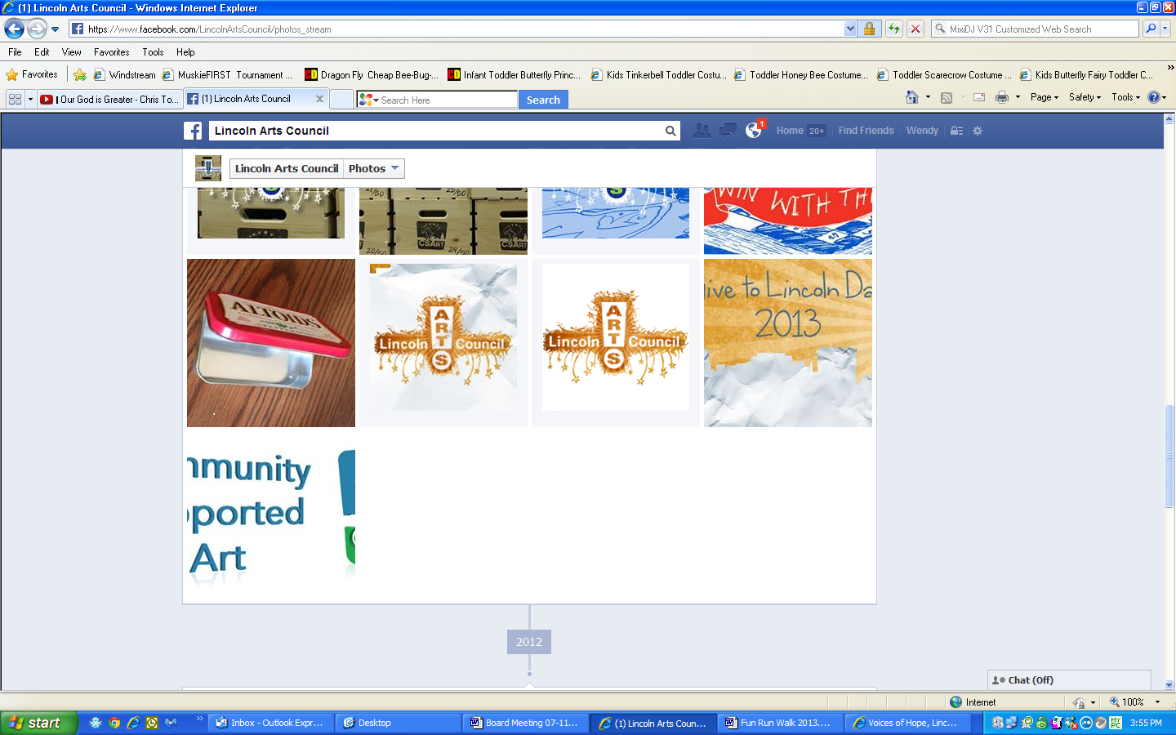
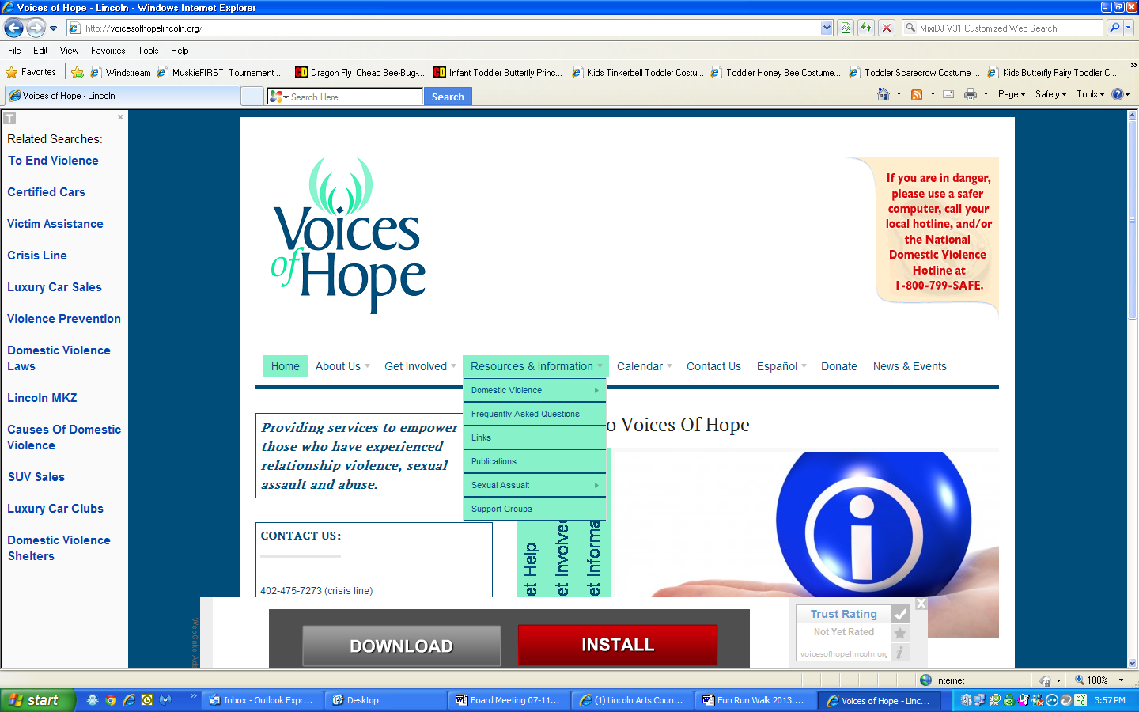
Questions: Contact Wendy Rieck 402-438-2244

