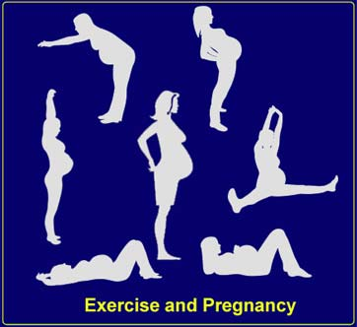

If you don’t exercise
- Doctor may order you to not exercise based on past miscarriages

- You also may not be allowed to exercise if you have more than one fetus, heart disease, high blood pressure, or diabetes

- If you can, exercise during pregnancy is really good for you and your baby

Developing a Good Exercise Program
TIPS
      - It is never too late to start exercising
      - Start slow: If you push yourself too hard it can be dangerous
- Warm-ups are really important
- Stretching before and after you exercise is really important
- Watch the clock: Make sure to remain safe and not over-do it
- Exercise regularly
- Make up for the calories you burn – make sure to consume enough
- Replace the fluids you burn off – water is essential during pregnancy
- Find a group or class to exercise with
- Make it fun

Exercises For Pregnancy

By: Emily Burd

Choosing the RIGHT PREGNANCY EXERCISE
-Select an exercise that is right for you.

Exercises for everyone:
- Briskly walking
- Swimming in shallow water
- Water workouts designed for pregnancy
- Cycling on a stationary bike
- A step machine
- A rowing machine
- Calisthenics designed for pregnancy
- Yoga designed for pregnancy
- Relaxation routines

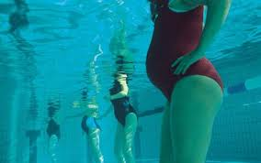

Exercises for well-trained athletes:
- Jogging
- Doubles tennis
- Cross-country skiing
- Light weight lifting
- Cycling
- Ice skating
- Hiking
- Volleyball
- Pilates
- Kick-boxing
- Dance workouts

Exercises to avoid:
- Jogging more than two miles a day
- Horseback riding
- Waterskiing
- Diving
- Scuba diving
- Softball, football, and other contact sports
- Sprinting
- Bicycling on wet pavement
- Calisthenics not designed for pregnancy

Playing It Safe
- Don’t exercise on an empty stomach
- Dress loosely and comfortably
- Select the right surface
- Do two or three brief exercise sessions a day instead of one long workout
- Do everything in moderation
- Know when to stop

Company Name
Street Address
Address 2
City, ST ZIP Code
Phone (555)555-0125
Fax (555)555-0145
Web site address

