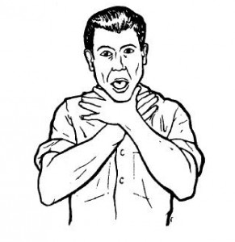


Choking

Choking occurs when an object blocks a person’s airway. Young children are especially prone to choking because of all the things they put in their mouth.
Signs of choking are wheezing or high-pitched noises or gurgling sounds. The person will have an inability to breathe
Abdominal Thrust is a quick upward thrust with the heel of the hand into the abdomen that forces air in the lungs to force out the object in the throat

A convulsion or seizure, is a brief period during which the muscles suddenly contract, causing the person to fall and twitch or jerk
Bites and stings:
Many children suffer from bites or stings from household pets or outside or other children. The type of treatment depends on the type of injury. When a child is bleeding, put pressure on to stop the bleeding, give child pain relief medicine if necessary. The greatest risk from stings and bites are allergic reactions and infections. If any child is allergic, they must be taken to the doctor immediately. Hives are blister-like sores that are caused by an allergic reaction.
20.2 Pages 561-566
Kelsey Finchum
Signs of Poisoning are: fever, difficult breathing, burns or stains around mouth, rash, choking, coughing, nausea, and dizziness
Shock

Shock is a serious medical condition where important bodily functions are impaired

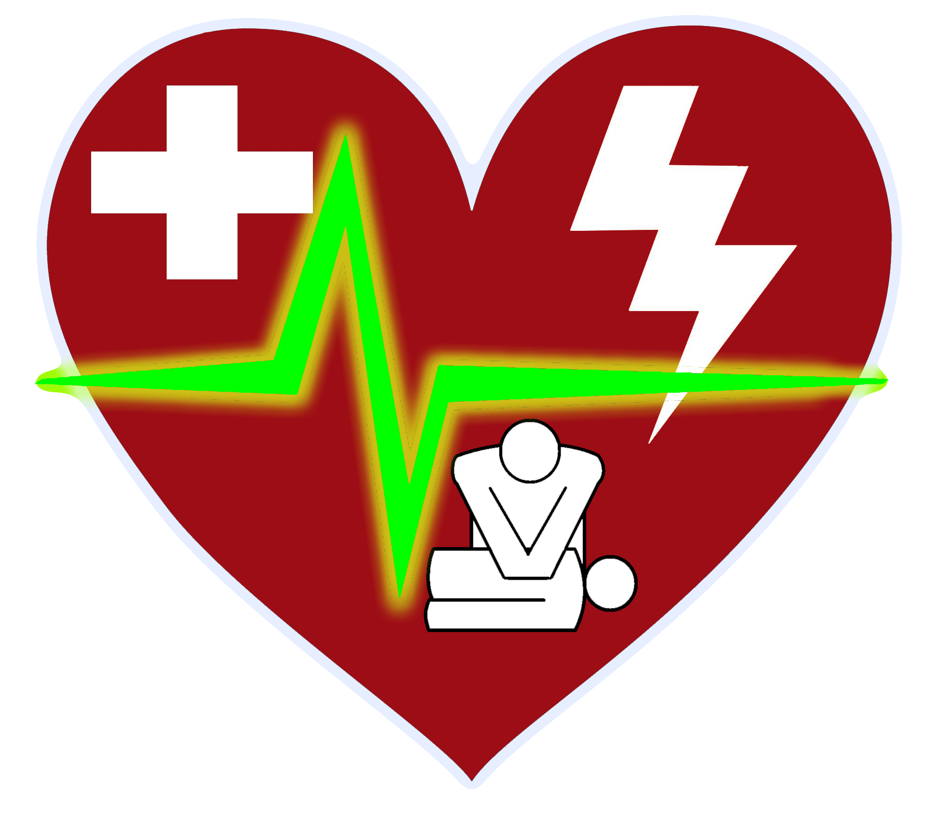
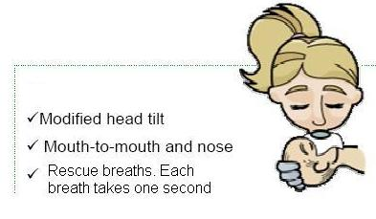

Rescue Breathing is a procedure for forcing air into the lungs of an unbreathing person. A period of more then 5 minutes with a deprived brain of oxygen can result in death.
When rescue breathing is used, childcare workers should wear gloves and use a protective facemask when using the technique. People can learn more about rescue breathing by taking a rescue training class
Rescue Techniques
When a child stops breathing, or when a child’s heart stops beating, immediate and correct action is vital. Learning rescue techniques will allow you to respond quickly and possibly help you to save a life.
Cardiopulmonary Resuscitation (CPR) combines rescue breathing with chest compressions to restore breathing and circulation. CPR can save the life of someone who needs his or her breathing restored or who has completely stopped breathing or whose heart has stopped beating. The CPR technique used for infants is very different than what is used for infants. Only people who are certified for CPR should administer it to the person in need.

