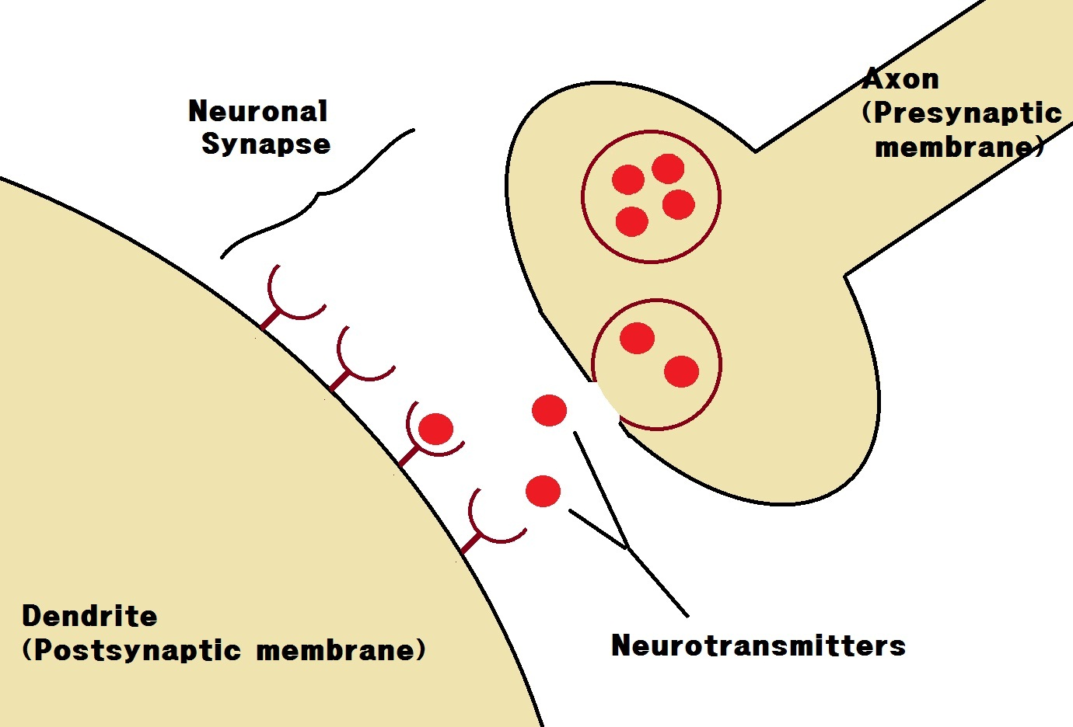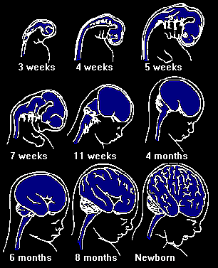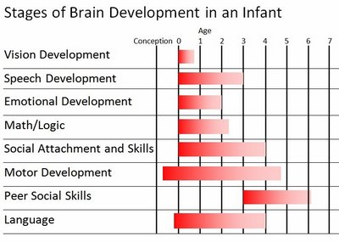

## Parts of the Brain

The brain has different sections, each section controls a specific function. One of the most important parts is the cortex. The cortex is the part of the brain that its growth permits more complex learning. Neurons in the baby’s brain are tiny messengers that transmit information in the brain and nervous system through and electrical-chemical process. These neurons are connected with axons and dendrites. The axon sends the information and the dendrites receive information from other neurons. This process of sending and receiving information begins when the baby is actually in the mother uterus, but after birth it happens more quickly.

In the first year of a baby’s life development happens faster than in any other time in life. It is now shown that the quantity and quality of experiences increases the baby’s brain functions. At birth, the brain has billions of neurons1. Due to experiences neural pathways2 develop. How the baby’s brain develops during this first year affects the child’s whole life. Newborns learn about the world through their senses. In general, most of the responses of a newborn are just reflexes. For example an overheated baby will kick until a blanket falls off or is removed. These are examples of reflexes not planned actions by the baby.

Neurons1: a nerve cell

Neural Pathways2: the link between neurons

Development

### The Structure of the Brain

Early Brain

#### By: Brenna Hansen

# Speed and Development of the baby’s brain

Ways to stimulate the infant brain development:

1. Keep the stimuli simple and natural
2. Match experiences to the child’s mental abilities
3. Practice makes perfect
4. Actively involve the baby
5. Provide variety, but don’t overload
6. Avoid pushing the child

The rate that a child learns is different from any other child throughout their life. This is due to the fatty coating called myelin on your neurons that increase the rate of signals. This makes learning faster and skills easier to master. The rate the neurons receive this fat explains why some children may have difficulty mastering specific tasks. Without this myelin the functions of the brain and body are greatly affected.

Therefore the best thing a caretaker or parent can do is to provide a very stimulating environment for the child. An environment that provides the opportunity for the infant to use all their senses, but not too overwhelming is the perfect place.

The way the brain becomes organized is a very personalized and unique way. No child’s brain is organized the same. This is because it is organization is based on experiences unique to the child. As connections grow stronger a group of neurons become linked together and become a system of nerve cells that control a certain action. For example a group of neurons could be responsible for using a spoon. When the neurons are first developed the action is not done well. However as time progresses the action occurs more and the neurons get better and stronger connections, therefore making the action better and easier.

Developing the Brain