Child Passenger Safety

Risk Reduction for Every Age
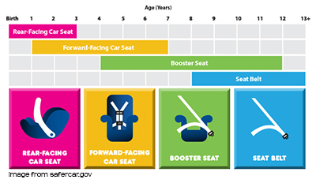
Car crashes are a leading cause of death for children 1 to 13 years old, but many times deaths and injuries can be prevented by proper use of car seats, boosters, and seat belts. Buckling children in age-and size appropriate car seats, booster seats, and seat belts reduces the risk of serious and fatal injuries and is the responsibility of all drivers, including teens that may be caring for a small child! Take a moment to learn about properly buckling kids in a car seat, booster seat, or seat belt, whichever is appropriate for their age, height and weight.
Birth up to Age 2: Rear-facing car seat.
For the best possible protection, infants and children should be buckled in a rear-facing car seat, in the back seat, until age 2 or when the upper weight or height limits of their particular seat. Check the seat’s owner’s manual and/or labels on the seat for weight and height limits.
Age 2 up to at least Age 5: Forward-facing car seat.
When children outgrow their rear-facing seats they should be buckled in a forward-facing car seat, in the back seat, until at least age 5 or when they reach the upper weight or height of their particular seat. Check the seat’s owner’s manual and/or labels on the seat for weight and height limits.
Age 5 up until seat belts fit properly: Booster Seat.
Once children outgrow their forward-facing seat, (by reaching the upper height or weight limit of their seat), they should be buckled in a belt positioning booster seat until seat belts fit properly. Seat belts fit properly when the lap belt lays across the upper thighs (not the stomach) and the shoulder belt lays across the chest (not the neck). Remember to keep children properly buckled in the back seat for the best possible protection.
Once Seat Belts Fit Properly without a Booster Seat: Seat Belt
Children no longer need to use a booster seat once seat belts fit them properly. Seat belts fit properly when the lap belt lays across the upper thighs (not the stomach) and the shoulder belt lays across the chest (no the neck). The recommended height for proper seat belt fit is 57 inches tall. For the best possible protection keep children properly buckled in the back seat.
Install and use car seats and booster seats according to the seat’s owner’s manual or get help installing them from a certified Child Passenger Safety Technician.
References: National Highway Traffic Safety Adminstration. Traffic safety facts, 2013 data.

