**Chapter 6: Characteristics of Polynomial Functions**

1. Write a polynomial function that has zeros 5, -2, and 0 in standard form. Classify the polynomial by degree and number of terms.

Factored Form:

Standard Form:

Name by Degree:

Name by Number of Terms:

1. Write a polynomial function that has zeros 0 with a multiplicity of 2, -3, and 4. Classify the polynomial by degree and number of terms.

Factored Form:

Standard Form:

Name by Degree:

Name by Number of Terms:

1. A polynomial of least degree with rational coefficients has the given roots of 2, -6, and $2+\sqrt{3}$. Find all other roots.
2. A polynomial of least degree with rational coefficients has the given roots of 2, $1-\sqrt{11}$, and 1 + 2i. Find all other roots.
3. Divide (x3 + 2x2 – x + 4) by (x – 3)
4. Divide (x5 – 3x3 + 2x – 6) by (x+2)
5. Divide (x4 – 3x2 – 2) by (x – 2)

8. Answer the following questions about the function below.

|  |  |
| --- | --- |
|  | Approximate the max(s)  Approximate the min(s)  What is the end behavior?    What are the zeros? (include multiplicity for multiple zeros)  What is the equation of the polynomial in factored form? |

9.

|  |  |
| --- | --- |
|  | Approximate the max(s)  Approximate the min(s)  What is the end behavior?    What are the zeros? (include multiplicity for multiple zeros)  What is the equation of the polynomial in factored form? |

**Chapter 6: Solve Polynomial Equations**

1. List the possible rational zeros of f(x) = 3x4 – 2x2 + 5x – 15
2. List the possible rational zeros of f(x) = 5x3 – 4x2 + 24
3. Determine the zeros and the multiplicity of any multiple zeros.

x5 – 2x4 + 8x3

1. Determine the zeros and the multiplicity of any multiple zeros.

x4 + 10x3 + 25x2

Solve each equation:

1. 
2. 
3. 
4. 2x4 – 14x2 – 36 = 0
5. 

**Chapter 5: Graph Quadratic Equations**

|  |  |  |  |  |  |  |  |  |  |
| --- | --- | --- | --- | --- | --- | --- | --- | --- | --- |
| 1. **Graph: y = -2x2 + 8x – 6** | Vertex: _______________________  Axis of Symmetry: _________________________  Y-intercept: _______________________  Is the vertex a max or min?   |  |  | | --- | --- | | **X** | **Y** | |  |  | |  |  | |  |  | |

|  |  |  |  |  |  |  |  |  |  |
| --- | --- | --- | --- | --- | --- | --- | --- | --- | --- |
| 1. **Graph:** | Vertex: _______________________  Axis of Symmetry: _________________________  Y-intercept: _______________________  Is the vertex a max or min?  **Transformations:**  Horizontal shift left or right?  Vertical shift up or down?  Vertical stretch or shrink?  Reflection over the x-axis? Yes or No   |  |  | | --- | --- | | **X** | **Y** | |  |  | |  |  | |  |  | |

|  |  |  |  |  |  |  |  |  |  |
| --- | --- | --- | --- | --- | --- | --- | --- | --- | --- |
| 1. **Graph: y = x2 - 4x + 1** | Vertex: _______________________  Axis of Symmetry: _________________________  Y-intercept: _______________________  Is the vertex a max or min?   |  |  | | --- | --- | | **X** | **Y** | |  |  | |  |  | |  |  | |

**Chapter 5: Simplify Quadratic and Complex Expressions**

**Factor the following quadratics. Remember to factor out a GCF if there is one.**

1. x2 + 9x + 20 2. x2 – 49
2. x2 – 11x + 24 4. x2 + 2x – 99
3. 2x2 – 72 6. 3x2 + 51x + 90

7. 4x2 – 81 8. 2x2 – 5x – 12

9. 5x2 + 16x + 3 10. 12x2 – 26x + 10

**Write the expression as a complex number in standard form. (remember i2 = -1)**

11. (6 – 5i) + (2 + 11i) 12. (3 + i) – (7 – 6i)

13. (2 – 7i)(-5 + 3i) 14. (4 – 11i)2

**Chapter 5: Solve and Apply Quadratic Equations**

**Solve the quadratic equation by using any method. Justify your answer.**

1. ** 2. **

**3. 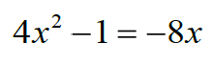 4. **

1. 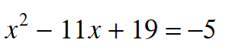 **6. **

**7.** 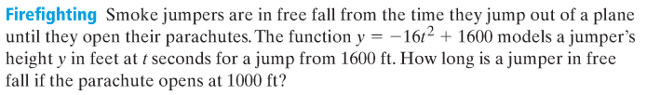

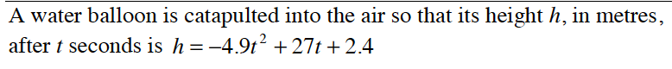

***If graphing use the following window: x-min: -10, x-max: 10, y-min: -10, y-max: 50***

How long does it take for the water balloon to reach its maximum height?

What is the maximum height of the water balloon?



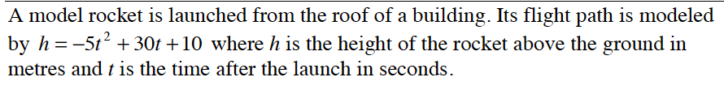

***If graphing use the following window: x-min: -10, x-max: 10, y-min: -10, y-max: 60***

How long does it take for the model rocket to reach its maximum height?

What is the maximum height of the model rocket?