Name ______________________________________________________________ Chapter 3 Review Worksheet

Solve the following systems of equations using any method. If you choose to solve by graphing then please use a separate sheet of graph paper. MAKE SURE TO SHOW ALL WORK FOR FULL CREDIT.

1.  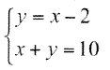 | 2.  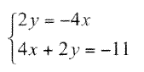
3.  $$\left\{\begin{aligned}x=2y+10 \\ y-x= -7\end{aligned}\right.$$ | 4.  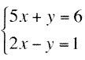
5.  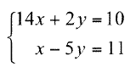 | 6.  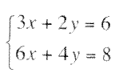
7.  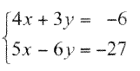 | 8.  $$\left\{\begin{aligned}-2x+y=4 \\ y=2x+4\end{aligned}\right.$$
9. Tell how many solutions each system has. One, None, or Infinitely Many.
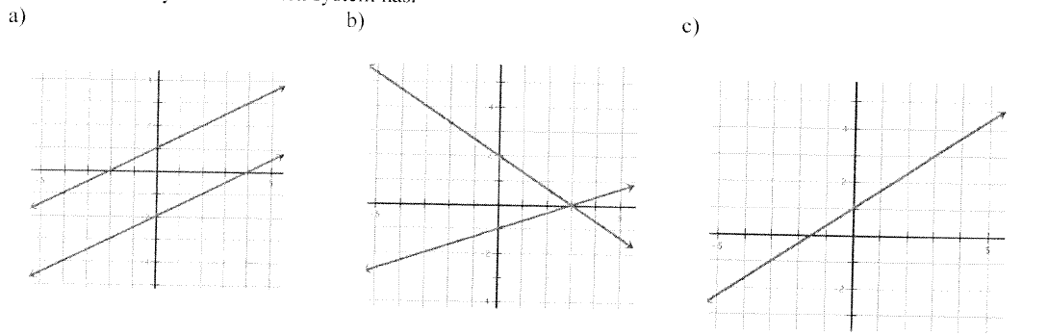

10. You are ordering softballs for two softball leagues. The pony league uses a larger softball priced at $3.50. The junior league uses a smaller softball priced at $4. The bill smeared in the rain, but you know the total for 80 softballs was $305. How many of each type of softball was purchased?

Equation 1: ____________________________ Equation 2: ___________________________

Smaller softball _______________________

Larger softball _________________________

11. You go to the grocery store and check out with 8 oranges and 1 grapefruit and the total is $4.60. The next person checks out with 6 oranges and 3 grapefruit and the total is $4.80. What is the price of 1 orange and 1 grapefruit?

Equation 1: ____________________________ Equation 2: ____________________________

Price of 1 orange: _____________________

Price of 1 grapefruit: _________________

12.
a) At Candy Store A you have to pay $2 for the bag plus $1.15 for every pound of candy. At Candy Store B you have to pay $.80 for the bag plus $1.25 for every pound of candy. How many pounds of candy do you need to buy for both candy stores to cost the same?

Equation 1: ____________________________ Equation 2: ____________________________

Pounds of Candy: _____________________

b) If you want to buy 3 pounds of candy, then which candy store is cheaper? Explain.

Solve the following system of inequalities: (Put an S where the final solution is)
13.  $$\left\{\begin{aligned}8x-4y>16 \\ y ≤ -\left|x+3\right|+2\end{aligned}\right.$$  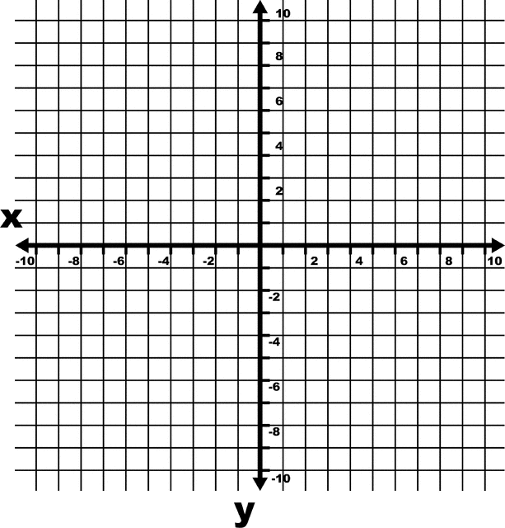 | 14.  $$\left\{\begin{aligned}y<3x+4 \\ y≥2\left|x+1\right|-4\end{aligned}\right.$$

15. Lucia is selling cookie dough to make money for her trip to Paris with the band. Chocolate chip cookie dough sells for $13 and sugar cookie dough sells for $10. She needs to raise at least $500 for her trip and can only sell at most 60 tubs of cookie dough. She also wants to sell at least 25 tubs of chocolate chip cookie dough. Write and graph a system of inequalities to model the possible solutions.

Inequality 1: ____________________________________

Inequality 2: ____________________________________

Inequality 3: ____________________________________

Graph the solution below and make sure to label your axes.

