Advanced Algebra Name______________________
6.3 Worksheet Date ________ Period _______

Divide using synthetic division.

1. $\left(x^{3}+3x^{2}-x-3\right)÷(x-1)$ 2. $\left(x^{3}-4x^{2}+6x-4\right)÷(x-2)$

3. $\left(x^{3}-7x^{2}-7x+20\right)÷(x+4)$ 4. ${(x}^{4}+6x^{2}-8)÷(x+2)$

5. $\left(x^{3}-2x^{2}+12\right)÷(x+3)$ 6. ${(x}^{3}+27)÷(x+3)$

Determine if each binomial is a factor of $x^{3}+x^{2}-16x-16.$ Justify your work.

7. $x+2$ 8. $x-4$ 9. $x+1$

Use synthetic division and the given factor to completely factor each polynomial function.

10. $f(x)=x^{3}+2x^{2}-5x-6;(x+1)$ 11. $f\left(x\right)=x^{3}-4x^{2}-9x+36;(x+3)$

Use the Remainder Theorem to determine if the given “a” value is a solution.

12. $P\left(x\right)=x^{3}+4x^{2}-8x-6;a=-2$ 13. $P\left(x\right)=x^{3}+4x^{2}+4x;a=-2$

Use long division to divide the polynomials.

14. 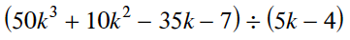 15. 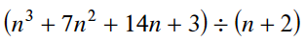

16. 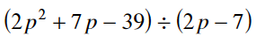 17. 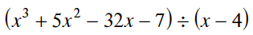

18. 