Date: 08/10/16

Important Dates
- August 15th–First day of school
- August 15th-17th-PLC Days-dismiss @ 2:18
- Thursday, August 25th-Family Learning Night
- Tuesday, August 30th-PLC Day
- Friday, September 2^{nd-} Prescott Nature Night
- Monday, September 5th-No School; Labor Day
- September 6th thru 9th-Heritage School Field Trips

Heritage School
Students will experience the life of a pioneer child from the late 1880’s in a real one room school house through a one day field trip. Please have your child wear pioneer clothes and bring an authentic pioneer lunch. More information will be coming with specifics. See Heritage School powerpoint and dates here:
Heritage School Slideshow
Sept. 6 Mrs. Colfack Sept. 7 Mrs. Areman Sept. 8 Ms. Myers Sept. 9 Ms. Majid
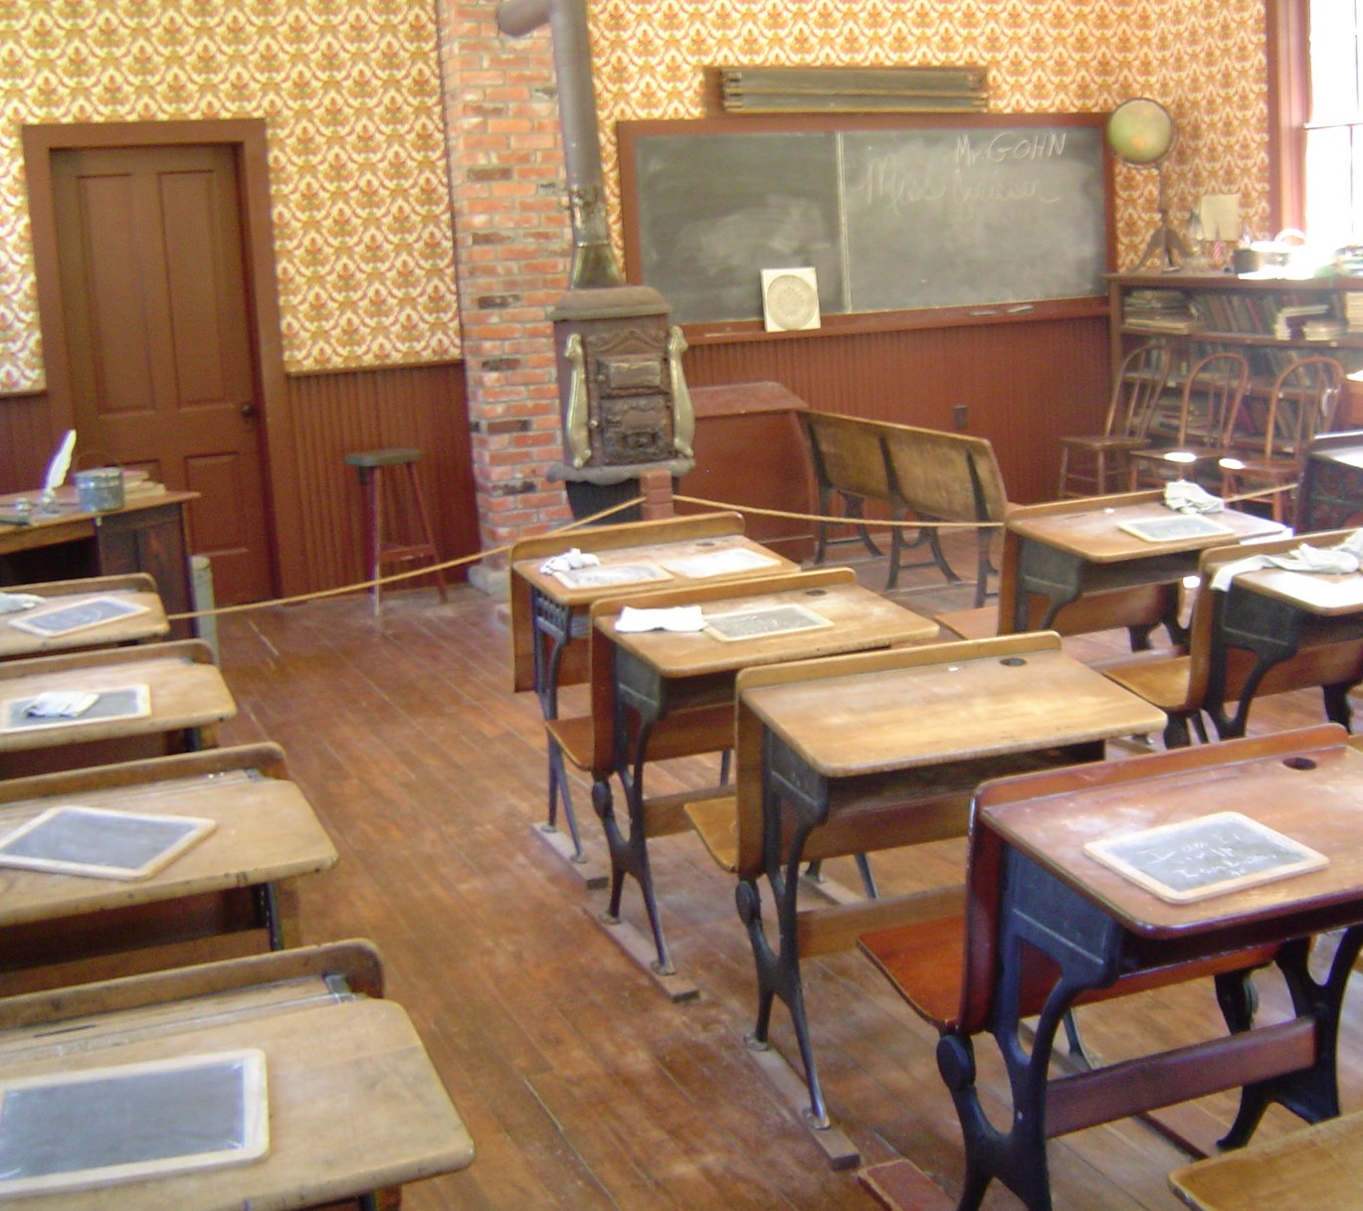

Learning Objectives:

Reading Objectives: Math Objectives:
The Big Idea: How can a challenge bring out our best? | Read, write, and compare positive rational numbers.
Genres: Fairy Tale; Realistic Fiction; Expository Text, Narrative Nonfiction, Persuasive Article | Add and subtract positive rational numbers.
Comprehension Strategies: Make Predictions & Reread | Demonstrate meaning of multiplication and division with whole numbers.
Comprehension Skills: Sequence, Problem & Solution; Compare & Contrast, Cause & Effect, Main Idea & Details. | Select and apply appropriate strategies to solve problems.
Vocabulary Strategies:: Context Clues; Idioms, Suffixes | Communicate mathematical relationships using expressions and equations.

Daily Schedule:
9:00-10:20 | Morning Meeting & Math
10:20-11:05 | Writing
11:15-11:35 | Intervention
11:35-12:25 | Specials
12:25-1:10 | Recess & Lunch
1::10-1:40 | Whole Group Reading/ Word Work
1:40-1:50 | Physical Activity Break
1:50-2:50 | Guided Reading
2:50-3:35 | Unit Studies
3:35-3:38 | Dismissal

Contact Information:
Please feel free to call or email your child’s teacher with any questions or concerns. If you would like to meet in person, please call or email the teacher so you can set up a time that works best.
Prescott Elementary Phone Number: 402 – 436 - 1161
Email: Mrs. Areman: tareman@lps.org Mrs. Colfack: nbenge@lps.org
Ms. Myers: amyers3@lps.org Ms. Majid: smajid@lps.org

