Bien Dit, Chapitre 3.1 Nom__________________________________

Describe the following people & celebrities. Tell about their size, hair color & length, eye color & their personalities. Tell if they are young or old, funny or serious, athletic or creative, smart, nice, etc. Show off!

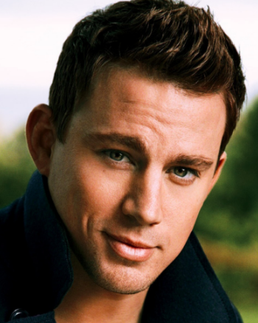  1-Channing Tatum | 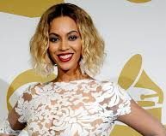  2-Beyoncé | 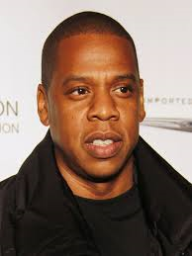  3-Jay-Z | 4-Mr. Gillotti. | 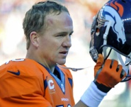  5- Peyton Manning | 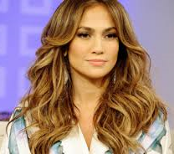  6-Jennifer Lopez
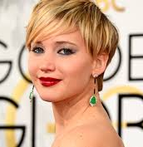  7-Jennifer Lawrence | 8-Lebron James | 9-Madonna | 10-Robert Pattinson | 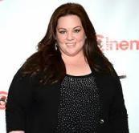  11-Melissa McCarthy | 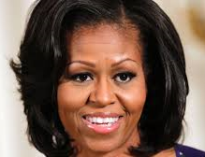  12-Michelle Obama
13- Père Noël | 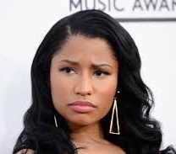  14-Nicki Minaj | 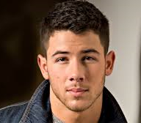  15-Nick Jonas | 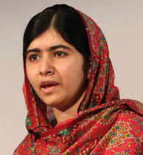  16- Malala Yousafzai | 17- Madame Van Zandt | 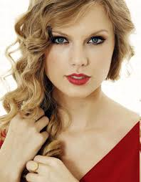  18- Taylor Swift

# | description

