Bloom’s Taxonomy
Thunder Boy Jr. Analysis
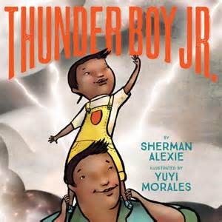

Knowledge Recall data or information.

Key Words:
Define, describe, identify, know, label, list, match, name, outline, recall, recognize, reproduce, select, state.

*Describe Thunder Boy Jr.

Comprehension Understand the meaning, translation, interpolation, and interpretation of instructions and problems. State a problem in one’s own words.

Key Words:
Comprehend, convert, defend, distinguish, estimate, explain, extend, generalize, give, infer, interpret, paraphrase, predict, rewrite, summarize, translate.

*Explain Thunder Boy Jr.’s issue with his name.

Application Use a concept in a new situation or unprompted use of an abstraction. Applies what was learned in the classroom into novel situations in the work place.

Key Words:
Apply, change, compute, construct, demonstrate, discover, manipulate, modify, operate, predict, prepare, produce, relate, show, solve, use.

How do you relate to Thunder Boy Jr.?
What would make a good name for Thunder Boy Jr.?
Why do you feel this way?
Analysis Separates material or concepts into component parts so that its organizational structure may be understood. Distinguishes between facts and inferences.

Key Words:
Analyze, break down, compare, contrast, diagram, deconstruct, differentiate, discriminate, distinguish, identify, illustrate, infer, outline, relate, select, separate.

Analyze Thunder Boy Jr.’s new name. How does this represent his identity? What does this say about childhood?

Synthesis Builds a structure or pattern from diverse elements. Put parts together to form a whole, with emphasis on creating a new meaning or structure.

Key Words:
Categorize, combine, compile, compose, create, devise, design, explain, generate, modify, organize, plan, rearrange, reconstruct, relate, reorganize, revise, rewrite, summarize, tell, write.

*Revise your name. If you could create a new name for yourself, what would it be? Write your reasoning.

Evaluation Make judgments about the value of ideas or materials.

Key Words:
Apprise, compare, conclude, contrast, criticize, critique, defend, describe, discriminate, evaluate, explain, interpret, justify, relate, summarize, support.

- Critique the purpose and function of a name.
- Do you support Thunder Boy Jr.’s decision to change his name? Defend or criticize his appeal to change his name.

