Plot Diagram Elements

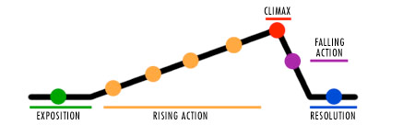

Plot—This is the literary element that describes the structure of the story. It shows arrangement of events and actions within a story.

Conflict—a struggle between opposing forces that drives the action of the story.

Exposition –The introduction of the characters and basic situation. The setting, characters, and main conflicts are introduced to the reader; this is
the beginning of a novel or story and may be short or long, but is always flat (little
action or emotion).

Rising Action - the round characters are developed, the conflicts are increased and
acted out in many ways, motives are introduced, things happen; generally, the
major part of a novel or story.

Climax - the peak of action in the story in which the major conflicts erupt in some
kind of final showdown (fight, argument, violent or physical action, very tense
emotional moment...); at the end of the climax, the "winner" will be clear (there is
not always a winner!). This is the point in the story where something CHANGES.

Falling Action - what events immediately follow the climax; a kind of "cleaning
up." The conflict decreases.

Resolution/Denouement – This is the outcome of the conflict where everything ends; the reader may have some sense of "closure" or may be asked to think about what might come next; in fairy tales, the Happy Ending; in some novels, you will read about the characters many years later.

