Greetings:
Give a greeting based on the time, how are you, and goodbye:

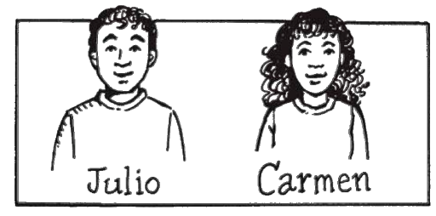
Introductions
Give a greeting based on the time, introduction of name, how are you, nice to meet you, and goodbye:

Presentations:
Give a greeting based on the time, introduce by name, nice to meet you, and goodbye:

