Student Reading: How Did Islam Become a World Religion?

With over 1.5 billion estimated followers today, Islam is truly a global religion. It’s hard to imagine that such a widespread and influential belief system began in a remote part of the world and was initially rejected by the people that would eventually take it to every corner of the globe. In the following paragraphs, you will read about how the Islamic religion and culture spread across Afroeurasia over the span of several centuries through conquest and trade.

The first era of Islamic expansion occurred in the first decade of the religion’s existence. In the last ten years of Muhammad’s life, he led a series of campaigns against the varied and numerous non-Muslim tribes of the Arabian peninsula. The most important of these was the capture of the city of Mecca. By the year of Muhammad’s death in 632 CE, Muslims had conquered most of the Arabian Peninsula. Though the territory was taken by force, the process was still relatively peaceful – historians believe there were very few people killed or wounded in these battles.
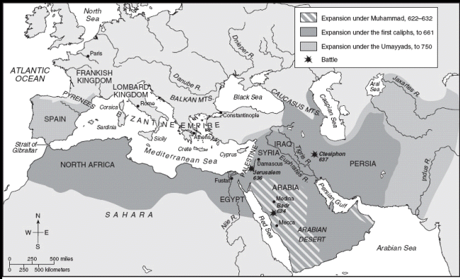

Expansion of Islam by 750 CE

Over the course of the next century, Muslims from Arabia conquered a vast territory that ranged from the Atlantic Ocean to the western edges of China and India. Some of the lands that fell under Muslim rule included large portions of present-day countries such as Pakistan, Afghanistan, Iran, Iraq, Turkey, Syria, and Jordan. In addition, regions that bordered the Mediterranean Sea fell under Muslim rule by the year 750 CE, including Northern Africa and present day Spain and Portugal. The territory conquered by Arab Muslims covered a span of over 5 million square miles – bigger than any existing country today with the exception of Russia.

It is important to understand, however, that although Muslim Arabs ruled over these newly conquered territories, the people who lived there did not usually convert to Islam right away. For example, in Egypt (which was conquered in the year 642 CE) few people initially became Muslim. It was not until several hundred years later that even half of the population had converted to Islam. According to the Koran, a Muslim should never force another person to accept Islam against their will. Most Muslim leaders followed that policy, and allowed people of other cultures to continue practicing their previous religions. In fact, early policies did not allow non-Arabs to convert to Islam within the newly conquered territories.

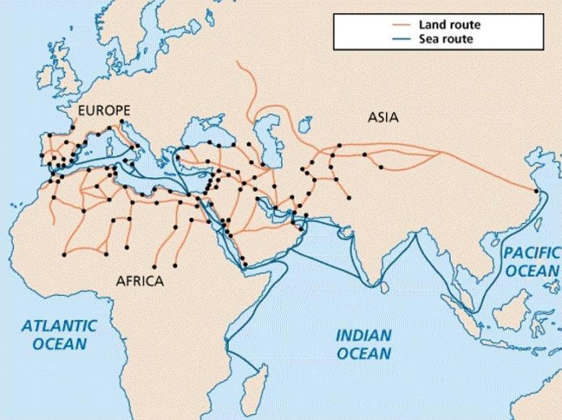
Therefore, the growth of Islam as the dominant religion in these areas was a gradual process, occurring over the span of several hundred years, and influenced by a variety of factors. First, the migration of Muslims outward from the Arabian peninsula and into the new territories led to an increase in the Islamic population. Under Islamic governments, these migrants were given special treatment and enjoyed a higher status than the Christian, Jewish, or polytheistic people groups living within these regions.

The elevated status of Muslims was another factor that led some non-Muslims to conversion. In order to gain equal status, and in some cases to avoid paying special taxes, non-Arabs began to blend the new Islamic teachings and Arabic culture with their own. Eventually, Muslim rulers began to change policies in order to allow for more conversions.

Another factor that encouraged the gradual growth and spread of Islam was trade. As Arab rulers dominated these parts of Afroeurasia, consequently so did Arabic language and culture. Arabic soon became the language of business and trade, which led to increased interaction between Muslim and non-Muslim people. In fact, it is most likely through trade that Islam first spread as far as India and Southeast Asia.
Arab-Islamic Trade Routes

Finally, it must be remembered that religion is also a spiritual and deeply personal issue. Individuals may have varied reasons for accepting new or different beliefs, and the beliefs of Islam may have appealed to many people on a personal and spiritual level. While political or economic factors undoubtedly contributed to Islam’s increase in popularity, it also provided spiritual comfort and guidance to people from a variety of cultural and religious backgrounds.

Adapted from: Bentley, Jerry H., and Herbert F. Ziegler. Traditions & Encounters: A Global Perspective on the Past. 3rd ed. New York: McGraw-Hill, 2006. Print.

