Trans-Saharan Trade
The Sahara Desert is perhaps the most recognizable desert in the world. It is the world’s hottest desert, with daily temperatures in some regions reaching over 110 degrees Fahrenheit. This parched, scorching landscape is also enormous – with an area of 3,600,000 square miles, it is nearly the size of the entire United States. Considering its size and extreme climate, one might think trade throughout the Sahara Desert would be impossible. Yet, in the past, trade flourished over a variety of routes across Northern Africa.

As Muslim Arabs conquered Northern Africa in the 7th and 8th centuries CE, it was natural that they would seek to trade with civilizations on the borders of their new empire. During this time, the most important society in Western Africa was the kingdom of Ghana. Over the next few centuries, Ghana was an extremely important part of the Afroeurasian trade network due to its abundance in a critical element of Afroeurasian economies – gold.

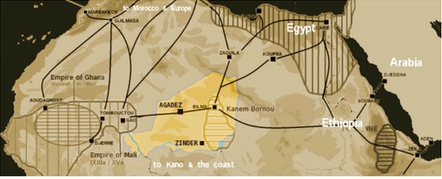

Gold was a preferred currency of merchants across Afroeurasia. Due to Ghana’s control of the world’s largest known supply of gold, they kingdom grew very wealthy through its trade. While many other goods were traded, the most desired luxury Ghana received in exchange for gold was just as valuable at the time – salt. Salt was very hard to obtain, and it was used to keep food from spoiling, increasing the safety and abundance of the food supply. Salt was so valuable it could also be used as a currency.
By the 13th century, the kingdom of Ghana had been replaced by the Mali Empire as the most powerful society in Western Africa. Like Ghana, Mali prospered due to their control of the abundant gold supply in the region. Major cities attracted merchants with caravans as large as 25,000 camels. Taxation of trade goods allowed the Mali Empire to surpass the level of wealth Ghana enjoyed before them. Mansa Musa, who ruled Mali in the early 14th century, amazed everyone he encountered on his pilgrimage to Mecca with his vast wealth.

Mansa Musa’s pilgrimage to Mecca illustrates an important and recurring theme regarding Afroeurasian trade; often, the spread of ideas was just as important as the movement of valuable goods. The rulers of Ghana and Mali were attracted to Islam by their Muslim trading partners. In turn, they encouraged the spread of Islam throughout their societies. Mansa Musa’s wealth and devotion to Islam further promoted the religion among the people of west Africa. Many mosques were constructed along the Saharan trade routes, and Islamic education was encouraged.

The role of the trans-Saharan trade routes began to decline in the 15th century, when European explorers began to establish sea trade with the civilizations along the coast of Western Africa. While some trade still occurs in the Sahara desert today (still by caravans of camels), the routes usually cover much shorter distances. Modern boundaries of countries restrict the flow of goods. Still, the trade that flourished across the vast desert from the 8th-15th centuries played a vital role in the development of Afroeurasia and is a prime example of the contribution of African cultures to global society.

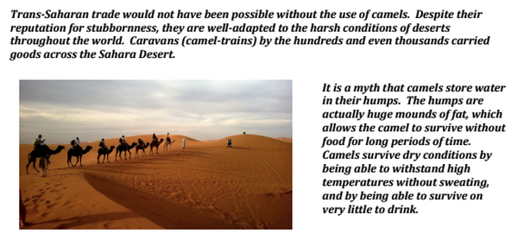

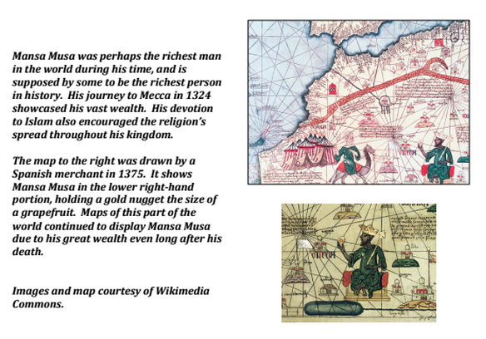

Source: Bentley, Jerry H., and Herbert F. Ziegler. Traditions & Encounters: A Global Perspective on the Past. 3rd ed. New York: McGraw-Hill, 2006. Print.

