Document A: Catalan Atlas

The Catalan Atlas is a medieval map from Spain drawn in 1375 by a mapmaker named Abraham Cresques. Cresques had never visited West Africa but relied on the accounts of travelers and traders to make his map.
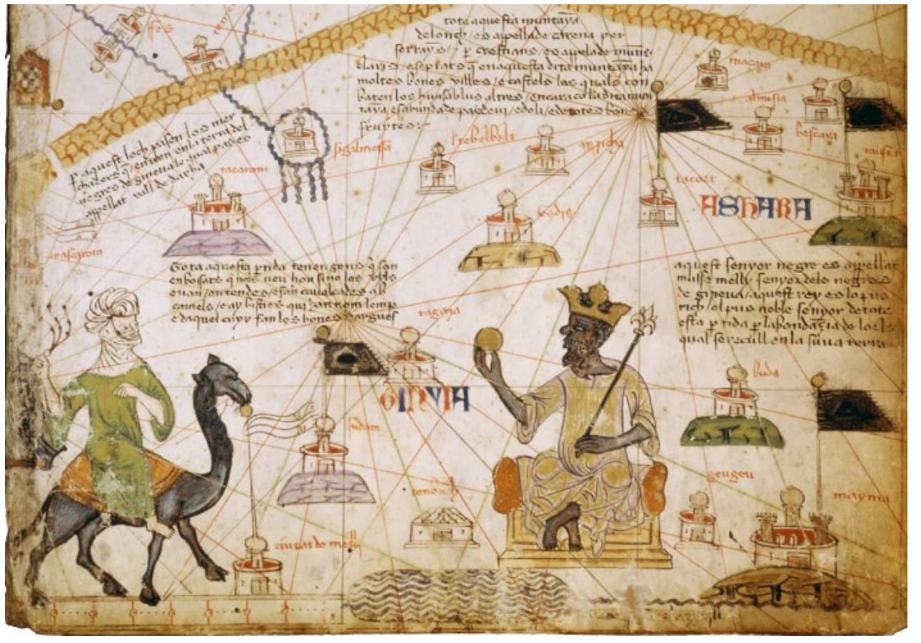
Catalan Atlas inscription: “This Black lord is called Musa Mali, Lord of the Black people of Mali. So abundant is the gold which is found in his country that he is the richest and most noble king in all the land.”

Source: Abraham Cresques, 1375

Adapted from: Stanford History Education Group

