Trade in the Indian Ocean Basin

As one of the world’s major oceans, the Indian Ocean has long been an important link in the Afroeurasian trade system. Today, thirty-six countries border the Indian Ocean and its marginal seas; merchants once sailed between distant and diverse cultures, from China to India to East Africa and even Egypt.

The Indian subcontinent, due to its geographic location, became a hub for trade in the Indian Ocean basin. Cotton textiles and steel from India, spices from Southeast Asia, silk and porcelain from China, and gold from East Africa all passed through Indian ports on their way to and from these distant lands. As a result, there was also great interaction between people of different cultures and religions, as Buddhists, Hindus, Muslims, and Jews did business with each other, exchanging both goods and ideas in the process.

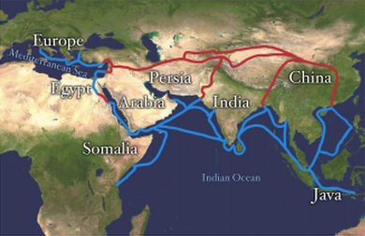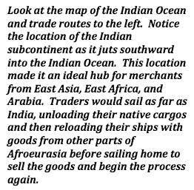

The societies and cultures of East Africa were influenced heavily by travel and trade across the Indian Ocean. As the people groups of East Africa came into contact with merchants from Arabia and India, their interactions led to the birth of the Swahili culture of East Africa. Swahili culture is a mixture of African, Arab, and even Hindu ideas, languages, and customs.

Swahili is, in fact, an Arabic word that refers to the fact that these people lived on or near the coast and engaged in sailing and trade. Just as in west Africa, the people of East Africa had access to large amounts of gold that was heavily desired by the Arab and Chinese cultures with whom they traded. Other items traded by the Swahili people included ivory (from elephants and rhinos) and exotic animal skins. In return, East African merchants desired silk and cotton textiles, as well as glass and pottery.

The cultures of East Africa also demonstrated other similarities with west African cultures due to inter-regional trade. Many kings of this region grew very wealthy, as evidenced by the ruins of many grand buildings. Some of those buildings were mosques, meaning Islam became an important religion in East Africa, just as it had in Western Africa.

By the early 16th century, the Indian Ocean continued its role as an important avenue of trade. However, it was around this time that Europeans, in search of a faster route to Asia (compared to the overland silk routes), sailed around the southern coast of Africa and began utilizing the Indian Ocean. Unfortunately, this brought about the end of most of the advanced civilizations of East Africa. The empire of Portugal conquered many of the lands and the seas surrounding the Indian Ocean, giving Europeans full control of the Indian Ocean trade networks thereafter.

