What is religion? And why did Islam form?

Before offering a definition of religion, it is very important to remember that religion is a deeply personal issue for many people. Because it is so personal, religion might be defined in a variety of ways. For the sake of talking about religion from a cultural perspective, it’s probably fair to say that religion is a set of beliefs about the existence and meaning of life, usually accompanied by a set of practices and attitudes regarding human behavior. One might say religion could be summarized in three questions: 1) How did we get here? 2) Why are we here? and 3) How are we supposed to act?

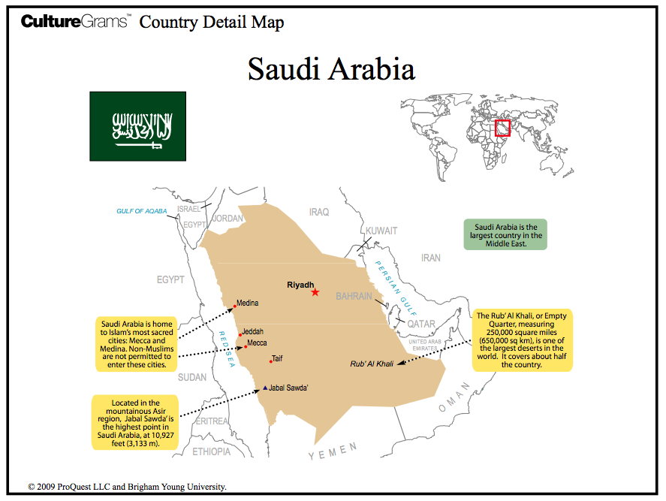
Talking about religion is important in social studies because religious beliefs are and always have been a part of almost every culture in the world. This means that, in addition to playing an important role in the lives of individuals, religion also plays four important roles within a culture: 1) Regulating behavior, 2) Maintaining order, 3) Providing meaning, and 4) Providing comfort. To understand the impact that Islam had on Arabic culture, we should first examine how those four roles were being fulfilled by religious and cultural beliefs before the formation of Islam.

The Arabian Peninsula (see above) in the 6th century could be a cruel place. It is a very dry land. Water and other resources needed for survival were scarce. There was no central government or authority to maintain law and order. Survival of oneself and one’s family was the ultimate goal of many people. Because of this, loyalty to one’s family and clan (tribe) were the basis for maintaining order. Clans stuck together, often fighting with rival clans over scarce resources.

As loyalty to the clan provided order, one’s behaviors and actions were almost completely determined by this fact. The limited resources that were available were a constant source of conflict and war between different clans. While war is considered by most to be an undesirable act, it was the way of life in 6th century Arabia. Each clan also had its own customs and traditions, and determined its own standards for behavior and conduct.

The religious beliefs of people in Arabia prior to formation of Islam were various and diverse. Many clans were animists, which isn’t one particular religion, but more of a general belief in a spiritual aspect of all the world’s living things. Some believed that the spirits of their ancestors were watching over them and could be called on to help them in times of need. Other people groups were polytheistic, believing in many different gods, while Judaism and Christianity (monotheistic religions with belief in one God) were also a part of some Arabian cultures.

While all belief systems provide meaning and comfort to those who invest in them, the diversity of belief systems in 6th century Arabia resulted in a variety of experiences for the many different clans and cultures. Some believed in an afterlife, while others did not. Some religious beliefs provided a sense of greater purpose and meaning in life, but not all.

The beliefs of Islam, which you will learn more about in the future, were a response to many of the cultural and religious practices of the time. Islam provided a means for regulating behavior; the writings in the Qur’an instruct Muslims (followers of Islam) on the proper way to live. Likewise, this religion brought order to the Arab people by providing one belief system for people to follow. As opposed to loyalty to their own clans, which all had different customs and traditions, people were unified by a common set of beliefs. They began to be loyal to each other, regardless of their family or clan.

Furthermore, Islam provided a common purpose in life for its followers. Rather than just survival, Muslims were taught that worshipping God, whom they call “Allah”, was the greatest purpose in life. Furthermore, it is believed in Islam that worshipping Allah and following His commands leads to eternal life in spiritual paradise. In a world as harsh and unforgiving as 6th century Arabia, the prospect of life after death was a source of comfort and hope.

Source: "Saudi Arabia." CultureGrams Kids Edition. ProQuest, 2014. Web. 17 Apr 2014.

