Mr. Ells Hazel G. Scott Middle School
7th Grade Social Studies Lincoln, Nebraska

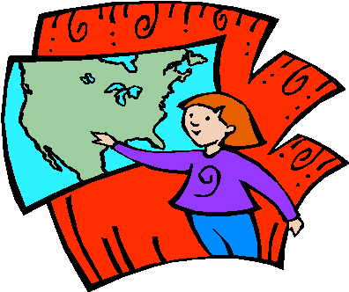

7TH GRADE SOCIAL STUDIES
EXPECTATIONS

What We Are Studying This Year

The content of the seventh grade social studies curriculum rests on the belief that world history is best understood as a unified chronology in which humankind as a whole has a story to be investigated. The seventh grade curriculum will begin chronologically where the sixth grade curriculum ends, covering the story of humankind from approximately 300 CE – 1450 CE. First semester focuses on the landmass of “Afroeurasia” and how religion, trade, empires and conflicts impacted the continents of Africa, Europe and Asia. Emphasis is placed on connections between societies. Second semester will bring the Americas into the picture, ending with a study of the Columbian Exchange within a global context.

Standard 1: Introduction to Big History and Historical Thinking
Standard 2: Rise and Fall of Classical Societies (Greece, Persia, Rome, Han)
Standard 3: Afroeurasia and the Rise of Islam (600- 750 CE)
Standard 4: Trading Networks: the impact of goods, customs, and ideas on Afroeurasia (1000 – 1250 CE)
Standard 5: The Mongol Empire (1200 – 1400 CE)
Standard 6: Calamities and Recoveries (1100 – 1500 CE)
Standard 7: Spheres of Interaction in the Americas (300 – 1500 CE)
Standard 8: Causes and Consequences of Interaction and Isolation (1400 – 1550 CE)
Standard 9: Civic Action and Research Project

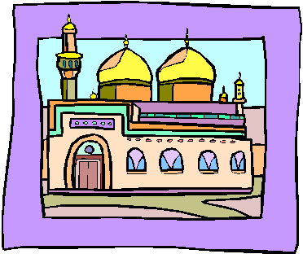

What Teachers Expect of Students
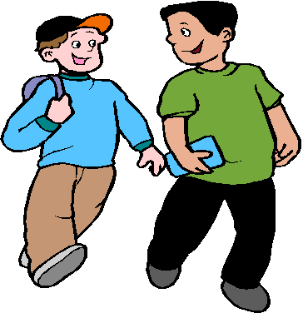
1. Be safe. This means
• walk in a safe manner.
• keep hands, feet, and other objects to oneself.

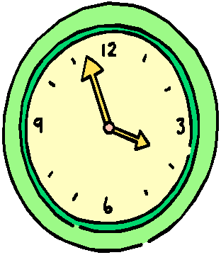
2. Be responsible. This means
• be on time.
• be prepared.
• complete work on time and accurately.
• keep your personal area clean.
• follow directions.
3. Be respectful. This means
• listen without interrupting.
• help others be successful.
• be accepting of individual differences.
• be courteous.

Me
Please visit with me as soon as possible should you encounter academic problems in my classroom. I can usually be found in my classroom before and after school. And, check out my LPS web site at http://wp.lps.org/pells/ for important information about our class.

