Name: _________________________ Period: ____

The Voyages of Columbus
Call to Freedom – Pages 39-43

Read “Crossing the Ocean” on Page 39. Answer questions 1-2.

1. What were the names of Columbus’s three ships?

___________________ ____________________ ____________________

2. Why do you think Columbus’s crew was worried?

Read “Columbus’s First Explorations” on Page 40. Answer questions 3-5.

3. How did Columbus describe the Taino people?

4. What do you think the Taino thought when they saw Columbus and his men? Write a quote from their perspective.

5. Why did Columbus build a colony on the island of Hispaniola?

Read “Europe Learns of Columbus’s Voyage” on Pages 41-42. Answer questions 6-7.

6. Why did King Ferdinand and Queen Isabella believe that Columbus deserved a reward?

7. Complete the chart:
What was the goal of Isabella for the Taino? | What was the goal of Columbus for the Taino?
______________________________________  ______________________________________  ______________________________________  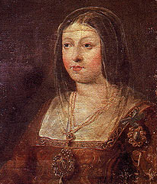 | ______________________________________  ______________________________________  ______________________________________  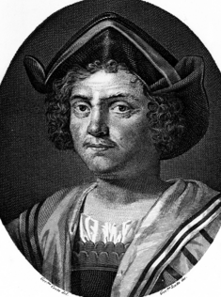

Read “Columbus’s Later Voyages” on Pages 42-43.

8. Use the graphic organizer below to record the results of each of Columbus’s next three voyages.

Date | Results
1493
1498
1502

Image Citations: https://en.wikipedia.org/wiki/Isabella_I_of_Castile; https://commons.wikimedia.org/wiki/File:Portrait_of_Christopher_Columbus._Wellcome_M0007952.jpg;

