Name: _____________________________

Directions: Create an imaginary resume that Christopher Columbus might have presented to King Ferdinand and Queen Isabella of Spain showing his qualifications for leading an expedition across the Atlantic Ocean.
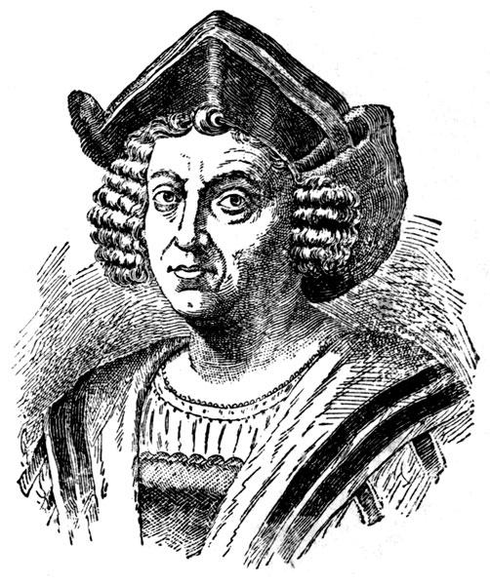

Christopher Columbus

Education:

1.)

2.)

Experience/Training:

1.)

2.)

Objectives for Exploring:
(Why does Columbus want to explore?)

You should fund my voyage because…
(How does this benefit the King and Queen?)

Image citation: https://commons.wikimedia.org/wiki/File:Portrait_of_Christopher_Columbus._Wellcome_M0007952.jpg

