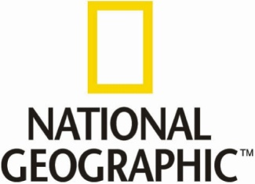

NAME: ___________________________________________________

America Before Columbus Video Questions

Directions: Please answer the questions below while you watch the video.

Questions:

- List any two pieces of “natural wealth” that exist in America before Columbus arrived:

- Why is Queen Isabella so desperate to find a water route to Asia?

- About how many people live in the Americas prior to 1492?

- What were a couple of important crops that were cultivated in the Americas in this time?

- What were a couple of animals that were essential to the Native Americans’ survival in America?

- What is the largest river in the Americas?

- Why was wood so scarce in Europe at this time?

- What is arguably the richest city in Europe?

- What animal is important to European conquest and was not available in the Americas?

- What disease was particularly deadly to the natives in the New World?

- Name a couple of resources that were sent from the Americas to Europe:

- Name three different things the Europeans brought with them to the Americas?

- Based on what you saw on the video, in what ways was Columbus arrival in the New World a bad thing?

- In what ways was Columbus arrival in the New World a good thing?

