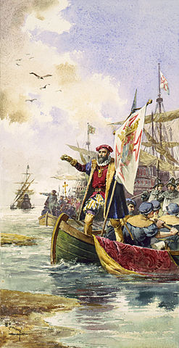
Portugal Video Questions

1. Why was Vasco da Gama looking for a sea route to India?

2. Who are the great heroes of Portugal? Why?

3. What was Portugal’s “secret weapon?”

Image: https://commons.wikimedia.org/wiki/File:Vascodagama.JPG

Portugal Video Questions

1. Why was Vasco da Gama looking for a sea route to India?

2. Who are the great heroes of Portugal? Why?

3. What was Portugal’s “secret weapon?”

Image: https://commons.wikimedia.org/wiki/File:Vascodagama.JPG

