NAME_________________________________________________ PERIOD______

MAPPING THE WHIRLWIND
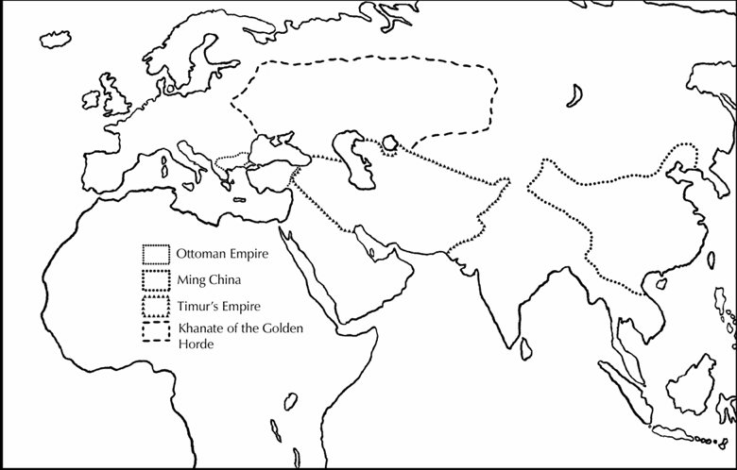

1) ____________________ was the capital city of Timur’s empire. Using an atlas, plot this city and label it on your map. This city is in the modern country of _______________________.

2) Lightly shade in Timur’s empire with the color RED. Timur’s empire is located between India and the Mediterranean Sea.

3) List 3 modern countries that are located within this shaded area:

a)_________________________ b)_________________________ c)_________________________

4) Timur raided and fought his powerful northern enemies all the way to Moscow. Plot this city and label it on your map. Then, shade in the territory of the Khanate of the Golden Horde in YELLOW.

5) Timur was also able to conquer parts of India, and destroyed the city of Delhi. Plot and label Delhi on your map. Also label India.

6) In the process of building his empire, Timur looted (stole from) the city of Damascus and burned Baghdad to the ground. Plot and label these two cities on your map.

7) In 1402 Timur defeated the _______________ Empire. In doing so, he temporarily (and accidentally) saved the Byzantine city of Constantinople. Plot and label Constantinople, and then shade in the Ottoman Empire in ORANGE.

8) The conquest of China was Timur’s final goal, but he died before he could begin. Shade in Ming China with the color GREEN.

9) Shade in the map key with the colors used throughout the activity.

