Name: ______________________________ Period: ______

History Assessment of Thinking (HAT)
Use your Historical Thinking Skills to study the two images below. Then answer the question that follows.

Document A Document B
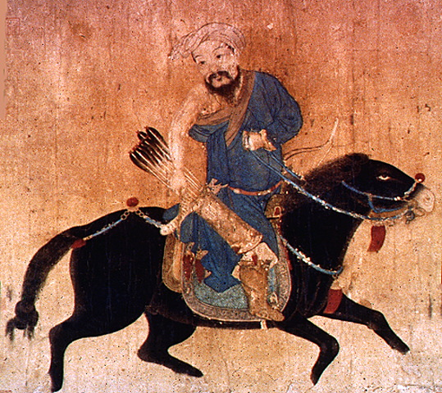 | 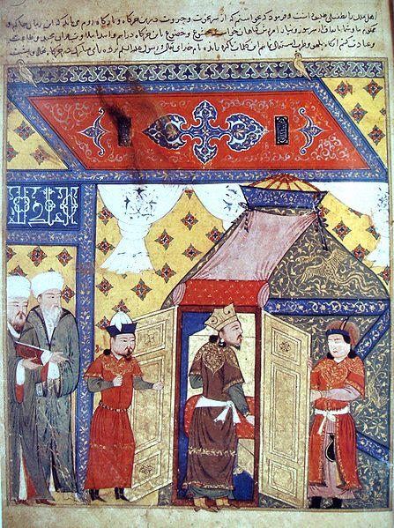
Source: Mongol light cavalryman, 15th to 16th century, by unknown author from Ming dynasty  Mongol Archer. 15th -16th century. Victoria and Albert Museum, London. Wikimedia Commons. Web. 31 July 2014.  http://commons.wikimedia.org/wiki/File:MongolArcher.jpg | Source: “Conversion of Ghazan [Mongol leader] to Islam,” 14th century, by Muslim historian Rashid al-Din  Ad-Din, Rachid. Ghazan Conversion to Islam. 14th century. Wikimedia Commons. Web. 31 July 2014.  http://commons.wikimedia.org/wiki/File:GhazanConversionToIslam.JPG

Which image do you believe most accurately portrays the Mongols? Explain your answer using at least 3 pieces of specific evidence from documents A-C.

________________________________________________________________________________________________________________________________________________________________________________________________________________________________________________________________________________________________________________________________________________________________________
________________________________________________________________________________________________________________________________________________________________________________________________________________________________________________________________________________________________________________________________________________________________________

