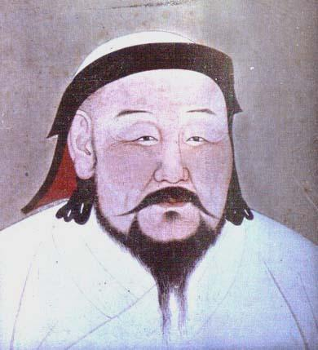
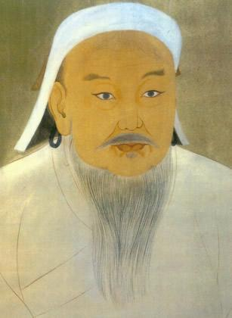
Mongol Memorial

Portrait of Chinggis. N.d. National Palace Museum, Taipei. The Mongols in World History. Web. 31 July 2014.
Portrait of Khubilai. N.d. National Palace Museum, Taipei. The Mongols in World History. Web. 30 July 2014.

Objective: To show the significance of Chinggis Khan and Kublai Khan.

Directions: Design a memorial to commemorate the life and accomplishments of Chinggis Khan and Kublai Khan. You must show the design of your memorial and provide a rationale for your choice.

Designing the Memorial:
- Consider memorials you have observed and/or those we viewed in class to help you get started.
- As you think about designing your memorial focus on Chinggis Khan’s and Kublai Khan’s leadership – consider their actions, what each leader did to bring about change, and how others were affected.
- If you believe one leader is more significant than the other, your memorial may focus more on that leader. Your rationale should explain your choice.

Writing the Rationale:
- Your rationale should be 3 paragraphs (3-5 sentences per paragraph) in length.
- Paragraph 1: Explain what made Chinggis Khan and Kublai Khan significant. Provide at least 2 specific examples about each leader.
- Paragraph 2: Describe your memorial including where it is located. Give details of how this memorial will be viewed by others.
- Paragraph 3: Tell how your memorial is fitting for Chinggis Khan and Kublai Khan. Why is it a good reflection of their leadership?

 | Minimal Evidence  10 | Gaining Proficiency  11-14 | Proficient  15-16 | Exemplary  17-20
Memorial | Lack of detail and accuracy in the design. It is not clear how the memorial is fitting. | The memorial is complete but may lack some detail or accuracy. | The memorial is an accurate representation, but could be more detailed. | The memorial is fitting and shows accuracy and details related to their lives.
 | Minimal Evidence  10 | Gaining Proficiency  11-14 | Proficient  15-16 | Exemplary  17-20
Rationale | Several details/requirements are missing and student does not explain the significance of Chinggis Khan and Kublai Khan. | Some questions are not addressed and student does not give a complete picture of the significance of Chinggis Khan and Kublai Khan. | All questions are addressed and student provides evidence of understanding the significance of Chinggis Khan and Kublai Khan. | All requirements are met. Student addresses all questions in detail and clearly explains the significance of Chinggis Khan and Kublai Khan.

Total: _______ / 40 points

