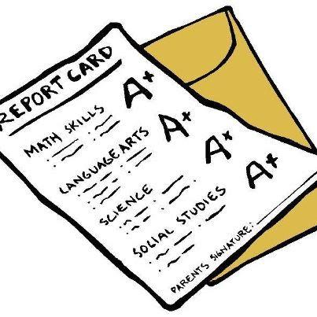
Report Card: Kublai Khan
Topic | Grade | Written Explanation  (Remember to use evidence from the text to support your grade!)
Becoming the Great Khan and Conquering China
Yuan Dynasty
Beyond China
Opening China to the World

