What Was the Significance of Kublai Khan?
Becoming the Great Khan and Conquering China
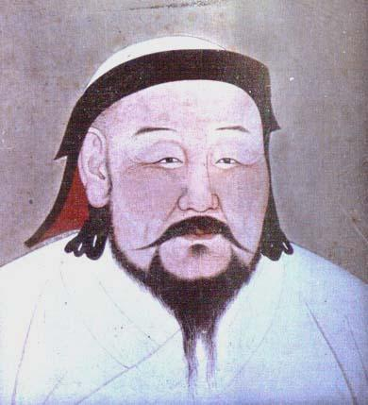
All of China came under Mongol rule during the reign of Kublai, one of Chinggis Khan’s grandsons. Kublai was perhaps the most talented of the great conqueror’s descendants. At twenty-one, Kublai was given northern China to govern. He earned the reputation of a talented military commander and wise leader. By 1260, although the empire remained divided into four regions, Kublai was named Great Khan of all the Mongols.
Although he had a large empire, Kublai wanted to extend Mongol rule to all of China. From his capital in northern China, he attacked the Song dynasty in southern China. Kublai’s armies attacked city after city with boulders and flaming torches launched from catapults. The Song capital at Hangzhou fell to Mongol forces in 1276, and within three years Kublai had eliminated resistance throughout China. In his conquest to control all of China, Kublai caused significant damage and loss of life to the Chinese.
The Mongols did not have much experience with government. The Chinese, on the other hand, had a long history of organized government. So Kublai kept many aspects of Chinese rule. He built his capital at Beijing in traditional Chinese style and declared himself emperor. He also founded a new dynasty – the Yuan Dynasty. These steps were familiar to the Chinese and made it easier for Kublai to control China.
While Kublai kept features of the Chinese form of government, he made sure that the Chinese politicians didn’t gain too much power. He did this to keep control of China in Mongol hands. He gave the important government jobs to Mongols or to trusted foreigners. Chinese officials were given only minor jobs with little or no power. Marriage between Mongols and Chinese was outlawed.
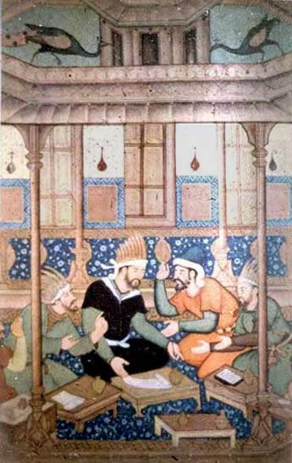

Kublai Khan recruited a multicultural group of advisors and administrators to help him rule China. This images shows him gathering Muslims from Central Asia and Persia.

Bentley, Jerry H., and Herbert F. Ziegler. Traditions & Encounters: A Global Perspective on the Past. 3rd ed. New York: McGraw-
Hill, 2006. Print.
Portrait of Khubilai. N.d. National Palace Museum, Taipei. The Mongols in World History. Web. 30 July 2014.
http://afe.easia.columbia.edu/mongols/pop/khubilai/images_kk.htm
Khubilai Khan and His Advisers. N.d. Jenghiz Khan Miniatures, Court of Akhbar. The Mongols in World History. Web. 30 July 2014. http://afe.easia.columbia.edu/mongols/pop/china/images_ch.htm
What Was the Significance of Kublai Khan?
Yuan Dynasty
While Kublai launched brutal attacks against his enemies, he also took an interest in cultural matters and worked to improve the welfare of his subjects. Kublai did not abandon Mongol rituals, but he also actively promoted Buddhism and provided support for many other religions in his empire. Kublai loved the arts and gave artisans freedom of expression and more support than they had ever had. He used a government printing press to make books more available. His reign marked a golden age for Chinese theater with hundreds of new plays written. Kublai also valued the sciences so he gathered the best foreign doctors and scholars. As a result of their work, a more accurate calendar and maps were created.
Kublai Khan worked to improve the lives of his subjects. He gave support to the peasants knowing that a strong economy would bring in more taxes and ultimately benefit the Mongols. He provided assistance and training for farmers. Welfare organizations were in place to provide help to those who needed it – orphans, widows, and the elderly. Kublai attempted to offer education to all boys.
Kublai Khan was a capable leader. He worked to rebuild China after years of warfare. He restored the Grand Canal and extended it 135 miles north to Beijing so people and goods could be easily transported. This remains the longest manmade waterway in the world. He built a paved highway that connected Beijing and Hangzhou. These land and water routes allowed for easy travel and communication between north and south. They were costly though (requiring high taxes) and needed a large investment of labor from the Chinese peasants.

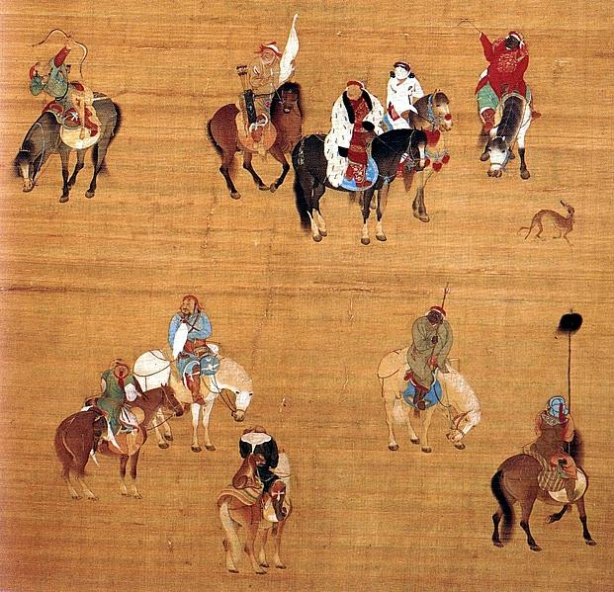
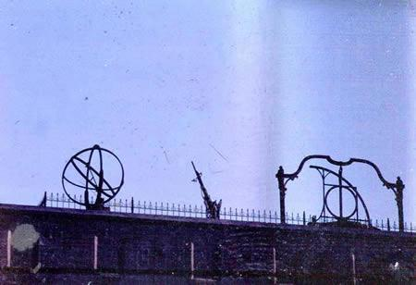

Knowing that the Persians had made great advances in astronomy, Kublai Khan invited the Persian astronomer Jamal al-Din to Beijing and asked him to build an observatory. This photograph shows a reconstruction of the observatory.

Kublai Khan had a Chinese painter produce this image of him as “the Emperor and Great Khan” on a hunt.

Kublai Khan had a Chinese painter produce this image of him as “the Emperor and Great Khan” on a hunt.

Kublai Khan had a Chinese painter produce the above image of him as “the Emperor and Great Khan” on a hunt.

Bentley, Jerry H., and Herbert F. Ziegler. Traditions & Encounters: A Global Perspective on the Past. 3rd ed. New York: McGraw-
Hill, 2006. Print.
Guandao, Liu. Khubilai Khan on a Hunt. N.d. National Palace Museum, Taipei. The Mongols in World History. Web. 30 July 2014. http://afe.easia.columbia.edu/mongols/pop/khubilai/images_kk.htm
Rossabi, Morris. "Ming Dynasty Reconstruction of Yuan Dynasty Observatory." The Mongols in World History. Asia for Educators, Columbia University, 2004. Web. 30 July 2014. http://afe.easia.columbia.edu/mongols/pop/china/images_ch.htm

What Was the Significance of Kublai Khan?
Beyond China
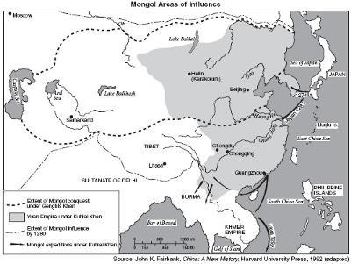
Beyond China, Kublai had little success as a conqueror. During the 1270s and 1280s, he launched several invasions of Vietnam, Cambodia, and Burma as well as a naval expedition against Java involving five hundred to one thousand ships and twenty thousand troops. But Mongol forces did not adapt well to the humid, tropical jungles of southeast Asia. There wasn’t enough food for their horses and the Mongols were forced to withdraw because of bad weather and diseases.
In 1274 and again in 1281, Kublai also attempted naval campaigns against Japan. These campaigns were launched because the Japanese leaders refused to submit to the Mongols after the arrival of Mongol ambassadors in Japan. On both occasions typhoons destroyed Kublai’s plans. The storm of 1281 was especially severe: it destroyed about 4,500 Mongol boats carrying more than one hundred thousand armed troops – the largest seaborne expedition before World War II.
These expeditions were extremely costly and hard on the Mongol rulers in China. With each failed campaign, large sums of money were used, and the empire was further weakened.

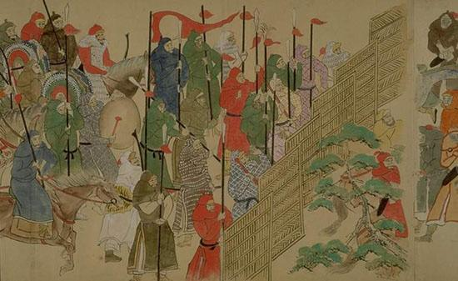
Mongol troops from the Yuan dynasty.

Bentley, Jerry H., and Herbert F. Ziegler. Traditions & Encounters: A Global Perspective on the Past. 3rd ed. New York: McGraw-
Hill, 2006. Print.
Fairbank, John K. Mongol Areas of Influence. Map. Harvard University Press, 1992. Mongolia Attractions. Web. 30 July 2014. http://www.mongolia-attractions.com/kublai-khanthe-conqueror.html
The Mongols in World History. Asia for Educators, Columbia University, 2004. Web. 30 July 2014. http://afe.easia.columbia.edu/mongols/index.html
UNK. Mongol Troops from Scrolls of the Mongol Invasions. N.d. Wikimedia. Web. 30 July 2014. http://commons.wikimedia.org/wiki/ File:Mongols.jpg - mediaviewer/File:Mongols.jpg

What Was the Significance of Kublai Khan?
Opening China to the World

During Kublai Khan’s rule, China became more open to the outside world. He was always looking for ways to improve trade, so he made it safer for merchants to travel the Silk Road. The Mongols also developed a successful sea trade and welcomed visitors from foreign lands. People from Arabia, Persia, and India often visited Mongol China. Even missionaries and government representatives from as far away as Europe made the long trip. These visitors helped tell the rest of the world about Chinese civilization.
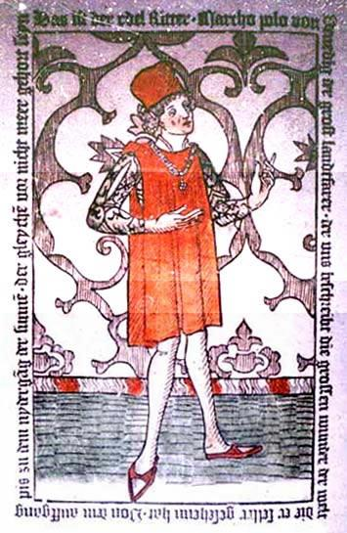
The most famous European visitor during this period was Marco Polo. Polo was a young trader from Venice, Italy. He stayed in China for 17 years. Polo became an assistant to Kublai Khan and traveled throughout China on government missions. He later published a book about his adventures.
In his book, Polo told about Kublai Khan's rich, advanced empire. He described the Khan's postal system. Riders on horseback communicated messages from one station to another. Polo wrote about many Chinese customs, such as the mining and use of coal as fuel. Coal had not yet been used in Europe. He was also impressed with the Chinese use of paper money. Europeans traded with gold, silver, copper, and lead coins. Polo’s stories led to a greater desire for Asian goods in Europe and inspired explorers to search for a sea route to Asia.
This is a Western artist’s image of Kublai Khan on a hunt with the Polos based on the accounts of Marco Polo. Polo wrote that Kublai Khan had become so obese that no single horse could support his weight. Elephants had to be used to transport him. It seems this artist had never seen someone from Asia – Kublai Khan looks like a European. It seems he had also never seen an elephant – the horses are larger than the elephants.
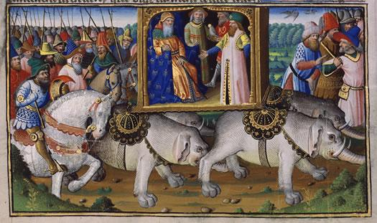

Bentley, Jerry H., and Herbert F. Ziegler. Traditions & Encounters: A Global Perspective on the Past. 3rd ed. New York: McGraw-
Hill, 2006. Print.
Elephants Carrying the Polo Brothers and Khubilai Khan. N.d. Bibliotheque nationale de France, Paris. The Mongols in World History. Web. 30 July2014. http://afe.easia.columbia.edu/mongols/pop/khubilai/images_kk.htm
Marco Polo. N.d. Bibliotheque nationale de France, Paris. The Mongols in World History. Web. 30 July 2014. http://afe.easia.columbia.edu/mongols/pop/images_mp.htm
McNeese, Tim. "Polo, Marco." World Book Student. World Book, 2014. Web. 22 July 2014.

