What Was the Significance of Chinggis Khan?

Mongol Political Organization

During the late twelfth century, Temujin made an alliance with an important Mongol clan leader. He gradually strengthened his position, sometimes by making useful alliances, often by conquering rivals for power. He eventually unified all the Mongol tribes, and in 1206 an assembly of Mongol leaders recognized Temujin’s supremacy by proclaiming him Chinggis Khan (“universal ruler”).

Chinggis Khan’s policies greatly strengthened the Mongol people. Because of his personal experiences, Chinggis Khan did not trust the Mongols’ tribal organization. He broke up the tribes and forced men of fighting age to join new military units who no tribal connections. He chose high military and political officials not on the basis of kinship (family) or tribal status but, rather, because of their talents or their loyalty to him. Although he spent most of his life on horseback, Chinggis Khan also established a capital at Karakorum where he built a luxurious palace. As command center of Chinggis Khan’s empire, Karakorum symbolized the strength of the unified Mongols. Chinggis Khan’s policies created a Mongol state that was not only much stronger than any earlier union but also less troubled by conflicts between clans and tribes.

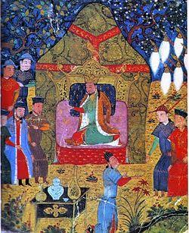

A 15th century illustration that shows Temujin in 1206 when he was proclaimed Chinggis Khan: ruler of all the Mongols.

Al-din, Rashid. Temujin Proclaimed Genghis with His Sons. 1206. Wikipedia. Web. 24 July 2014. http://en.wikipedia.org/wiki/Genghis_Khan - mediaviewer/ File:Genghis_Khan%27s_enthronement_in_1206.jpg
Bentley, Jerry H., and Herbert F. Ziegler. Traditions & Encounters: A Global Perspective on the Past. 3rd ed. New York: McGraw-
Hill, 2006. Print.
What Was the Significance of Chinggis Khan?

Mongol Army

The most important institution of the Mongol state was the army. In the thirteenth century the Mongol population was about one million people – less than 1 percent of China’s numbers. During Chinggis Khan’s life, his army numbered only 100,000 to 125,000 Mongols. How was it possible for so few people to conquer so much land?
All Mongols were fighters, but Chinggis made a reorganized army the core of the society. Under him and his successors, the Mongol army had the following characteristics, many designed by Chinggis himself:
All males 15-70 served in the army, all as cavalry (soldiers on horseback).
The army’s 95 units of 10,000 soldiers were subdivided into units of 1,000, 100, and 10. Members of different tribes were mixed together in units of every size to ensure loyalty to the army above loyalty to the tribe.
Absolute obedience to orders from superiors/officers was enforced.
No one in the army was paid, though all shared in stolen goods. All contributed to a fund to take care of those too old, sick, or hurt to fight.
During three months every year, large-scale hunting expeditions served as military training.
Cavalry troops had to supply their own bows and other military equipment, which had to meet officers’ standards.

Gathering information had high priority. Scouts/spies were sent out, information from locals was gathered, and traveling merchants were rewarded for information.
Foreign experts and advisors were used, notably Chinese and Persian engineers skilled at making and using siege weapons such as catapults and battering rams.

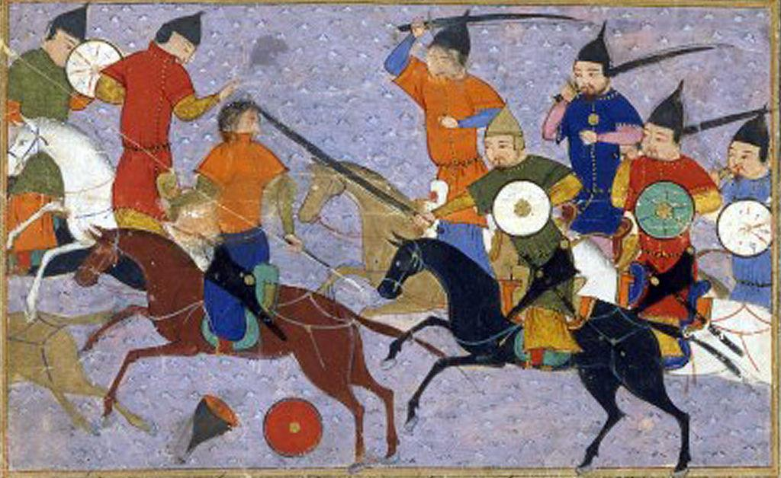
This illustration shows a battle between Mongol warriors and the Chinese in 1211. Mongols grew up riding horses and were among the most mobile forces, sometimes traveling more than 62 miles per day to surprise an enemy.

Al-Vâhidî, Sayf. Battle between Mongols & Chinese. 1211. Wikimedia Commons. Web. 30 July 2014. http/::commons.wikimedia.org:wiki: File/Bataille_entre_mongols_%2526_chinois_(1211).jpeg
Bentley, Jerry H., and Herbert F. Ziegler. Traditions & Encounters: A Global Perspective on the Past. 3rd ed. New York: McGraw-
Hill, 2006. Print.
National Center for History in the Schools at UCLA. "Landscape Teaching Unit 5.4 Mongol Empire Builders." World History for Us All. San Diego State University, n.d. Web. 19 June 2014.
What Was the Significance of Chinggis Khan?
Mongol Conquests
Once he had united the Mongols, Chinggis Khan turned his army and his attention to other parts of central Asia and particularly to nearby settled societies. These conquests were important because they protected him against the possibility that other nomadic leaders might challenge his rule. Chinggis Khan himself extended Mongol rule to northern China. The conquest of China began in 1211 and by 1215 the Mongols had captured the capital near modern Beijing.
While part of his army strengthened the Mongol hold on northern China, Chinggis Khan led another force to Afghanistan and Persia. He hoped to open trade and political relations with their leader, the shah. The shah hated the Mongols, however, and he ordered his officials to murder Chinggis Khan’s messengers and the merchants accompanying them. The following year Chinggis Khan took his army west to seek revenge. Mongol forces pursued the shah to an island in the Caspian Sea where he died. Meanwhile, they destroyed the shah’s army and seized control of his kingdom.
To prevent any possibility that the shah’s state might survive and become a challenge to his own empire, Chinggis Khan destroyed the conquered land. The Mongols devastated one city after another, demolishing buildings and massacring hundreds of thousands of people. Some cities never recovered. The Mongols also destroyed the irrigation systems that sustained agriculture in the region, resulting in severely reduced agricultural production. For centuries after the Mongol conquests, Persian chroniclers (historians and storytellers) cursed the invaders and the devastation they brought upon the land.

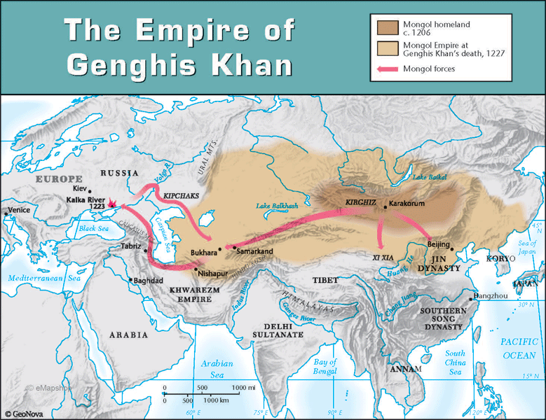

Bentley, Jerry H., and Herbert F. Ziegler. Traditions & Encounters: A Global Perspective on the Past. 3rd ed. New York: McGraw-
Hill, 2006. Print.
The Empire of Genghis Khan. Map. 2014. The Mapshop. Web. 30 July 2014. http://classroom.mapshop.com/HISTORY/World/Genghis-Khan-Empire-Map.asp

What Was the Significance of Chinggis Khan?
Central Government
By the time of his death in 1227, Chinggis Khan had laid the foundation of a vast and mighty empire. He had united the Mongols, established Mongol supremacy in central Asia, and extended Mongol control to northern China in the east and Persia in the west. Chinggis Khan was a conqueror, however, not an administrator. He ruled the Mongols themselves through his control over the army, but he did not establish a central government for the lands that he conquered. Instead, he assigned Mongol rulers to supervise local administrators and to obtain a generous tribute (tax) for the Mongols’ own uses.
Chinggis Khan’s heirs continued his conquests, but they also took on the task of creating a more permanent government to guide the empire of the Mongol people. His death created a struggle for power among his sons and grandsons. Eventually, his heirs divided Chinggis Khan’s large empire into four regional empires.

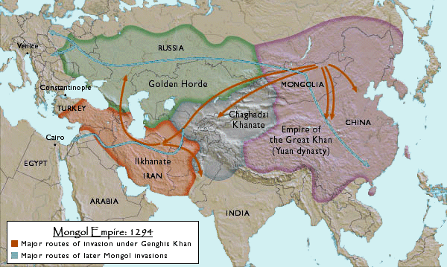

Bentley, Jerry H., and Herbert F. Ziegler. Traditions & Encounters: A Global Perspective on the Past. 3rd ed. New York: McGraw-
Hill, 2006. Print.
"Mongol Empire: 1294." Map. Professor Brian Hoffert. N.p., n.d. Web. 30 July 2014.
http://bhoffert.faculty.noctrl.edu/HST165/07.NorthernAndSouthernSong.Summer.html

