Name: ________________________ Period: ______

Preview: How did the Mongols create an empire?
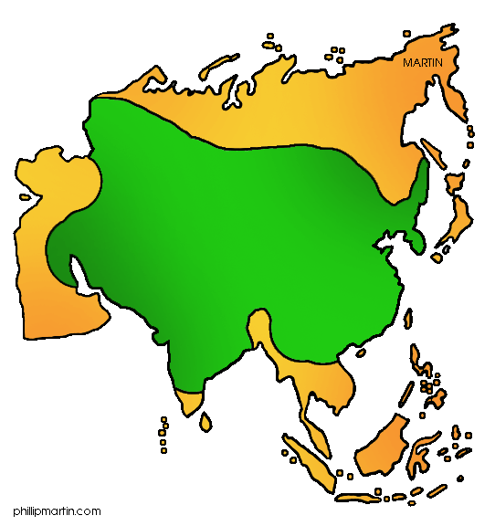
List the most important factors in conquering and creating a successful empire.

First Response: Were the Mongols villains or cultural brokers?

According to the Persian historian Juvaini:
In the Muslim countries devastated by Chinggis Khan, not one in a thousand of the inhabitants survived.

According to the Muslim chronicler Ghazi:
Under the reign of Chinggis Khan, all the countries . . . enjoyed such peace that a man might have journeyed from the land of the sunrise to the land of sunset with a golden platter upon his head without suffering the least violence from anyone.

National Center for History in the Schools at UCLA. "Landscape Teaching Unit 5.4 Mongol Empire Builders." World History for Us All. San Diego State University, n.d. Web. 19 June 2014.

_____________________________________________________________________________________________________________________________________________________________________________________________________________________________________________________________________
_______________________________________________________________________________________
_______________________________________________________________________________________
_______________________________________________________________________________________
_______________________________________________________________________________________

