Background Reading/Timeline: How did the Mongols create an empire?
By the early 1200s, the Mongols exploded onto the world scene by conquering the territories of both nomadic and settled peoples from China to Syria and Russia to Korea in about half a century. They created the world’s largest empire and managed to hang on to their conquests for nearly two centuries. The founder of the empire was Chinggis (Genghis) Khan. The unified empire that he established between 1206 and 1227 broke up about 1260. It did not shatter, however. Rather it divided into four large Mongol kingdoms ruled by his grandsons and later descendants. Therefore, the age of Mongol domination continued far into the fourteenth century.
During that time these Mongol rulers, called khans:
- Connected Europe and Asia as never before.
- Promoted interaction between peoples of many different religions and cultures.
- Enabled the exchange and spread of ideas, goods, technologies, and disease.

As you read the primary documents that describe the tactics of the Mongols, keep in mind this question: How did the Mongols create an empire?

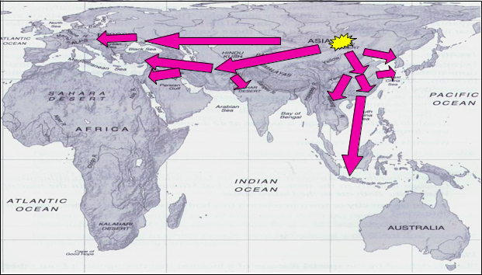
Mongol Conquests and Expeditions 1211-1300 CE
- 1206: Chinggis Khan is named supreme chief of the Mongols

- 1211-1234: Mongol conquest of northern China

- 1219-1221: Mongol conquest of Persia

- 1227: Death of Chinggis Khan

- 1237-1241: Mongol conquest of Russia

- 1258: Mongol capture of Baghdad

- 1264-1279: Mongol conquest of southern China

- 1264-1294: Reign of Kublai Khan in China (the Yuan dynasty)

National Center for History in the Schools at UCLA. "Landscape Teaching Unit 5.4 Mongol Empire Builders." World History for Us
All. San Diego State University, n.d. Web. 19 June 2014.

