Background Reading: Who were the Mongols?
In the grasslands and mountains northwest of China lived a nomadic, tribal, largely illiterate people numbering 700,000 to 1,000,000. These were the Mongols. Like other nomadic peoples, they showed deep loyalty to kin (family) groups organized into clans and tribes. Strong loyalty to kinship groups made it difficult for the Mongols to unify and organize a stable society.
What was it like to live in the Mongol homeland? John of Plano Carpini, an Italian friar (Catholic religious leader) who traveled to Mongolia in the 1240’s described the Mongol homeland as follows:

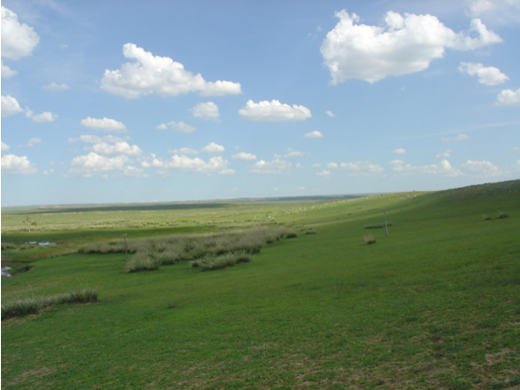
“In some parts the country is extremely mountainous, in others it is flat . . . in some districts there are small woods, but otherwise it is completely bare of trees . . . Not one hundredth part of the land is fertile, nor can it produce . . . unless it be irrigated by running water, and brooks and streams are few there and rivers very rare . . . Although the land is otherwise barren, it is fit for grazing cattle; even if not very good, at least sufficiently so.
The weather there is astonishingly irregular, for in the middle of the summer . . . there is fierce thunder and lightning, which cause the death of many men, and at the same time there are very heavy falls of snow. There are also hurricanes of bitterly cold winds, so violent that at times men can ride on horseback only with great effort. [Sometimes one can] scarcely see owing to the great clouds of dust. Very heavy hail also often falls there. Then also in summer there is suddenly great heat, and suddenly extreme cold.”

The Mongol economies depended on flocks and herds of sheep, goats, horses, and cattle and on raiding for goods, so they were in constant conflict with each other. They fought over pasture, water, and potential slave captives and engaged in long, bloody feuds. They raided each other for goods, for women (no marriages were allowed between members of the same tribe), and to avenge insults. Largely self-sufficient, they often raided, traded with, and obtained tribute (payment) from neighboring settled agricultural communities.
In most tribes, there were no specialists other than shamans (spiritual leaders) and blacksmiths. Women and men both contributed to the economy. Those men who could afford it married more than one wife, each of whom had her separate household. Women rode, shot with bow and arrow, and hunted. They gave political advice and could rise to the rank of chief, though rarely. The senior wife had special status and respect, and her children were often favored as heirs. On campaign, wives, children, and flocks often went with the army. Women and even children could be drafted to ride on the fringes of battle to simulate larger numbers. It is unclear whether they ever took an active part in combat. The tribes were divided into nobles and commoners, and only members of noble lineages could become chiefs, though class differences were not strongly marked.

The Mongols’ religion was shamanism. They believed in an earth and fertility goddess and in nature spirits.
Shamans were considered go-betweens or bridges, joining the human and the spirit world. They could be women or men, and they were always people of prestige and importance. They communicated with the spirits in trances, drove out evil, blessed flocks and herds, and made prophecies (predictions) by examining cracks in the burnt shoulder-blades of sheep. Mongols had no temples, no hierarchy of religious specialists, no regular public worship, no sacred scriptures, and no required beliefs. Their religious concerns were practical, aimed toward ensuring fertility, prosperity, health, and military success.

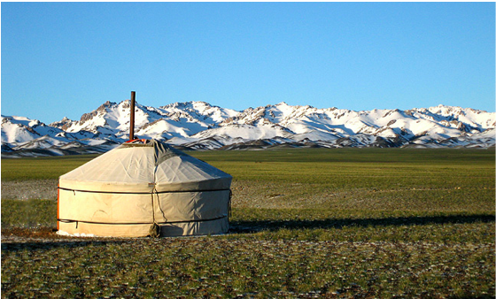

A ger (also called a yurt) is a Mongolian tent home. Each ger has one doorway, no windows, and a little peak at the top to let the smoke out. Gers were so well constructed that it took only two hours to break down, load it onto some oxen and be on your way to seek fresh pastures for your cattle. This style of home is still in use today in Mongolia.

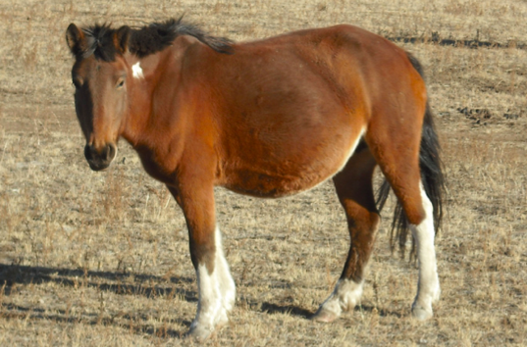

Horses were essential to the Mongol way of life. They were pastured entirely on the open steppe, with no supplementary grain or hay even in winter. Although extremely hardy, Mongol horses could not be ridden day after day or carry heavy loads. Therefore, every mounted soldier ideally possessed not one horse but a string of extra horses as well.

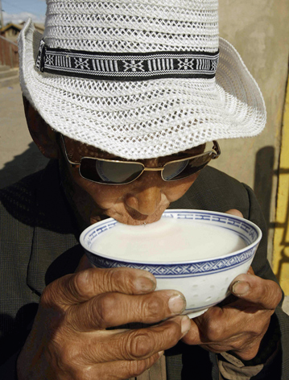
The Mongolian diet consisted largely of dairy products and meat. In this photo, a man drinks fermented mare’s milk, called airag. This drink is often served instead of tea during the summer. Food was cooked over a fire. To bake food, they placed meat and bread dough on hot stones that had been placed near or in the fire. To make fire, they did not use wood. Wood was scarce on the steppes. Instead, they used dried animal dung. If you were a Mongol child in ancient times, it would have been one of your jobs to collect animal dung and set it out to dry.

Sources:
Bentley, Jerry H., and Herbert F. Ziegler. Traditions & Encounters: A Global Perspective on the Past. 3rd ed. New York: McGraw-
Hill, 2006. Print.
National Center for History in the Schools at UCLA. "Landscape Teaching Unit 5.4 Mongol Empire Builders." World History for Us
All. San Diego State University, n.d. Web. 19 June 2014.

