European Trade During the Middle Ages
For many, the words “Europe” and “Middle Ages” call to mind images of grand castles and knights in shining armor. The time period we refer to as the Middle Ages spanned nearly ten centuries, and while knights and castles were certainly part of what defined this time in Europe, there is much more to the story.

After the fall of the Roman Empire in the 5th century, most of Western Europe was plunged into disorder and chaos. The continent that had formerly been controlled by Rome was fractured into thousands of smaller pieces ruled by rival kings. Meanwhile, the eastern part of the Roman Empire (later referred to as the Byzantine Empire) survived, with its capital of Constantinople in present- day Turkey.

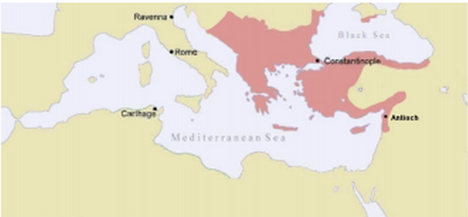
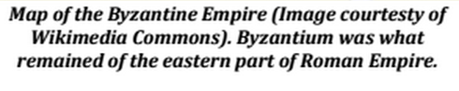
Economic prosperity continued in the Byzantine Empire due to its location as a trade hub in Afroeurasia. Many goods passed from, into, and through Byzantium’s important cities; grain from Northern Africa, silk from China. Cloth, timber, oils, spices and perfumes, as well as many other products, were bought and sold by Byzantine merchants.

However, the prosperity and trade of the Byzantine Empire was absent from the rest of Europe in the early middle ages. Instead, the economy of Western Europe was based on the concept of land ownership known as feudalism. Under the feudal system, powerful landowners, or lords, allowed others to use their lands to grow crops in exchange for service. Knights provided the lord with military service in exchange for land, and the lowest class of people, known as serfs, worked to grow food for themselves and for their lords.

Trade was almost non-existent in the early middle ages. This meant that the people who lived on the manor (the lord’s land and possessions) had to be self-sufficient, producing all of the things needed for daily life themselves. Of course, not everything they needed was available to them.

By the late Middle Ages, however, many changes in society – population increases, improved agricultural production, technological advancement – led to an increase in trade. Merchants across Northern and Western Europe traded wool and cloth. By the 12th century, land routes between the Northern Italian city-states and the rest of Western Europe had opened. By the 14th century, merchants were able to sail from the ports of the Mediterranean Sea to ports across Western Europe by way of the Strait of Gibraltar, giving Europeans access to goods from across Afroeurasia. Europeans imported rare products such as spices, pearls, dyes, linen, and perfume, while exporting wool, iron, and precious metals.
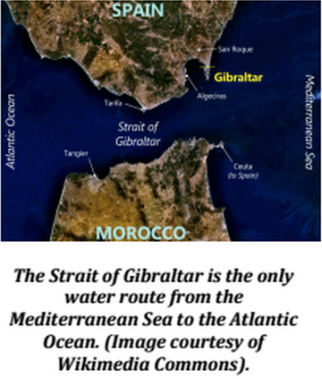

This increase in trade in Western Europe led to the creation of a new economic middle-class of merchants and skilled craftspeople. As trade and overall prosperity of the population grew, the need for the old ways of the feudal system faded away. Powerful kings no longer required the support of feudal lords for their wealth. The introduction of gunpowder to Europe from Asia led to the decline of the knight.

