The following readings are taken from a textbook.
Frey, Wendy, John Bergez, and Amy Joseph. History Alive!: The Ancient World. Palo Alto, CA: Teachers' Curriculum Institute, 2004. Print.

3. Government
The Han emperors made significant improvements in Chinese government. They adopted the centralized government established by Emperor Qin Shihuangdi. But they softened the harsh ruling style of the Qin emperor and brought Confucian ideas back into government.
Han emperors needed many government officials to help run the vast empire. The government of China during this time functioned as a bureaucracy. A bureaucracy is a large organization that operates using a fixed set of rules and conditions. At each level of the bureaucracy, people direct those who are at the level below them.
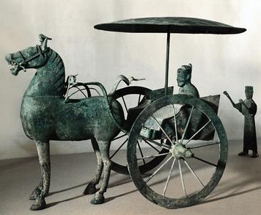
The highest-level Han officials lived in the capital and gave advice to the emperor. Lower-level officials lived throughout the empire. They had many responsibilities, including overseeing the maintenance of roads and canals. They also had to make sure that, in case of famine, enough grain was produced and stored.
One key improvement made by the Han concerned the way civil servants, or government workers, were hired. Before the Han dynasty, social status determined which government officials got jobs. The Han, however, based their choices on ability and knowledge. To become officials, young men had to pass a long, difficult civil service exam. It was based on the principles of classic Chinese writings. The candidates had to learn five books by heart. Legend says that the men then had to spend several days taking the exam in tiny rooms. All the while, they were watched by guards to prevent cheating.
Once hired, civil servants were not allowed to serve in their home districts. This rule was intended to prevent officials from giving special favors to friends and relatives. Every three years, civil servants could be promoted or demoted depending upon an evaluation of their work.

6. Art
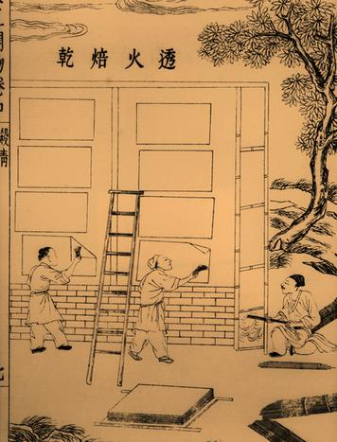
During the Han dynasty, a key advance was made in art—the invention of paper. Paper was the ideal material for calligraphy, which is the art of fine handwriting. Calligraphy was important in Chinese culture. It was a style of writing especially valued for its natural flow, as if inspired by nature.
Chinese scribes used some of the same tools and techniques as painters did. They wrote their characters by painting them with a brush and ink. Characters were created by one or more strokes, drawn quickly in a particular order. The ideal stroke created both delicate and bold lines. Paper was perfect for this art because of the way it absorbed the ink…

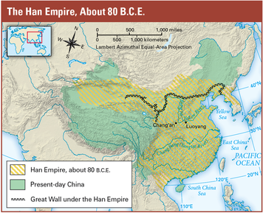
2. Warfare
The Han excelled in warfare. Their military methods and new weapons helped them expand their dynasty. At its height, the Han dynasty reached west into Central Asia, east to present-day Korea, and south to present-day Vietnam.
The Han dynasty had a large and well-organized army. All men from about the ages of twenty-five to sixty had to serve two years in the army. Historians estimate that Han armies had 130,000 to 300,000 men.
The army was helped by new technologies. Advances in iron making improved the strength and quality of armor. Han ironworkers produced a kind of fish-scale armor that flexed and moved with the body. The Han were among the first people to make iron swords. The strength of iron allowed skilled workers to fashion longer swords. With a long sword, a soldier could swing at an enemy from a safer distance.
Another favorite weapon of the Han was the crossbow. A crossbow is made of two pieces of wood in the shape of a cross. A string is attached to each end of the horizontal piece of wood. When that string is pulled back and released, an arrow is shot from the crossbow…

4. Agriculture
Farmers in ancient China faced a number of difficulties. Several important advances made in agriculture during the Han dynasty improved their lives.
Han farmers were expected to grow enough food to feed their families and to help stock the shared granaries, or grain storehouses. In addition to growing crops, farmers had to make their own clothing, build their own homes, and give one month of unpaid labor to the government for building projects such as canals and roads. Hard as this life already was, floods and drought often destroyed crops, presenting farmers with yet another challenge.
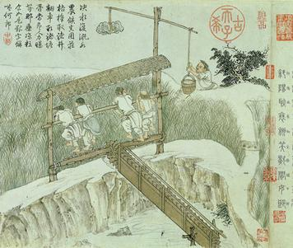
One invention that helped farmers was the chain pump. The chain pump made it easier to move water from low irrigation ditches and canals up to the fields. Workers used pedals to turn a wheel, which pulled a series of wooden planks that moved water uphill to the fields.
The Han skill in ironwork also came to the farmers’ aid. The Chinese were the first to learn how to pour melted iron into molds. This process enabled them to make strong iron plows. Han plows were designed to push the dirt away from the row being plowed so that the soil would not pile up in front of the plow.
The Han also invented the wheelbarrow. The Chinese wheelbarrow had one large wheel in the center. Goods were carried on either side of the wheel. It was much easier for farmers to push a heavy load in a wheelbarrow than to carry it on their backs or in buckets suspended from a pole across their shoulders.

