Rome Supplemental Reading

Rise of the Roman Republic 509 BCE to 100 BCE

Society in Rome was divided into two groups: citizens and non-citizens. Women and slaves were not citizens.

Most Roman citizens were plebeians. They were farmers, traders and craftsmen.

A few noble families were patricians. They owned large farms and plebeians worked the land for them.

These two groups decided to work together to improve Rome’s government. It was called a republic. And it lasted for almost 500 years.

The language of ancient Rome was Latin. This is the language from which the romantic languages are formed: Spanish, Italian, French, Portuguese, and Romanian. Many English words come from Latin root words.

Unlike Greece, Rome didn’t have a democracy where everyone participated in the government. Rome had representatives who acted on their behalf. This is similar to the government of the United States.

There were three branches of government: Senate, Tribunes, Consuls

The oldest branch was the Senate. The Senate was made up of patricians. It controlled foreign affairs and controlled all money collected and spent. There were about 300 Senators.

Plebeians formed a citizen assembly and they chose Tribunes as their representatives. There were about 10 tribunes.

Consuls heard plebeian complaints and made sure plebeians got fair trials. Each year two men were elected consuls. They were the army commanders and the most powerful judges. They could propose new laws or order anyone to be arrested. Consuls’ actions could be vetoed by the citizen assembly.

The Twelve Tables were wooden tablets that contained written laws that were published in the forum. This way, the patricians couldn’t interpret the laws in their favor. Laws covered things like marriage, debt collection and slavery.

The Expansion of the Republic 509 BCE to 14 CE

Historians generally classify Roman expansion into four phases:
Conquest of Italian Peninsula 509 BCE to 264 BCE
Punic War Expansion 264 BCE to 146 BCE
Expansion during Republic’s final years 145 BCE to 44 BCE
From a Republic to an Empire 44 BCE to 14 CE

1. Conquest of the Italian Peninsula 509 BCE to 264 BCE
Romans were constantly on the defense against neighbors like the Gauls (from the North) who wanted their fertile lands. They were also constantly fighting neighbors whose lands they wanted to steal. Some of these conquered people were able to become citizens as long as they paid Roman taxes and provided soldiers for the Roman army. Rome had a very large standing army that defended the city and surrounding lands. By 264 BCE, the Romans controlled almost the entire Italian peninsula.

2. Expansion during the Punic Wars 264 BCE to 146 BCE
One of the unfriendly neighbors to Rome was Carthage. Carthage was a city in Northern Africa who wanted control of the Mediterranean, just like the Romans. This desire led to three big battles between Rome and Carthage called the Punic Wars.

*1st: 20 years of fighting resulted in Carthage giving Rome the island of Sicily.
Rome seized more lands than agreed upon, and Carthage was outraged!

*2nd: Hannibal seeks revenge in a way no one had ever tried before! He marched from
Spain to Rome with an army of 90,000 men AND elephants! Romans had never seen an elephant before. They had crossed the Alps and braved landslides and snowstorms. But he wasn’t able to finish his attack because Rome had gone to Carthage to attack and Hannibal was forced to return to help defend his city. He was defeated and that ended the second Punic War. Carthage had to give up Spain, and pay a lot in fines.

*3rd Rome burned Carthage to the ground. It killed many people, sold many into slavery and some say they put salt in the soil of Carthage as they left so no crops would grow.
Rome had officially become the most powerful empire in the Mediterranean.

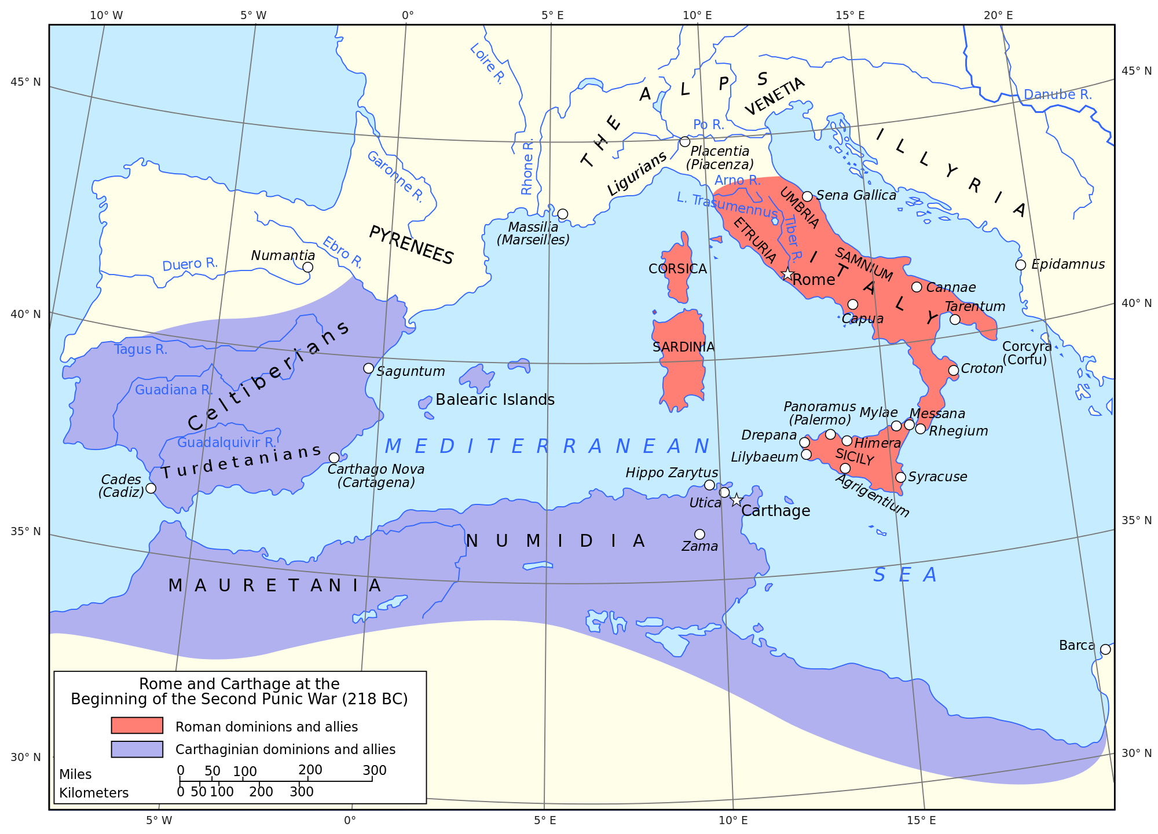
https://en.wikipedia.org/wiki/Roman_Republic

3. Expansion during the final years of the republic 145 BCE to 44 BCE
While their conquests had expanded their realm and made the city of Rome very rich, it also put the ideals of the republic under great strain. In addition to constant slave revolts, farmers and laborers were out of jobs. Rome was turning into a mob, and a mob needed to be ruled by one person, it seemed. Julius Caesar became the man for the job and he had many accomplishments. He put people back to work by starting projects like new roads and public buildings. He staged gladiator contests that people could watch for free to keep themselves occupied. He offered free grain to the poor and adopted a new calendar. He even offered citizenship to non Romans and started more new colonies. Some Senators thought he was becoming too powerful, and to save Rome, they staged a plot to kill Caesar. On March 15, 44BCE (Beware the Ides of March) Caesar was stabbed to death on the floor of the Senate. Power would never return to the Senate, and Rome’s time as a republic was over.

4. Rome transitions from a republic to an empire 44BCE to 14CE
After Caesar’s death, civil war engulfed Rome for over ten years. Caesar’s grand-nephew and adopted son, Octavian, became the sole ruler of Rome. His rule was challenged often, particularly by a man named Marc Antony who was a popular general. Antony had married Queen Cleopatra of Egypt. After their defeat, Octavian became the supreme ruler of the Mediterranean region. He was called Augustus, which means “honored”, and he was Rome’s first emperor.

Caesar Augustus encouraged education, art and literature. He repaired temples and started construction projects in the city. Rome got a police force, fire fighters and a library. Trade was improved by the building of harbors, canals and roads. Romans made trade easier by establishing a standard form of currency and trade goods came in from places as far away as China. And to protect himself, he established a private army called the Praetorian Guard. Under Rome’s control, the region was at peace for almost 200 years. This is called the “Pax Romana”, or Roman Peace.

Accomplishments of the Roman Empire 100 BCE to 14 CE

By this time, there were almost a million people living in Rome. Under this period called the Pax Romana, Romans enjoyed things like police and fire protection. They also had beautiful marble temples and government buildings. They had theatres and public baths that even had heated floors. Fresh water came to the city in aqueducts. Laws were strict and taxes were heavy. Every five years Rome took a census, which is a count of people living in the empire. To ensure laws were enforced and roads were safe, Rome stationed army units far and wide across the empire. Most of these soldiers were not citizens, they were paid to serve in the army full time, and for many men, this was their best chance to earn a decent living.

If there were two words to describe the success of Rome during this time, they would be TRAVEL and TRADE. There were over 50,000 miles of roads! Merchants and travelers felt safe moving around the empire since the army guarded against bandits, so trade flourished across the empire. Frequent items that were traded were wine, dried fish, Spanish silver and Egyptian linen. There was even a system of messaging like the pony express. Every eight miles, riders would change horses so they could deliver messages quickly.

To honor their gods and goddesses (and entertain the masses) in Rome, the Pantheon and Colosseum were built and held gladiatorial games, where fighters matched against animals like lions and bears, or other fighters. A fan favorite was always the chariot races. The Colosseum even had waterways so it could be flooded to reenact naval battles. But as Christianity continued to spread throughout the empire, the games and these temples meant to honor Roman gods and goddesses were no longer encouraged.

Decline of the Roman Empire

The Pax Romana couldn’t last forever with an empire as large and powerful as Rome. Large armies started to invade from the north. This weakened the army and made trade more risky. Pirates and thieves waited on roads and coasts to ransack merchant’s goods. Collecting taxes became too difficult because of the vast area they had to cover, and Rome couldn’t pay their bills. Some soldiers deserted because they weren’t getting paid, which made raids and thievery even more possible.

There was an emperor in 284 CE who realized the empire was simply too big to be ruled by one man. His name was Diocletian (di uh KLEE shun) and he divided the Roman Empire into two parts. Three assistants ruled the troubled western empire (which included the capital city of Rome) and Diocletian was head of the eastern empire (Greece, Egypt and Palestine). This marked the first time the city of Rome was not the most important part of the empire. Power began shifting to the east.

In 306, Constantine became emperor. Although he reunited the empire into one, he focused mainly on the eastern half of the empire, and his base was on an ancient Greek colony called Byzantium. He renamed the capital Constantinople (after himself, of course). This city still exists today as Istanbul, Turkey. It was the perfect place for a capital. It was surrounded by water on three sides, making it easier to protect. It was on major trade routes, and it was far away from Rome with all of its traditions and government. Constantinople not only had temples to many gods and goddesses, but it also had Christian churches.

Although the western empire eventually fell and collapsed by 476 CE, the eastern part of the empire continued on as Byzantium for another 1,000 years.

Adapted by Cindy Wright in part from:
Banks, James A. Adventures in Time and Place. McGraw Hill, New York, NY, 1997. Frey, Wendy, John Gergez and Amy Joseph, History Alive! The Ancient World. Palo Alto, CA. Teachers’ Curriculum Insititute, 2004.
WorldBook ebook, Ancient Romans, 2013.

