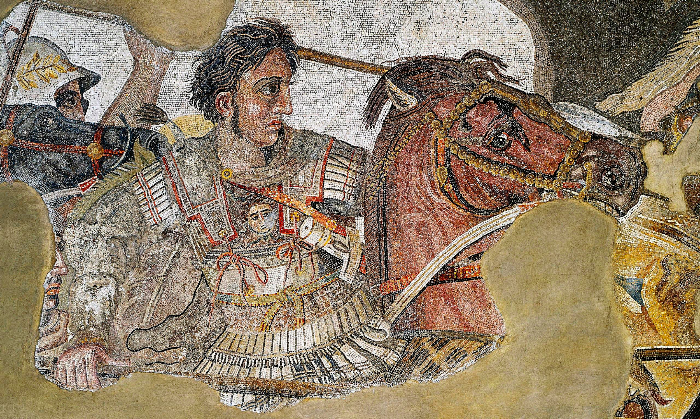
Alexander the Great

Alexander the Great became King of Macedonia when his father was assassinated in 336 BCE.

Macedonia is the northern part of Greece.
https://en.wikipedia.org/wiki/Alexander_the_Great

King Philip had conquered most of the Greek peninsula, which was weak after the Peloponnesian Wars. After his assassination in 336 BCE, the Greeks thought they could rebel since the heir, Alexander, was a mere boy. Alexander proved them wrong by capturing the city of Thebes as a warning to others. Then he captured Persia, a longtime enemy of Greece and the mightiest empire in the world. He embraced the Persians into his army and even married the daughter of a Persian King.

He quickly assembled a large empire reaching all the way to India. In 332 BCE, he went to Egypt to rest his troops. The Egyptians welcomed him since he had freed them from the harsh rule of the Persians. They crowned him Pharaoh and declared him a god.

His troops were very trained and organized. He was admired by his troops for his courage. Instead of sitting behind the lines in safety like most other military leaders, Alexander was the leader at the front of the lines, sharing the dangers of fighting and it inspired his troops!

In his thirteen years as leader, he had created a huge empire. But when he was only 33 years old, he fell ill from a fever and died. His empire quickly crumbled, and his mother, wives and children were all killed in the violence after his death. Eventually, his empire was divided among his generals into three parts.

He is considered to be “great” not because of his accomplishments on the battlefield, but because he spread Greek ideas and their love of learning through the empire. He founded the great city of Alexandria, which was a center for learning and culture in Egypt. There was a large library there that told of Greek culture and knowledge. This became important because when Greece later fell to barbarians who couldn’t read or write, much of their history was lost.

This document was adapted in part from World Book ebook, Ancient Greeks.

