Student Reading: Athens and Sparta

Government

Athens became a democracy around 500 BCE. Athens allowed only free men to be citizens. Women, slaves and men not born in Athens were not permitted citizenship. Men had to be over the age of 18 to be citizens. Each citizen could take part in the city’s government, which is why they call it a democracy, because a democracy is a government ruled by many. Citizens would gather on a hill every 10 days to make up the Assembly of Athens. There had to be at least 6,000 citizens present for a meeting to take place. If they were short, more men would be rounded up to attend. Every person had the right to speak at Assembly meetings. Some speakers were more skilled and spoke longer. Sometimes they would use a water clock to time speakers. A cup filled with water had a small hole in the bottom, and it drained into a cup below. When the water was empty, the speaker had to be finished. Athenian men were very proud to be a part of their democratic government.

Sparta was different from Athens. They had an oligarchy, where the ruling power belonged to just a few people. They had an Assembly like Athens. Their Assembly met to vote “yes” or “no” to laws proposed. All members had to be males. They didn’t do much debating or discussing. The real power in government was held by a small group called the Council of Elders. The Council was made up of two kings, who inherited their powers, and then 28 other men who were elected. To be elected, you had to be 60 years old and be from a noble family. Once elected, you served for life. The Council prepared laws for the Assembly to be voted on, and they could stop laws the Assembly passed if they wanted to.

Economy
The economy of any group is the way in which they organize the making and exchange of things like money, food, and goods and services.

Athenian economy was heavily based on trade because the land around Athens didn’t provide enough food for all the people. Athens was near the sea, and it had a good harbor, so Athenians were able to trade with nearby city-states and other foreign lands to get the things they needed. Wood came from Italy and grain came from Egypt. Athenians traded honey, olive oil, silver and beautifully painted pottery.

Within Athens, they had a huge marketplace called the agora. Athenians bought and sold things like lettuce, onions, olive oil, lamps, pottery, furniture, leather sandals, and jewelry. The agora was also the place where slaves were bought and sold. Athens had their own coins made to make trade easier. They were mostly gold, silver and bronze.
Here are some coins that have been found from Ancient Greece.
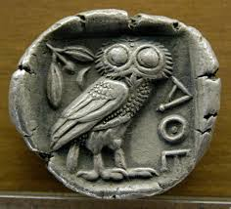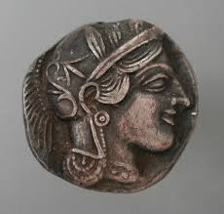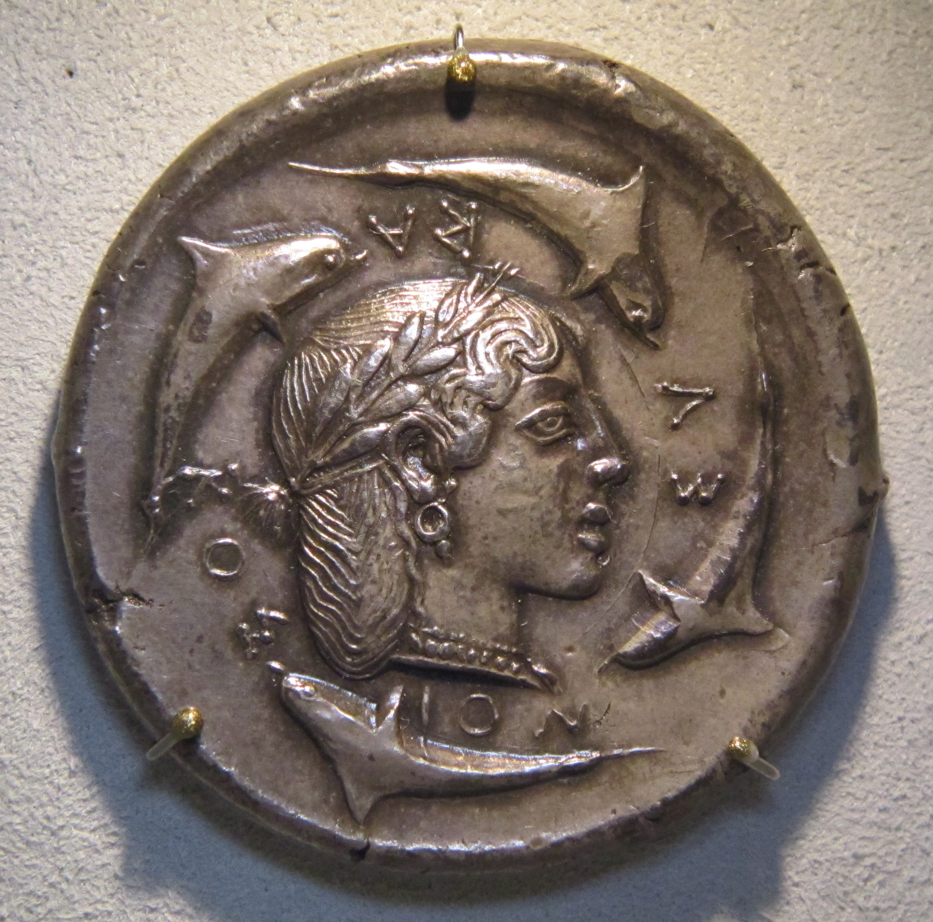https://en.wikipedia.org/wiki/Ancient_Greek_coinage

Spartan economy was very different from Athenian economy. Sparta’s economy relied on farming and conquests of other people. They had fertile soil for farming, but that still didn’t provide enough food, so when necessary, they took lands from their neighbors. These neighbors had to then work to produce food and goods. Because Spartan men had to be in the army until the age of 60, they relied on these slaves and noncitizens to produce enough food.

People Sparta conquered often became slaves, called helots. They were allowed to live in their own villages, but they had to give food to Sparta. It is estimated that helots outnumbered Spartan citizens 8 to 1. Helot revolts were dealt with harshly.
While helots produced food, free non-citizens produced things like shoes, iron tools, pottery and red cloaks for the soldiers.

Sparta discouraged trade. They thought contact with other city-states would lead to new ideas that would weaken their government. Spartans didn’t have coins. They used heavy iron bars for money. Legend has it they used these bars to discourage stealing. And other city-states were not very excited to get a heavy iron bar as payment.

Education
To run a successful democracy, Athens had to have well-prepared citizens. To have well-prepared citizens, they had to be educated. And because only boys participated in democracy, education was very different for boys and girls. Boys were taught at home until the age of 6 or 7. Then they went to school until the age of 14. They learned reading, writing, arithmetic, and literature. Books were too rare and expensive so they had to read out loud and memorize everything. They also learned wrestling, gymnastics, and music such as singing and the lyre. Athenian men began military training at 18. After their military service, wealthy men might study debating and public speaking in order to participate in the Assembly.

Athenian girls most often didn’t learn to read or write. They were taught to cook, clean, spin thread and weave cloth. They often learned secret songs and dances to perform at religious festivals. Girls usually married around the age of 15, often to a man chosen by her father.

Education in Sparta was quite different than Athens. The purpose of education in Sparta was not to participate in government, but rather to produce capable fighters. This began at birth, where legend tells us that Spartan babies were examined at birth and if they were not fit to become a soldier, they would be abandoned on a cliff to die. At the age of 7, all children began training for battle. Even girls learned wrestling, boxing, footracing and gymnastics. Boys were taken from their homes at the age of 7 and lived in barracks, where they received their training. This system is called the agoge (pronounced “uh goj”). Here they were taught to endure intense training and physical pain, including marching with no shoes and often being underfed. They excelled at hand to hand combat. If they passed a test at the age of 20, they became citizens and soldiers. They could not live at home with their wife and family until they were 30, and they would not retire from the army until they were 60 years old.

Women and Treatment of Slaves
Athenian women could not be citizens, and they couldn’t inherit or own much property. They couldn’t vote or attend the Assembly, and most didn’t choose their own husbands. Women could never go out alone. Some women, however, did hold jobs. They sold goods in the market and some were priestesses. Their influence came from their homes, where they managed households, raised children, and supervised slaves. They taught sons until the ages of 6 or 7 and daughters until they were 15 and ready to be married.

Most Athenians owned at least one slave. Some slaves were born into slavery, but many were forced into slavery as captives of war. Most slaves were quite skilled, often teaching children, running households, being artisans and some were even clerks in the city. Unfortunately though, many slaves had to work in silver mines for up to ten hours a day. Silver mines were 300 feet below the surface, and it was hard to breathe there.

Spartan women were different than Athenian women. They wore plain clothing with no jewelry, cosmetics or perfume. They were expected to be strong and healthy, mostly to bear strong children, but also to be ready to fight if need be. While her husband was away, she had to guard his property and protect it against slave revolts. Women in Sparta had many rights that Athenian women did not. They were able to talk to their husband’s friends and they could even own and control their own property. They were allowed to remarry if their husband was off at war for too long a time.

Spartan slaves were called helots. They were treated very harshly so they wouldn’t be tempted to revolt. One story tells that the government in Sparta asked the helots to choose their best fighters, and they would be set free as thanks for fighting for Sparta. Two thousand men were chosen. The Spartans killed every one of them to eliminate the chance of any future helot leaders. But despite this harsh treatment, helots did have some rights. They could marry whomever and whenever they wanted and they could pass their names onto their children. They could also sell leftover crops and keep the money. Helots who saved enough money could buy their freedom, although that didn’t happen often.

This reading has been adapted by Cindy Wright in part from History Alive!: The Ancient World, Teachers’ Curriculum Institute, 2004 as well as Banks, James A. Adventures in Time and Place. McGraw Hill, New York, NY, 1997.

