Problem
Use fossil evidence to infer when and how Pangaea drifted apart.

Introduction
Imagine that the five continents of South America, Africa, Antarctica, Australia, and India are each represented by a stack of sedimentary rocks on five lab tables. The continents are in their natural geographical shape and their sizes are proportional. The blue, top layer, represents modern times, and the pictures of the modern animals you see are native to the continent. The three lower layers depict sedimentary rocks of three past ages:
- Green rock samples—Late in the Age of Dinosaurs 100 mya
- Yellow rock samples— Early in the Age of Dinosaurs 200 mya
- Red rock samples—The Coal Age 300 mya
Materials
- Sedimentary rock samples (continent cutouts) from South America, Africa, Antarctica, Australia and India
- Fossil Catalog (one at each station)
Procedure
- In your group, proceed to the station designated by your teacher.
- On your data sheet, record the names of the fossils you find in the rock on the continent at your station.
- Also, record the names of the animals now living on the present day continents.
- At the teacher’s signal, rotate to the next station and repeat data collection.

Data
 | South America | Africa | India | Australia | Antarctica
Present Day (blue)

100 mya (green)

200 mya
(yellow)

300 mya (red)

Analysis and Conclusions

- On the basis of what you found in the red rocks,
  - which continetns has similar fossils?
  - from this fossil evidence, which continents seem to have been connected 300 mya?
- On the basis of what you found in the yellow rocks,
  - which continetns has similar fossils?
  - from this fossil evidence, what can you infer about the connections of the five continents 200 mya?
- On the basis of what you found in the bgreen rocks,
  - which continetns has similar fossils?
  - from this fossil evidence, which continents seem to have been connected 100 million years ago?
- Refer to the continent cutous and Southern Hemisphere pages to complete this question.
  - Arrange the cutouts of the continents according to where you think they were situation during each of the three past ages. Arrange them also as they appear in the present.
  - Explain your resaons for putting the continents together as you did for each time period.
300 mya

200 mya

100 mya
- Look at the black arrow on the red rocks of the continents. The arrows represent grooves in the rock. The grooves were carved by advancing continental glaciers about 300 mya. The arrows point in the direction the glaciers were moving.
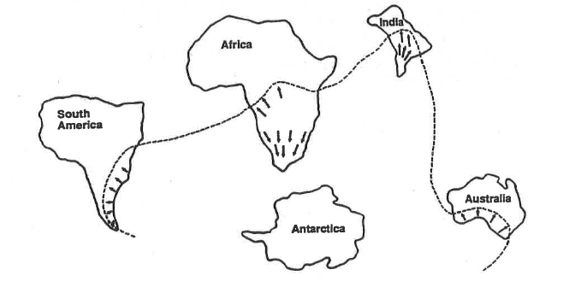
  - Suppose you were the first person to have found the glacial grooves in south-eastern South America. From where would it seem the glacier came?
    - Could the glacier have come from the ocean? Explain your answer?
  - Why would the geologist who first found the glacial grooves in India be puzzled by the discovery?
  - How might the idea of continetal drift explain 300-million-year-old glacialgrooves on four separate southern continents?
  - Where was the probable spreading center of the glaciers? Make an “X” to mark this location on the map above. Where on the surface of the earth was the probably location of the “X” 300 mya? (Remember that a continental glacier tends to move out and away from its center, the North or South Pole – like a spreading mass of break dough.)
  - Where would you look for glacial grooves in the 300 million year old rock of Antarctica? Draw arrows where you would expect to find glacial grooves in the Antarctica on the map above.
- Two species of living earthworms in the soils of southern South American and Africa were found to be very closely related (members of the same genus). Also, two species of living earthworms in soils of southern India and southern Australia were found to be very closely related (members of the same genus), How was the theory of continental drift strengthened by discoveries of closel related earthworms on widely separated continents?
- Examine the mammals pictured on the continents of South America, Africa, India and
Australia. These living animals are native on their continents. Each eats insects, and is a major ant/termite eater among all the mammals there. Each species belongs to a different order of mammals. These four mammals are vary distantly related, even though each is highly specialized for eating ants and/or termites.
Explain in terms of continental drift and evolution how four different kinds of ant/termite eaters could occur in Inda, Africa, South America and Australia. (Remember, the Age of Mammals began on earth after Dinosaurs became extinct about 65 mya.)
- List as many pieces of evidence as you can to support the theory of continental drift.
- Why do you think it is so difficult for some people to accept the idea of continental drift?

