Ms. Sullivan’s Daily Schedule

12:00 - 12:30 Arrival/Handwashing/Lunch
12:30 - 12:35 GoNoodle (movement)
12:35 - 12:50 Large Group
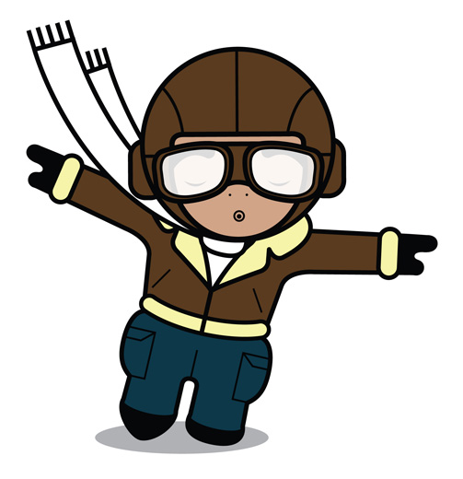
12:50 - 1:10 Small Group
1:15 - 1:45 Outside Recess
1:50 - 2:50 Work Time/Play Time
2:50 - 2:55 Clean Up
2:55 – 3:05 Storytime
3:05 – Snack
3:20 – Pack Bags
3:30 - Dismissal

