Summer 2015
Family Activities & Resource Guide

Community Events

Jazz in June Market
Every Tuesday in June/ Market 5:00pm to 7:00pm/ Concert 7:00pm to 9:00pm
12th & R Streets on the University of Nebraska–Lincoln City Campus
- Bring a blanket or a lawn chair for relaxing! This event is free!
Visit http://www.jazzinjune.com or call (402) 472-2461 for more information!

Stransky Park Concert Series
Thursday Nights/ May 14th through July 30th/ 7:00pm
Stransky Park, 17th & Harrison
- Enjoy free live music! This event is free!
Visit http://www.kzum.org/ for concert schedule!

Lincoln Community Foundation Garden Performance Series
Every Wednesday May 6th through August 26th/ 12:00pm
1415 N Street
- Enjoy free live music! This event is free!
Visit http://www.artsincorporated.org or call (402) 433-6902 for more information!

Lincoln Haymarket Farmers Market

Every Saturday May 2nd through October 10th/ 8:00am to 12:00pm

7th & P Streets
- Fresh produce, entertainment, shopping, and more! This event is free!

Visit http://www.lincolnhaymarket.org or call (402) 435-7496 for more information!

F Street Farmers Market
Every Tuesday May 5th through October 6th/ 4:00pm to 7:00pm
1302 F Street
- Kids activities, live music and dinner available for purchase. EBT accepted. This event is free!
Visit http://food.unl.edu/localfoods/fmcsa or call (402) 802-2918 for more information!

Old Cheney Farmers Market

Every Sunday April 26th through October 25th/ 10:00am to 2:00pm

Old Cheney Center, 55th and Old Cheney Road
- Fresh local produce, artisan cheeses, baked goods, natural meats, eggs, plants, and more! Customers wishing to shop with their SNAP benefits can simply stop by the information booth and request the amount they'd like to spend and receive tokens as a market currency to spend with vendors! This event is free!

Visit http://oldcheneyroadfarmersmarket.com/ or call (402) 309-9096 for more information!

Fallbrook Farmers Market

Every Thursday May 15th through September 25th/ 4:30pm to 8:00pm
- Fallbrook Town Center, Hwy 34 and Fallbrook Blvd
Fresh, seasonal produce, farm-raised meats and eggs, farmstead cheeses, breads, and pastries. Live music, family-friendly events, and hand-crafted and artisanal products! This event is free!

Visit http://www.fallbrookfarmersmarket.com/ or call (402) 309-9096 for more information!

Juggling Festival
Jun 5th through June 7th/ Friday 5:00pm to 12:00am; Saturday 9:00am to 5:00pm & 7:00pm to 9:00pm; Sunday 9:00am to 3:00pm
Abbott Sports Complex, 7600 North 70th Street
- Juggling and variety acts. The public is welcome anytime during the festival to come and watch, learn, or join in with all the juggling. A special time to stop by is Saturday 1:00pm to 5:00pm during the juggling games. This event is free!
Visit www.underthecouch.com/flatland or call (402) 429-0099 for more information!

Bike to the Ballpark
Jun 7th/ 1:05pm
Haymarket Park 403 Line Dr Cir
- The Nebraska Colon Cancer Screening Program and the Lincoln Saltdogs will be hosting the 2nd Annual Bike to the Ballpark Event/Colon Cancer Awareness Day. This event is geared towards promoting an active, healthy lifestyle within the community by encouraging patrons to bike to Haymarket Park. Whether you ride as a family, meet up with friends or hit the trail on your own, we encourage you to join in the festivities! Discounted game tickets will be available to riders who purchase in advance at www.saltdogs.com/b2tb and the first 1000 fans will receive a free water bottle!
Visit www.saltdogs.com or call (402) 474-2255 for more information!
$5 per ticket

Celebrate Lincoln
June 5th & June 6th/ Friday 5:00pm to 11:30pm & Saturday 11:00am to 11:30pm
Pinnacle Bank Arena's Festival Space, North of Pinnacle Bank Arena
- The Family Zone will include great kid’s activities such as inflatable’s, The String Beans, spin art, face painting and more! Concerts will take place in the evenings and food and drink vendors available.
Friday $10; Saturday is Free from 11:00am to 5:00pm; Saturday $10 from 5:00pm to 11:30pm
Visit http://www.pinnaclebankarena.com/events/detail/celebrate-lincoln or call (402) 904-4444 for more information!

Hop, SCIP, Jump to the Golden Ticket
June 6th/ 9:00am to 12:00pm
Haymarket Park, 403 Line Drive Circle
- Children will hop, skip, and jump their way around Haymarket Park, participating in fun, healthy activities. At the end of the route, each child will choose a candy bar indicating a prize. Each child will win a prize and one child will win a grand prize "Golden Ticket!"
For more information visit www.lmep.com/scip.aspx or call (402) 327-6851!
$6 per Child

Juneteenth
June 20th/ 11:00am to 5:00pm
Trago Park, 22nd & U Streets
- Join the Malone Community Center for live entertainment, a special Kids’ Corner with bouncy houses, a Health & Human services fair from 11:00am to 2:00pm, with all types of information on healthy living and lifestyles along with health screenings. Juneteenth commemorates the 1863 signing by President Abraham Lincoln of the Emancipation Proclamation that ended slavery. This event is free!
Visit http://www.malonecenter.org/ or call (402) 474-1110 for more information!

Archie’s Late Night Party
June 25th/ 6:00pm to 10:00pm
Morrill Hall, 645 North 14th Street
- Identify constellations you can see from your own backyard, Lincoln City Libraries will lead bedtime stories in the Museum (be sure to wear your pajamas!) Take a short walk to the UNL Student Observatory to look at the night sky through telescopes, Learn about animals in your neighborhood that come out to play once the sun goes down, Grab a snack in the "Whole Foods Snack Shack" and pose for a picture in the Emerald Isle Productions
Visit http://museum.unl.edu/latenightparty/index.html or call (402) 472-2642 for more information!

Regular Museum Admission

Family Activities

Lincoln City Libraries Summer Reading Program
May 22nd through July 31st
All library locations
- Events at all Lincoln libraries throughout the summer to keep children interested in reading!
Visit http://www.lincolnlibraries.org/kids/summerreading2015.pdf or call (402) 441-8510 for the summer reading schedule at all library branches!

Kids Bowl Free
This program allows registered kids to receive 2 free games of bowling daily all summer long!

Sun Valley Lanes | May 26 to Aug 8
Parkway Lanes | May 1 to Aug 31
Hollywood Bowl | May 1 to Aug 31
Champions Fun Center | April 16 to Aug 31

- Choose a bowling location above. Make sure that you call or check on the website of the location that you choose to find out the specific days and times that the Kids Bowl Free program runs! Then register directly on the bowling center page. Once you register, you will have the opportunity to purchase the family pass! The Family Pass was created to allow for adult family members to enjoy bowling throughout the summer as well! The Family Pass starts from $24.95 and includes 2 GAMES PER PERSON PER DAY. The Family Pass covers up to 4 adult family members. You may have 1, 2, 3, or 4 adults on the family pass. The whole family will be able to bowl together!
Visit http://www.kidsbowlfree.com/ or call a bowling alley above for more information!

Pioneers Park Nature Center
Monday through Saturday 8:30am - 5pm/ Sunday 12:00pm to 5:00pm
3201 South Coddington, West end of Pioneers Park
- Visit buildings that house hands-on and small animal exhibits. The Edna Shield’s natural play area for Children provides a place for kids to dig, build and climb. Prairie, bird, children’s and herb gardens with many labeled specimens are both beautiful and instructive. Admission is free, suggested donations $3/person, $5/family or $10/group
Visit http://lincoln.ne.gov/city/parks/naturecenter/index.htm or call (402)-441-7895 for more information.

Trago Park Sprayground
May 25th through September 7th/ 11:00am to 7:00 pm
North 22nd & U Streets
Cool off on a hot day!

Hyde Observatory
Saturdays April through October/ 8:00pm to 11:00pm
South side of Holmes Lake in Holmes Park
- Gaze at the night sky through three powerful telescopes, enjoy two programs about astronomy or space exploration that change monthly, and interact with knowledgeable volunteers.
For more information check out http://lincoln.ne.gov/city/parks/parksfacilities/hyde/index.htm

Lincoln Public Pools
Opening May 23rd

Arnold Heights Pool | 4000 NW 46th | 402 441-7829
Ballard Pool | 3901 N 66th | 402 441-7898
Belmont Pool | 12th & Manatt | 402 441-7826
Eden Pool | 4400 Antelope Creek | 402 441-7827
Highlands  Aquatic Center | 5511 NW 12th | 402 441-7800
Irvingdale Pool | 1900 Van Dorn | 402 441-7828
Star City Shores  Aquatic Center | 4375 S. 33rd Ct. | 402 441-6670
University Place  Aquatic Center | 2000 N 48th | 402 441-7834
Woods Pool | 33rd & J | 402 441-7782

Call for information on applying for swim passes!
Visit https://lincoln.ne.gov/CITY/parks/ParksFacilities/pools/index.htm or call 441-7960 for more information!

Family Swim Night
May 25th to August 7th; 6:00pm to 8:00pm
Evening swims for $7/family. Locations vary on day.
Arnold: Tuesdays and Fridays
Ballard: Fridays
Belmont: Mondays
Eden: Mondays and Tuesdays
Irvingdale: Wednesdays and Fridays
Woods: Fridays*
*Except during scheduled swim meets, June 19, July 24, July 31.
Visit https://lincoln.ne.gov/CITY/parks/ParksFacilities/pools/index.htm or call 441-7960 for more information!
Lincoln YMCA
Camps, Swimming, gymnastics, art, music, martial arts, and more!
Visit http://www.ymcalincoln.org/ to check out what the YMCA has to offer!
Financial Assistance is available. Visit http://www.ymcalincoln.org/OpenDoors for information on completing an application for assistance!
Cooper YMCA Downtown YMCA
6767 South 14th Street 1039 P Street
323-6400 434-9230
Fallbrook YMCA Northeast YMCA
700 Penrose Drive, Suite B 2601 North 70th Street
  - 434-9262
Lincoln Children’s Zoo Camps
1222 S. 27th St
Preschool, ages 3-4 with a parent/adult, 9:30 to 11:30 a.m., $89 members ($104 nonmembers).
Half-day camps, ages 4-12, 8:30 a.m. to noon or 1 to 4:30 p.m., $108 members ($129 nonmembers).
Full-day camps, ages 4-12, 8:30 a.m. to 4:30 p.m., $218 members ($258 nonmembers).
Visit lincolnzoo.org or call 402-475-6741, Ext. 133 for camp themes, dates, information about zoo passes, and more!

Lincoln Parks & Recreation Crunch and Lunch
Monday through Friday, May 28th through August 7th (Mid-day Specific time TBD)
A free hour of active games/activities followed by lunch! Call (402) 441-4900 for more information.

Multiple locations daily:
- Ager Play Center, 1300 S. 27th St.
- Carol Yoakum Family Resource Center, 4621 N.W. 48th St.
- Belmont Community Center, 1234 Judson
- Calvert Community Center, 4500 Stockwell
- Everett Elementary School, 1123 "C" St.
- "F" Street Community Center, 1225 "F" St.
- UPCO Park, 40th and Adams streets.
Salvation Army Day Camp
2625 Potter Street
9:00 am - 5:00 pm
Dates have not been announced
For kids entering Kindergarten-5th grade in the fall
- Summer Day Camp is limited to 65 campers each session. Children are served breakfast, lunch and snack daily. Camp activities include summer education activities, recreation, sports, arts & crafts and exciting field trips.
$25 per Week

Salvation Army Moonbeam Camp
Friday, June 12th
Deadline for registration is Friday, May 29th
- A one day camp experience for children ages 3 to 5. Campers will experience many aspects of camp life including a nap in a cabin!
-Camp registration forms may be downloaded at http://www.usc.salvationarmy.org/lincoln
-Mail or drop off forms at The Salvation Army Corps
-For additional information, you can contact Theresa at 402-474-6263 ext. 509.

Lincoln Children’s Museum
1420 P Street
Think Factory
- Weekly themed camps for preschool and elementary ages. Learn how to use a microscope, make homemade pasta, throw paint-filled balloons, play a life-sized game of Clue, make movies and attempt to break world records.
Dates: June 1-5, 8-12, and 15-19, June 22-July 1, July 6-10, 13-17, 20-24 and Aug. 3-7.
Preschool Play Days, ages 3-5. 9:30 a.m. to 5 p.m. Tuition: $25 (nonmembers $30).
Elementary Camps, ages 6-10. 8 a.m. to 5 p.m. Tuition: $170 for elementary camps (nonmembers $195).
Visit http://www.lincolnchildrensmuseum.org or call 402-477-4000 for more information!

Music and Mozzarella
June 4th, 11th, 18th, & 25th/ 5:00pm preconcert show & pizza sales & 6:00pm live performance
- Lincoln Children’s Museum, Outdoor Museum Plaza, 1420 P Street
Four weeks of live music performances featuring popular children's bands from across the country, including two of Lincoln's in-demand bands: The String Beans and The Mighty Magic Pants. The event is presented as a way to give back to the community while introducing children to different styles of music to develop a sense of music appreciation. This event is free!

Kids Dream Summer Film Series
June 14th through August 12th, Sundays, Mondays & Wednesdays, 10:00am
Tickets: $3.00, Concessions Specials: $2.75 Popcorns and $2.75 Fountain Drinks
- View your favorite family flicks for just $3.00! Grab the family and head to your nearest participating Marcus Theatres® location! FREE tickets to the show? It’s easy – visit one of our participating agents at American Family Insurance, and you can receive two FREE tickets to your choice of this year’s titles!
For more information and movie schedule visit http://marcustheatres.com/Promotion/PromotionDetail/113/ or call (402) 441-0222!

Second Saturday Science
Morrill Hall, 645 North 14th Street

What’s the dirt on soil Pond Life
Saturday June 13th July 11th
10:00am to 12:00pm 10:00am to 12:00pm

Bubbles
Saturday August 8th
10:00am to 12:00pm

Visit http://museum.unl.edu/events/ or call (402) 472-2642 for more information
Free with regular museum admission

Resources
FOOD

Summer Food Service Program

2015 locations and times TBD

June to mid August

Free meals for children 2 to 18

Visit http://www.lincoln.ne.gov/city/health/educat/food.htm or call (402) 441-8000 for more information.

Foodnet Sites

Perishable foods, such as fruits and vegetables, dairy products, and bread.

Bring bags or boxes to carry food home.

Visit http://www.foodnetlincoln.org/index.php/foodnet-sites for schedule with location and times or cal (402) 416-6197 for more information!

Center for People in Need FOOD Program

3901 N 27th Street

Free food for families (income guidelines to qualify)

Visit http://centerforpeopleinneed.org/programs-services/neighborhood-food/ for income guidelines, site locations, and times or call (402) 476-4357 for more information!

F Street Community Center

1225 F Street

Free dinner Monday through Friday at 4:30pm

For children ages 2 to 18

Call (402) 441-7951 for more information!

Gathering Place

1448 E Street

Evening meal for homeless and near homeless individuals and families from 5:00pm to 6:00pm

Call (402) 476-7398 for more information!

Matt Talbot

2121 N 27th Street

Lunch served from 11:30am to 12:30pm and Dinner served from 5:30pm to 6:30pm 7 days a week

Call (402) 477-4116 for more information!

Utility/Rent

Community Action Partnership

210 O Street

(402) 471-4515

Assists families with rental and deposit assistance, LES assistance, and other utility assistance. For assistance call and leave voicemail. Contact early in the week.

Catholic Social Services

2241 O Street

(402) 474-1600

Assists families with utility bills and rent. Contact early in the week.

St Vincent de Paul

(402) 435-7968

Assists with utility bills and rent. Leave a message and call will be returned.

Salvation Army

2625 Potter Street

(402) 474-6263

Assists with utilities. Must apply with Health and Human Services Energy Assistance program first. Call for appointment.

Good Neighbor Center

2617 Y Street

(402) 477-4173

Assists with eviction notices and utility shut off notices.

Lincoln Electric System (LES)

(402) 475-4211

As soon as notice is received contact LES and reasonable arrangements can be made so service will not be disconnected.

Health

Clinic with a Heart
5:30 pm to 7:00 pm (you can sign in as early as 2:00 p.m., doors open at 4:00 p.m.)
1701 S. 17th Street, Lower Level
For schedule and more information visit http://www.clinicwithaheart.org/get_help or call (402) 421-2924

*You can use this as a resource to complete physical, dental, and vision exams before August 12th if you have children going to Kindergarten!

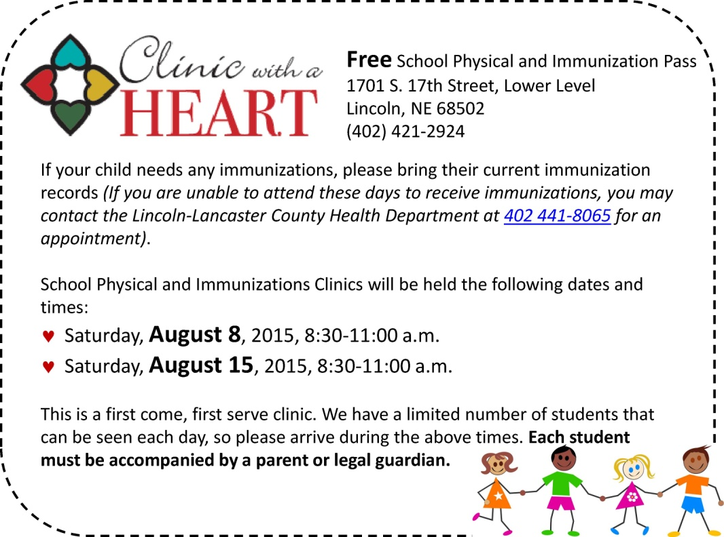

Peoples Health Center
1021 N 27th Street
(402) 476-1455
- Medicaid, Medicare, and private insurance accepted. Sliding fee program for patients without insurance (based on ability to pay)

Peoples City Mission Medical Clinic
110 Q Street
(402) 817-0980
- Medical, dental, optical, behavioral health services for low-income, uninsured residents.
To make an appointment, see a schedule and income guidelines call the clinic!

Health Hub at Center for People in Need
3901 North 27th
(402) 817-0808
- Advocates are available to help you find community resources to help meet healthcare needs including doctor/medical home, free or discounted medications, apply for programs such as Medicaid, see a medical specialist.

Fans
Center for People in Need
3901 North 27th
(402) 476-4357
- Neighborhood fan distribution during summer months.

Salvation Army
2625 Potter Street
(402) 474-6263
- 20 inch box fan once per year. June 1st to August 31st.

Indian Center
1100 Military Road
(402) 438-5231
- Summer fan distribution program

Other
Bike kitchen
1635 1st street
(402) 915-2453
- Provide bikes for children in need. Program available providing volunteer opportunities for adults that includes refurbishing and taking home a bike. Program provides a dependable bike, knowledge and skills!

YWCA Take a Break Program
2620 O Street
(402) 434-3494
Friday evenings from 6:30pm to 8:30pm
- A break to any parent or guardian of children six weeks through 10 years of age. The program facilitates opportunities for caregivers to recharge while their children are cared for in a safe, fun, and nurturing environment. The program is located at Grace Lutheran Church.

