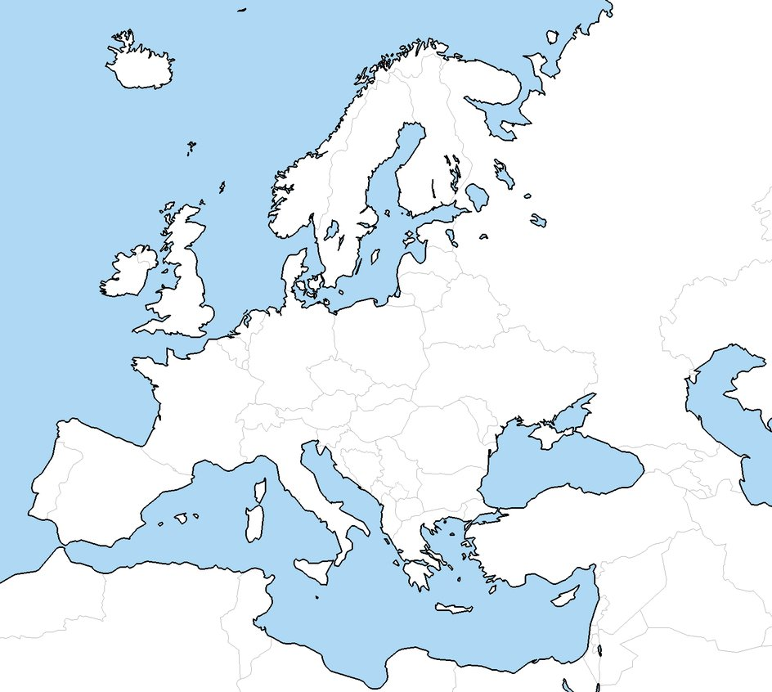

Allies Axis (Central) Powers

**Pre-WWII**

**Map**

NAME_______________________________________________ P.



Major

Events/

Places

MAP