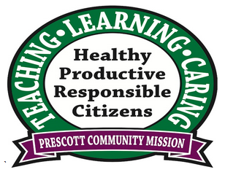
We are working on really knowing our single-digit multiplication facts. Please help your student by practicing these at home. We are working in our Units of Measure chapter right now. Students will be able to:
Science – We have started our Chemistry Unit. Students will be able to:
• Describe magnetic behavior in terms of attraction and repulsion.
• Identify physical properties of matter (color, odor, elasticity, weight, volume).
• Identify state changes caused by heating and cooling solids, liquids, and gases.
• Identify mixtures and pure substances.
• Use appropriate metric measurements to describe physical properties.
• Distinguish between physical and chemical changes (phase changes, dissolving, burning, rusting).

Don’t forget to explore our 5th grade team website: http://wp.lps.org/kriley/
“If there is no struggle, there is no progress.”
--Frederick Douglass

This Month in Science
September 2016

Prescott Team 5
  - Volume 2 Issue 2
And Now…
MATH
• Measure capacity and volume using customary units of measure
• Compare and convert length, weight, and capacity using customary and metric units of measure
• Measure mass using metric unit of measure

Later in November we will work with Data and Statistics. Students will be able to:
• Choose an appropriate graph to display data
• Compare sets of data using different graphs
• Generate questions and answers from data sets
• Represent data using line plots
• Represent the same set of data in different formats
• Draw conclusions based on a set of data

“When you get into a tight place and everything goes against you, till it seems as though you could not hang on a minute longer, never give up then, for that is just the place and time that the tide will turn.”

--Harriet Beecher Stowe

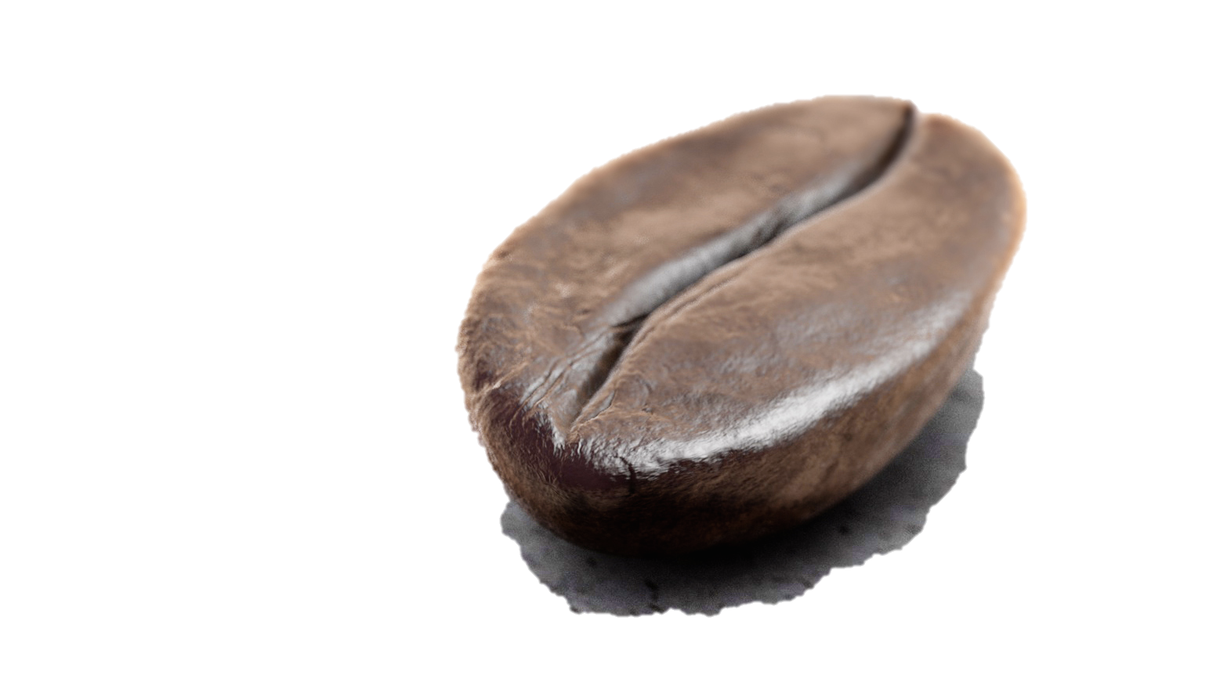
We will be researching different careers during the week of November 7th
Career Week is
November 14th-18th
Donec sit amet arcu.
We encourage you to read all handouts that come home with your student.

Your student will be bringing home homework nearly every day this year. This is a district requirement.

It is important for your student to do the work himself or herself but we encourage you to look it over, read it with them, and take an active role in their educational process. Remember: students should not spend more than about 1 hour on their homework. If your student is struggling with a particular area on the homework encourage them to give their best effort but don’t sit there and struggle. Move on to the other questions on the assignment and after an hour, call it good and ask your teacher about the problem the next day. Homework is vital practice of the skills we work on each day. If a student is struggling with a single problem, they aren’t practicing the skill. Stress is not the goal of homework; practice is.

The expectation is that students will do their homework each night and return it the next school day completed. However, we’re all parents as well as teachers and we understand that occasionally, things happen and there is no time for your student to complete his or her assignment. Do not sacrifice your child’s sleep or meal or opportunity to spend time with family for homework. If something comes up, write a note on the homework and sign it so that we know you saw the homework and that there was a legitimate reason it didn’t get done.

Our goal is not simply to get your student to pass 5th grade. Our goal is to give your student tools with which they can and will begin to build their future: Middle School, High School, College and the rest of life.

Homework!
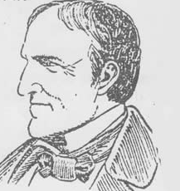
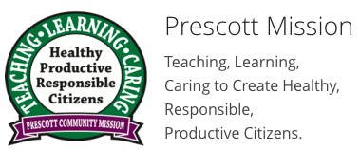
9:00-9:50 | Specials
9:55-11:00 | Math
11:00-11:10 | Word Work
11:10-12:00 | Unit Studies
12:00-12:45 | Recess & Lunch
12:45-1:15 | Intervention
1:15-1:55 | Whole Group Reading
1:55-2:05 | Physical Activity Break
2:05-2:55 | Guided Reading
2:55-3:35 | Writing

School Schedule:
“You’re braver than you believe, and stronger than you seem, and smarter than you think.” – Winnie the Pooh
1665 First edition of London Gazette published
1733 France & Spain sign the Treaty of Escorial
1805 Lewis and Clark sight the Pacific Ocean
1848 Zachary Taylor elected 12th President of United States
1874 First time a cartoon showing an elephant as the symbol of the Republican Party
1885 Canadian Pacific Railway is completed
1907 Delta Sigma Pi fraternity is founded at New York University
1914 The first issue of The New Republic magazine published
1929 New York City Museum of Modern Art opens
1932 First broadcast of “Buck Rogers in the 25th Century” on radio
1942 President Franklin Roosevelt becomes first US President to broadcast in a foreign language (speech was broadcast in French)
1954 Cleveland Browns defeat Washington 62 to 3 setting record for largest margin of victory
1967 President Lyndon Johnson signs a bill establishing the Corporation for Public Broadcasting
1973 New Jersey becomes the first state to allow girls to play little league
1985 The shuttle Challenger landed safely at Edwards Air Force Base after a weeklong scientific mission that was chartered and controlled by West Germany.
1991 Magic Johnson retires from the NBA (LA Lakers)
2000 Hillary Clinton elected to US Senate—becomes first person to win election to a public office currently US First Lady
2015 Sierra Leone is declared free of Ebola by the World Health Organization

This Date in History:
Novemver 7th
November 11th: Picture Re-Take Day
November 14th. Grandparents’ Day
November 18th: Prescott Talent Show
November 23-28 Thanksgiving Break
November 29th: PLC Early Release Day
**Iowa and CogAt Testing is taking place duiring November
December 6th. Band and Orchestra concert
December 13th. Chorus Concert
December 20th. PLC Early Release Day
December 21st. Acting Club performance (5pm)
December 21st. Science Fair Parent Meeting (6:30pm)
December 22nd. End of 2nd Quarter
December 23rd-January 3rd 2017 Winter Break
“You are here for but an instant, and you mustn't take yourself too seriously”
― Edgar Rice Burroughs

Upcoming Dates of Importance!
Throughout the year there may be opportunities for parents and guardians to volunteer to help out in 5th grade classrooms and/or on field trips. If you would like to volunteer throughout the year please don’t hesitate to give us a call or an email.
1930 S 20th St
Lincoln, Nebraska 68502

