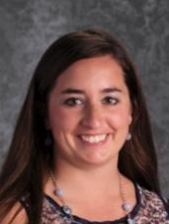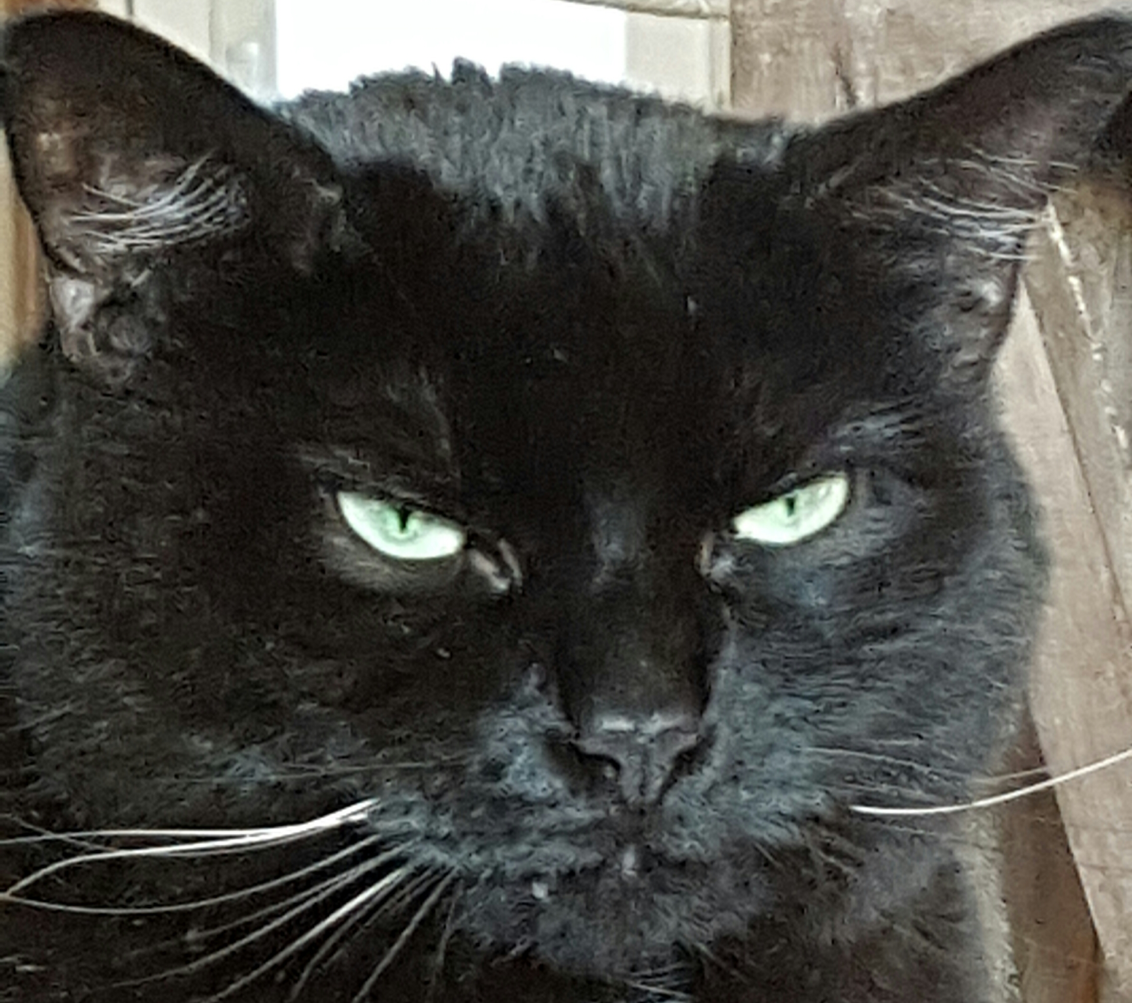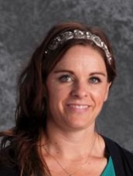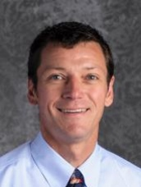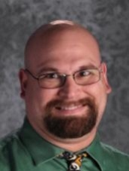

### Mrs. Satterly

Hi! My name is Jenna Satterly and I am the 5th grade Resource teacher. This is my third year at Prescott School and I’m very excited to be back again this year. I graduated from Nebraska Wesleyan University with my Bachelors in Elementary Education and K-12 Special Education. Last spring I started working on my Masters degree in Educational Administration from Concordia University.

My husband and I grew up in eastern Colorado before moving to Lincoln for college. We loved Lincoln so much we decided to stay! We are parents to a cat, Yoda, and a dog, Chewbacca.

I am a sports fanatic. My favorite teams are the Huskers (of course), Denver Broncos, New York Yankees, and Duke Blue Devils. I also love to read, especially mysteries, and bake.

I am excited for a new year and can’t wait to get started. If you have any questions throughout the year, please don’t hesitate to ask!

## Prescott Elementary School Proudly Presents to You the Best 5th Grade Teaching Team at Prescott!

# Our Team

“Great minds discuss ideas. Average minds discuss events. Small minds discuss people”.---Eleanor Roosevelt

August 2016

Prescott Team 5

Volume 2 Issue 1

*There is nothing more unequal than the equal treatment of unequal people—Thomas Jefferson*

Hi! My name is Mrs. Hughes and I am so blessed and very excited to be a part of Prescott School and your child's education!  This is my second year at Prescott.  I graduated from the University of Nebraska-Lincoln in 2012 with a Bachelors in Elementary Education.  I substituted for Lincoln Public Schools and Raymond Central Schools for 2 years, and taught 6th grade at Waverly Middle School.

My family and I live outside of Lincoln in the country.  I have two children who keep me very busy with FFA, dance, volleyball, trapshooting, football, etc.  I forgot to mention our other child, our dog, Moseby.  In my spare time I love to spend time with my family, be outside, ride horses, play tennis, and collect antiques.

Please contact me anytime if you have any questions or concerns throughout the year.  I believe communication is very important in helping to support your child's learning.

Thank you for all that you do, and letting me be part of your child's educational journey!

Hi! My name is Kaysha Brady. This is my 5th year teaching and I am so excited to be at Prescott! Prior to joining the 5th grade team at Prescott, I taught intervention, 5th grade, and 3rd grade at Sheridan Elementary. I also started my teaching career at Dimensions Educational Research Foundation. I am a product of Lincoln Public Schools and grew up in Lincoln, NE and attended Calvert, Pound, and Southeast High School. I graduated college from the University of Nebraska Lincoln. I have a 9 year old son named Landyn who keeps us very busy! He will be in 4th grade this year. We are also in the process of adopting a child from India so we are very excited about that! My husband's name is Travis and he is a Coordinator at Southwest High School. We also have two dogs, 1 Weimaraner named Biz, a yorkie-poo named Chewy, and a cat named Finn. I love the outdoors so my family and I spend a lot of time camping in our VW bus, traveling, as well as going on walks and bike rides. I also love learning new things, yoga, reading at coffee shops and of course teaching!

### Mrs. Hughes

### Mrs. Brady

Donec sit amet arcu.

Nunc cursus magna quis

My name is Jim Glenn-Hash and this is my 17th year as a public school teacher and my 5th here at Prescott.  Before moving to Lincoln in 2004, I taught 6th grade and 2ndgrade in Washington, DC.  I have taught every grade first through sixth and this is my second stint at 5th grade having taught it at Maxey Elementary School.  My wife, Erin, and I have two children – Henry (born in 2005) and Maeve (2010).  I grew up in Northern Idaho and went to college in Colorado.  In 2011, I received my M.A. in Educational Leadership from Doane College.

I enjoy spending time with my family, exercising, and reading.  When not at school you will most likely find me playing outside with Maeve, Henry and Erin.  I’m looking forward to working with all the Fifth graders and their families.

I am Kale Riley and I am thrilled to be teaching 5th grade at Prescott again this year! This is my 13th year teaching, my second year at Prescott.

I have 5 kids, 3 cats, 2 tarantulas, and 1 dog. I collect Darth Vader and Owls. I love 70’s and 80’s rock music; especially Aerosmith. I also love Mountain Dew, Husker Football and the Green Bay Packers. Yes…yes…yes…I am a fan of WWE wrestling. Besides teaching, I enjoy playing the piano, writing fiction, playing Madden Football on my Playstation and spending time with my family.

I have a Bachelor’s of Science degree in Elementary Education, a Master’s of Education in Instructional Technology and I am currently finishing work on a Doctorate of Education. Besides teaching 5th grade, I have had the pleasure of teaching 6th, 7th, and 8th grade, Adult Education, a college course and driving lessons. I have high expectations of my students. I expect them to think critically every day and actively dialogue in class. Most importantly, I expect my students to give their best effort every day and never give up.

*Are you an egg, a carrot or a coffee bean?*

### Mr. Glenn-Hash

### Mr. Riley

This is an exciting time of year! Who doesn’t love that first scissor cut into a new piece of construction paper? Or that first dip into a fresh jar of Jiff?

The 5th grade team welcomes you to a new year at Prescott. We invite you to explore our 5th grade team website: <http://wp.lps.org/kriley/>

We also encourage you to read all handouts that come home with your student. Your student will be bringing home homework nearly every day this year. It is important for your student to do the work himself or herself but we encourage you to look it over, read it with them, and take an active role in their educational process. We are looking forward to a fun year, filled with learning and growth. You have entrusted your student into our care and we assure you we will do our best everyday to help them feel safe, feel respected, grow academically and grow socially. Our goal is not simply to get your student to pass 5th grade. Our goal is to give your student tools with which they can and will begin to build their future: Middle School, High School, College and the rest of life.

Throughout the coming school year we will, of course, be focused on teaching academic skills however, we believe it is also essential for our students to be prepared for life outside the school building. We have three powerful *Goals for Life* that we will emphasize this year: 1. I can take care of myself, even if I am mad. 2. I can be productive and follow directions even if I don't want to. 3. I can be okay, even when others are not okay

Remember: 5th Graders are *the leaders* at Prescott Elementary School. All the other students here will look to our fifth graders for an example of how to behave. This is a heavy responsibility but we know our students are up to the challenge. That is why we can say that the 5th grade class is **The Pride of all Prescott!**

**Welcome to 5th Grade!**

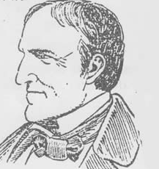

|  |  |  |
| --- | --- | --- |
| 9:00-9:50 | Specials |  |
| 9:55-11:00 | Math |  |
| 11:00-11:10 | Word Work |  |
| 11:10-12:00 | Unit Studies |  |
| 12:00-12:45 | Recess & Lunch |  |
| 12:45-1:15 | Intervention |  |
| 1:15-1:55 | Whole Group Reading | |
| 1:55-2:05 | Physical Activity Break | |
| 2:05-2:55 | Guided Reading |  |
| 2:55-3:35 | Writing |  |

**School Schedule:**

Parents take note! We have our first **FIELD TRIP** coming up on **AUGUST 24th!**

On Wednesday, **August 24th, LPS 5th grade students will attend the Lincoln Saltdogs baseball game in Haymarket Park.** The first pitch will be at 11:00 am. School staff will accompany their students to the game that is expected to end about 1:30 pm. LPS and charter busses will transport students from school to the game, then return them to school prior to dismissal. **Please see informational letter on page 8 of this newsletter.**

**We will have to order lunches for students right away. Teachers will be taking a count on Friday, August 19th of students planning on ordering a sack lunch from the school. Please talk with your student ahead of time and plan accordingly.**

1848 - The dental chair was patented by M. Waldo Hanchett.   
1877 - Thomas Edison wrote to the president of the Telegraph stating that "hello" would be a more appropriate greeting than "ahoy" when answering the telephone.   
1911 - The product Crisco was introduced   
1939 - "The Wizard of Oz" premiered in Hollywood, CA.   
1944 - The Allied forces of World War II landed in southern France.   
1947 - India became independent from Britain and was divided into the countries of India and Pakistan.  
1948 - The Republic of Korea was proclaimed.   
1961 - East German workers began construction of the Berlin Wall.   
1970 - Pat Palinkas became the first woman to ‘play’ in a pro football game when she held the ball for the Orlando, Panthers.  
1994 - The U.S. Social Security Administration became an independent government agency. It had been a part of the Department of Health and Human Services agency.   
2000 - A group of 100 people from North Korea arrived in South Korea for temporary reunions with relatives they had not seen for half a century. Also, a group of 100 South Koreans visited the North.   
2001 - Astronomers announced the discovery of the first solar system outside our own. They had discovered two planets orbiting a star in the Big Dipper.   
2011 - Google announced that it would acquire Motorola Mobility for $12.5 billion.

**This Date in History:**

**August 15th**

*It is not our abilities that show what we truly are… it is our choices. – Professor Dumbledore*

August 24th: Salt Dogs Field Trip

August 25th: Family Learning Night 6:00pm

August 30th: PLC Early Release Day

September 5th: Labor Day = NO SCHOOL

September 16th: Family Fun & Art Festival

September 27th: PLC Early Release Day

**Upcoming Dates of Importance!**

Here are 6 circles for your calendar…

Throughout the year there may be opportunities for parents and guardians to volunteer to help out in 5th grade classrooms and/or on field trips. If you would like to volunteer throughout the year please don’t hesitate to give us a call or an email.

August 2016

To Parents/Guardians of 5th Grade Students:

On Wednesday, August 24, LPS 5th grade students will attend the Lincoln Saltdogs baseball game in Haymarket Park. This community event is made possible by the generous sponsorship of the Lincoln Saltdogs organization. Thanks go to many parents who have also contributed. Free bus transportation and game tickets will be provided for all students.

The first pitch will be at 11:00 am. School staff will accompany their students to the game that is expected to end about 1:30 pm. LPS and charter busses will transport students from school to the game, then return them to school prior to dismissal. Students should bring a sack lunch and refillable water bottle to the game or they may order lunch from the school cafeteria.

Prior to game day, teachers will be using various instructional activities related to baseball within the curriculum. This field trip provides many opportunities for 5th graders to apply what they are learning in math, reading, writing, science, social studies, character education, health, physical education, and other areas of the school curriculum. It is also an effective and fun way for students to learn about their community and some of the outstanding resources Lincoln has to offer its citizens.

During the game LPS students will lead the singing of the national anthem, serve as guest announcers, and participate in activities between innings. Students will remain with their teachers during the game. The public will also be admitted to this game, however no alcoholic beverages or peanut products will be sold. Parents are welcome to purchase tickets and attend the game, but they will **not** be able to sit with their students.

We look forward to making this field trip a special day for our 5th grade students as they begin their final year of elementary school. If you have any questions about this event, please contact your student’s 5th grade teacher.

[1930 S 20th St](http://maps.google.com/maps?q=1930+S+20th+St+68502)  
Lincoln, Nebraska 68502