PERIOD III (1754-1800) EXAM: MULTIPLE CHOICE QUESTIONS

Directions: Each of the questions or incomplete statements below is followed by either four suggested answers or completions. Select the one that is best in each case and then fill in the appropriate letter in the corresponding space on the answer sheet.

Questions 1-3 refer to the following quote.

“And whereas it is just and reasonable, and essential to our Interest, and the Security of our Colonies, that the several Nations or Tribes of Indians with whom we are connected, and who liver under our Protection, should not be molested or disturbed in the Possession of such Parts of Our Dominions and Territories as, not having been ceded to or purchased by Us, are reserved to them, or do therefore, with the Advice of our Pricy Council, declare it to be our Royal Will and Pleasure, that no Governor or Commander in Chief in any of our Colonies of Quebec, East Florida, or West Florida, do presume, upon any Pretence whatever, to grant Warrants of Survey, or pass any Patents for Lands beyond the Bounds of their respective Governments, as described in their Commissions…”

-Proclamation of 1763-

1. Following the Treaty of Paris in 1763, one of the biggest concerns of the British regarding North America was
A. creating a lasting peace with the French still residing in their new land acquisitions
B. settling the newly acquired land to establish commerce with Indians
C. preventing westward expansion to mend relations with natives previously allied with the French
D. establishing governments that could control French Quebec and Spanish Florida

2. Following the French and Indian War, the American colonists were determined to
A. declare independence from Great Britain
B. settle lands in the Ohio River Valley
C. create commercial relationships with Indians in the interior of the continent
D. pay British merchants for the debt they incurred during war

3. A Direct result of colonial encroachment on native lands in the Great Lakes region led to
A. a renewed dispute between French-Canadian woodsmen and American colonists
B. an uprising by an Ottawa chief, Pontiac
C. hostilities between British regulars and American settlers wishing to venture west
D. taxes on colonials to prevent their expansion westward

Questions 4-6 refer to the following image.
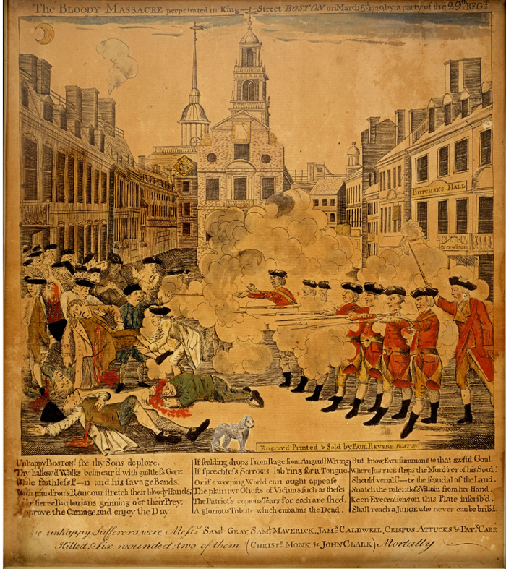

“The Bloody Massacre,” 1770 engraving by Paul Revere

4. The event depicted in this engraving of 1770 entitled “The Bloody Massacre”
A. quickly led to the outbreak of war between the British and the American colonists
B. had relatively little immediate impact because it coincided with the repeal of four of the five Townshend
duties
C. was strongly condemned by John Adams, winning him the admiration of the Patriots
D. never actually occurred; it was a product of Paul Revere’s imagination

5. When John Adams described the victims of the massacre as “a motley rabble of saucy boys, negroes, and
mulattoes, Irish teagues and outlandish jack tarrs”, he was
A. implying that one motive behind the disturbance might have been resentment of British soldiers by those
who were competing with them for jobs
B. affirming the right of the common people to organize a demonstration against oppressive British policies
C. making a plea to his fellow colonists to respect the rights of immigrants and members of racial and ethnic
minority groups
D. criticizing the British soldiers for firing on a group of poor innocent victims

6. In the immediate aftermath of the Boston Massacre, many of the citizens of the city of Boston
A. decided to enlist in the British army in order to obtain weapons to defend themselves
B. organized the Boston Tea Party
C. became more receptive to the pleas of radicals such as Samuel Adams, who saw the need for vigilance in
view of signs of increasing British oppression
D. looked to George Washington to organize and lead a new colonial military force

Questions 7-10 refer to the following passage:

War Song, 1776

Hark, hark the sound of war is heard,
And we must all attend;
Take up our arms and go with speed,
Our country to defend.

Our parent state has turned our foe,
Which fills our land with pain;
Her gallant ships, manned out for war,
Come thundering o’er the main.

There’s Carleton, Howe, and Clinton too.
And many thousands more,
May cross the sea, but all in vain,
Our rights we’ll ne’er give o’er.

Our pleasant homes they do invade,
Our property devour;
And all because we won’t submit
To their despotic power.

7. What is the main point of the lyrics in the excerpt?
- The lyrics warn that Americans should be aware of an impending English invasion of their homes.
- The words are meant to inspire American colonists to take up arms and fight against the despotic mother country.
- There was a fear of a French attack and Americans needed to be ready to fight.
- There was a continued fear of an impending attack by Native Americans and Americans must take up arms to protect their homes.

8. Based on the previous lyrics, what were Americans fighting for?
A. Americans were fighting for their rights as Englishmen.
B. Americans were fighting for economic liberty and to be able to practice free trade.
C. Americans were fighting for the right to replace their despotic royal governors
D. Americans were attempting to replace British Enlightenment philosophy with their own ideas on
government.

9. Despite the strength of the patriotic “call to arms” attitude in the lyrics, which of the following events would
discourage the American spirit in 1776?
A. The fact that Native Americans were attacking British colonists from the west while the British navy was
attacking from the east.
B. The fear of a massive slave rebellion.
C. The lack of economic means to support a war effort against England.
D. The presence of Loyalists throughout the colonies.

10. Based on the lyrics, which of the following is the most plausible reason for the reaction described in the song?
- The passage of restrictive regulations on the British North American colonies by Parliament
- The continued violation of American freedom of the seas and free trade
- The fear of invasion of American ports by the English Navy in order to stop American trade with the Spanish and French Caribbean colonies
- The continuous attack by Native Americans on frontier settlements west of the Appalachian Mountains

Questions 11-13 refer to the following quote.

“Commotions of this sort, like snow balls, gather strength as they roll, if there is no opposition in the way to divide and crumble them. Do write me fully, I beseech you, on these matters; not only with respect to facts, but as to opinions of their tendency and issue. I am mortified beyond expression that in the moment of our acknowledged independence we should by our conduct verify the predictions of our transatlantic foe, and render ourselves ridiculous and contemptible in the eyes of all Europe.”

-Letter from George Washington to David Humphreys, October 22, 1786-

11. The major weakness of the Articles of Confederation, and the one that sparked the “commotion” that Washington
addresses, was that Congress could not
- reate treaties
- levy taxes
- control the sale of lands
- draft militia soldiers into service

12. Shays’ Rebellion occurred in Massachusetts as a result of
A. foreclosures on the lands of farmers in Massachusetts
B. unfair taxes placed on farmers by Congress
C. mandatory enlistment into the militia of Massachusetts
D. Indian raids on the frontier

13. Washington’s fear, along with many other politicians’ fears, of a rebellion sweeping through the nation
uncontrollably eventually led to
- a renewed debate over a stronger central government
- amendment of the Articles of Confederation
- emergence of pro-British sentiments through America
- alliances with foreign nations to improve America’s military forces

Questions 14-16 refer to the following quote.

Article 2

“His Majesty will withdraw all His Troops and Garrisons from all Posts and Places within the Boundary Lines assigned by the Treaty of Peace to the United States. This Evacuation shall take place on or before the first Day of June One thousand seven hundred and ninety six, and all the proper Measures shall in the interval be taken by concert between the Government of the United States, and His Majesty’s Governor General in America, for settling the previous arrangements which may be necessary respecting the delivery of the said Posts: The United States in the mean Time at Their discretion extending their settlements to any part within the said boundary line, except within the precincts or Jurisdiction of any of the said Posts.”

Article 6

“Whereas it is alleged by divers British Merchants and others His Majesty’s Subjects, that Debts to a considerable amount which were bona fide contracted before the Peace, still remain owing to them by Citizens or Inhabitants of the United States, and that by the operation of various lawful Impediments since the Peace, not only the full recovery of the said Debts has been delayed, but also the Value and Security thereof, have been in several instances impaired and lessened, so that by the ordinary course of Judicial proceedings the British Creditors, cannot now obtain and actually have and receive full and adequate Compensation for the losses and damages which they have thereby sustained: It is agreed that in all such Cases where full Compensation for such losses and damages cannot, for whatever reason, be actually obtained had and received byt the said Creditors in the ordinary course of Justice, The United States will make full and complete Compensation for the same to the said Creditors.”

-Excerpt from Jay’s Treaty, 1795-

14. The significance of Article 2 was that it urged the British to
A. remove troops and garrisons from American homes and buildings
B. hand over American posts that had been occupied by the British during the Revolution
C. remove British soldiers from forts in American territories according to the Treaty of Paris
D. evacuate its citizens from the territory as American settlers began moving west

15. As a stipulation of the treaty, according to Article 6, America
A. could not guarantee that British debts that existed before the war would be paid
B. agreed to consume the debts of its citizens and pay the British for compliance with terms of the treaty
C. believed that the British merchants were falsifying claims and refuse to acknowledge them
D. would only agree to the terms of the treaty if British merchants relinquished all debt claims held with
Americans

16. As a result of the treaty
A. the British immediately began evacuating their forts and posts in the Old Northwest
B. citizen Edmund Genet, a French minister, began advocating war against the British
C. many Americans were angry because they saw the treaty as a sign of weakness against their former enemy
D. John Jay was hailed as a hero in America because of his efforts to prevent another war

Questions 17-20 refer to the following excerpt.

“One of the expedients of party to acquire influence within particular districts is to misrepresent the opinions and aims of other districts…The inhabitants of our Western country have lately had a useful lesson on this head; they have seen, in the negotiation by the Executive, and in the unanimous ratification by the Senate, of the treaty with Spain, …decisive proof how unfounded were the suspicions propagated among them of a policy in the General Government and in the Atlantic States unfriendly to their interests in regard to the Mississippi; …the…two treaties, that with Great Britain, and that with Spain, …secure to them everything they could desire, in respect to our foreign relations, towards confirming their prosperity.”

-Address of General Washington to the People of the United States, September 19, 1796-

17. The excerpt from President George Washington’s Farewell Address makes reference to both Jay’s treaty and
Pinckney’s Treaty, in part for the purpose of
A. increasing the president’s popularity with the American people
B. encouraging the development of a stronger national identity
C. discrediting criticisms of the president made by Thomas Paine
D. discouraging radical New Englanders from seceding from the Union

18. President Washington’s references to “the expedients of party” and to “the inhabitants of our Western country”
indicate that he feared that
- the Federalist Party might lose seats in Congress in the next election
- people living in the West might form a new political party
- attacks by Native Americans might devastate frontier settlements
- Westerns’ regional identity might be exploited for partisan political purposes

19. President Washington was aware that, during the previous decade, John Jay, a trusted collaborator and negotiator
of the Treaty of London (Jay’s Treaty) of 1794, had given “the inhabitants of our Western country cause to
suspect that he was unfriendly to their interests in regard to the Mississippi” when he negotiated the Jay-Gardoqui
Treaty in 1786. Therefore, in the previous passage from his Farewell Address, that president was careful to allude
to the fact that Pinckney’s Treaty
- guaranteed United States navigation rights on the Mississippi
- contained several provisions unfriendly to England
- stopped the Atlantic States from discriminating against Westerners
- protected the United States from the threat of a French invasion

20. The partisan conflict President Washington was alluding to in his Farewell Address was between American
supporters of which two competing European powers?
- Britain and France
- Spain and France
- Russia and Japan
- Britain and Russia

