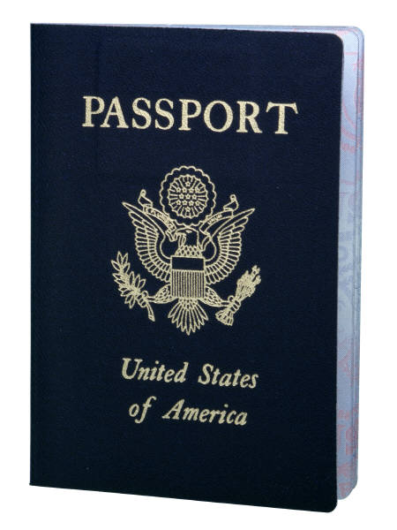**Overview:** You are going to organize a trip to Europe. This trip is partly business and partly fun. You may take one person with you. While in Europe, you will meet up with 2 potential business clients in each country.

**Other directives regarding the trip and your assignment are as follows:**

1. Your trip will last two weeks.
2. You need to travel to at least 4 European countries during those two weeks.
3. MC900047775[1]You have a total trip budget of **$40,000 (US dollars)** for travel, hotels, and meals, sightseeing, and entertaining clients.
4. Check with your boss (your teacher) to gain permission to exceed your budget. ☺
5. Assume you have a current passport and do not need to pay or arrange anything for VISA-entry to any country.
6. Use the Internet to research your plane schedule, travel plans, and hotel arrangements
7. Be creative; have fun with the project!
8. Create an *FinalProjectLastName* folder and save all documents to this folder so that you can zip it and upload it to DocuShare later

**Requirements:** Here is your list of requirements to complete the project:

* **MC900297177[1]Word** - Memo to Mr. Fagler outlining your plans for your trip (general travel plans--dates & location, anything specifically that you’ll be doing.) **Do this first!**
* **Excel** - Travel Budget and Expense Report – both on [spreadsheets](Spreadsheet.xlsx). Complete the budget figures and display the spreadsheet in an attractive format. Create a chart on the Budget worksheet to show how much you have allotted for each expense. The shell of the expense report should be set up so that you can detail expenses each day (using your laptop) that you are on the road. Create a chart on the Expense sheet showing the expenses and the totals.
* **Excel** - Database of clients in other countries. Research your business contacts prior to your trip and include any pertinent fields about your clients to help you understand their needs and business practices. Headings on your database might include: Name of business, Contact Name, Address, City, Country, Zip, Phone, E-mail, Website, Company Logo, Product Information.
* **Word** – Itinerary – Day by Day schedule, including hotel stay, travel, arrangements, and time schedule.
* **Word** – Access Mail Merge with Potential Clients Database – Letter from you to arrange meetings with potential clients. Letter can be faxed, mailed, or e-mailed.
* **Word** – Table of Travel Arrangements – Dates, Flights & Hotels, include prices and amenities (5-Star, 4-Star, Bed & Breakfast, etc…)
* **Word or Excel** – Table of Currency Rate Exchanges for each country you visit (US Dollars converted to designated currency and back again.)
* **Power Point** – Create a slide show presentation about trip. Include what you did in each country, what clients you met where, where you stayed, etc. Research business customs in one of the countries you visited and create at least one slide about these customs. Include the 2 charts you created in Excel.

**URL’s that might help you with this project:**

http://www. kayak.com Travel, Hotel, Car Rental Clearinghouse

<http://www.orbitz.com> Travel Site

<http://www.hotels.com> Discount Hotels Site

<http://www.worldbusinessculture.com/> Doing Business in other nations

<http://www.executiveplanet.com> Guide to International business cultures

<http://www.disordered.org/Travel.html> Main in a Suitcase travel tips site

<http://www.getcustoms.com> Getting through Customs

<http://www.internationalist.com/travel/> International travel links

<http://www.lonelyplanet.com/> World guide to travel

<http://www.lonelyplanet.com/destinations/> Select a specific country to visit

<http://www.newspapers.com/country.htm> Newspaper links to countries

<http://www.odci.gov/cia/publications/factbook/index.html> World Factbook

<http://www.ricksteves.com/plan/plan_menu.htm> Rick Steves’ European travel tips

|  |  |  |  |  |  |  |  |
| --- | --- | --- | --- | --- | --- | --- | --- |
| Required Software Skills/Features –Business/Vacation Trip Project | | | | | | | |
| **Word Skills** | **Points** | **Excel Skills** | **Points** | **Access Skills** | **Points** | **Power Point Skills** | **Points** |
| * Table * Clip Art * Pictures * Map * Hyperlink * Theme Colors * Text Box * Word Art * Wrap Text * Mail Merge |  | * Formulas * Chart * Use of Formatting – colors, themes, fonts, bold, italics |  | * Table * Form * Report w/ Totals * 2 Queries |  | * Smart Art * Bullets * Hyperlink * Embedding Excel Chart * Consistent Theme/Background * Transitions & Text Animations * Cultural Facts and/or Business Protocols listed |  |
| Optional Software Skills/Features – Bonus Points | | | | | | | |
| **Word** | **Bonus Points** | **Excel** | **Bonus Points** | **Access** | **Bonus Points** | **Power Point** | **Bonus Points** |
| * Title Page for Project * Table Calculations * Smart Art * Shapes |  | * Pivot Table * Linking Spreadsheets * Company Logo Complex Formulas (Ex: If, HLookup, etc..) |  | * Pivot Table or Chart * Formulas in Query or Report * Company Logo on Form or Report * Lookup Field |  | * Action Buttons * Sounds/Music from Country of Choice |  |