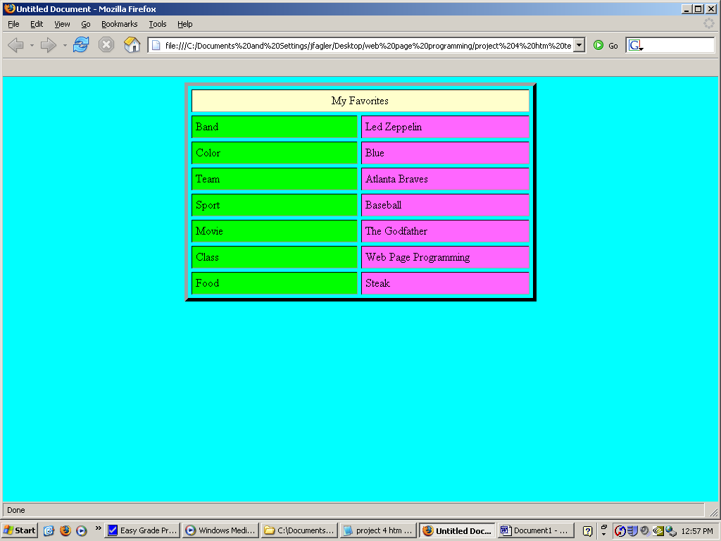

Instructions:
- Open Notepad and enter the code necessary to recreate the Table above as close as you can get it. You may choose your own colors.
- In the column on the right, enter your personal favorites for each category.
- Create a Test folder in your Tutorial05 folder. Name the file favorites.htm and save it in there.

